
Using UniSA
Virtual Desktops

Go to:
Connecting to a Virtual Desktop
Using a Virtual Desktop
Disconnecting from a Virtual Desktop

Warning: These instructions assume the Virtual Desktop Infrastructure (VDI) Client ‘VMware View Client’ is installed on the device. To install the VDI Client please refer to Installing VDI Client.


Instructions: Connecting to a Virtual Desktop
Step 1: Open the VDI Client: VMware View Client.
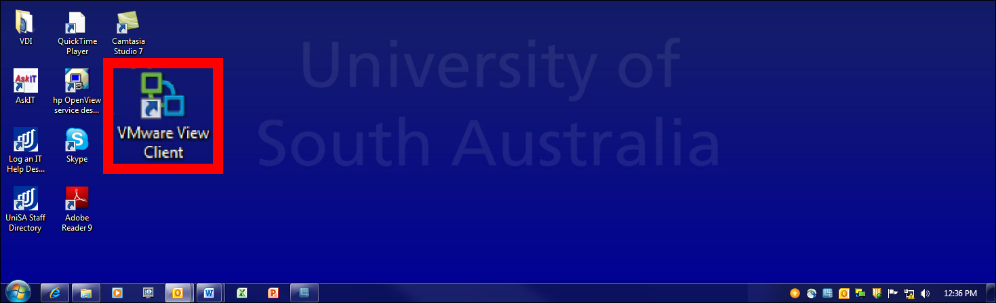
Step 2: Select the Connect button.
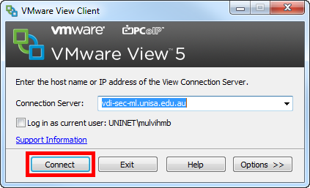
Step 3: Enter your UniSA Username and Password, and select the Login button.
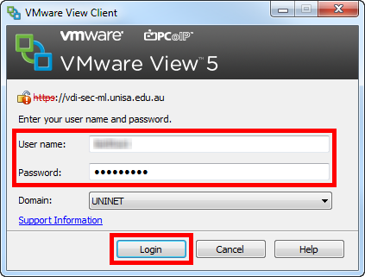
Step 4: Select the Virtual Desktop you want to connect to, and select the Connect button.
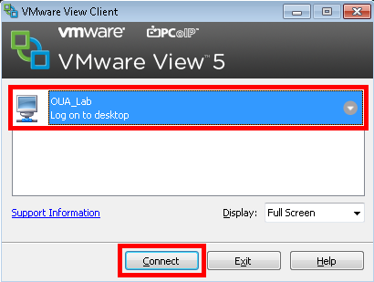
You will be connected to a virtual desktop within the selected VDI Pool (lab), and will have access to all software and applications installed on the virtual desktop.
If all virtual desktops within the selected VDI Pool (lab) are already connected to other users, a warning message will advise TBC.

Outstanding Queries:
Warning: Will need to insert hyperlink to install process
Step 2: Mark to test what happens if they don’t enter a default Connection Server when installing the VDI Client (the install wizard allows you to select Next without entering a default). Mark to test if no default entered during install, but address is manually entered on first login, does the address remain as the default for the second and subsequent logins or does it have to be manually entered each time?
Step 3: Even using Matt’s testoua1 credentials I still can’t get beyond step 3 (step 4 screen image from Matt E’s email).

Important Notes: Using UniSA Virtual Desktop
Note 1: All work must be saved on your local device or other local storage device such as a USB
- Do not save work or files of any kind on a virtual desktop
- Files saved to a virtual desktop are deleted when the next user connects and cannot be recovered
Note 2: There is a limited number of virtual desktops within a VDI Pool, so please follow these simple protocols to maximise the availability of virtual desktops:
- only connect to a virtual desktop to access applications not installed on your current device; do not connect to a virtual desktop if you can use your local device to complete the task(s)
- disconnect from the virtual desktop as soon as you finish using the applications not installed on your device

Outstanding Queries:
What else do we need

Instructions: Disconnecting from a Virtual Desktop
Step 1: .

