**Reference list formatting**

**Become an expert user of bibliographic software**

***Top tips***

1. Become **familiar** with your preferred discipline-specific referencing style [Note: more than 300 different styles exist.] The trend is:
   * ‘sentence-case’ for titles e.g. Encyclopedia of research design
   * ‘capital-case’ for Journal names e.g. *Journal of Biomedical Education*
2. Be **consistent** with the entry form of all elements – e.g. enter Author names the same way e.g. Behrend, Monica otherwise in-text might have (Behrend 2020) or (Behrend, M 2020)  
   [Note: for names of organisations add a comma at the end of the name, e.g. University of South Australia, otherwise it will appear as Australia, UoS !!!]
3. Always **check** each reference methodically as you enter it [Note: imported references will not be consistent, so modify them to be consistent according to your style.]

**Activity 1** Examine these references for completeness and consistency.

* Which seem incomplete?
* Spot inconsistencies
* What questions do you have?

**References** (from a thesis, used with permission)

Adom, D, Hussein, E & Joe, A-A 2018, 'Theoretical and conceptual framework: Mandatory ingredients of a quality research', *International Journal of Scientific Research,* vol*.* 7, 01/02, pp. 438-41.

Ahuja, D, Nasr, N, Fawcett, J, Whitfield, M & McLean, S 2015, 'Implementing a triangulation protocol for integration of findings in a mixed methods study: A worked example', *Physiotherapy,* vol*.* 101, 05/01, pp. e42-e43.

American College of Obstetricians and Gynaecologists 2013, *Weight gain during pregnancy Committee opinion number 548, American college of obstetricians and gynaecologists.*,

American College of Obstetricians and Gynecologists 2017, *Oral health care during pregnancy and through the lifespan*,

Antonenko, PD 2015, 'The instrumental value of conceptual frameworks in educational technology research', *Educational Technology Research Development,* vol*.* 63, no. 1, February 01, pp. 53-71.

Armstrong, J 2010, 'Encyclopedia of research design', in NJ Salkind (ed), Thousand Oaks, California.

Aromataris, E & Munn, Z 2017, *Chapter 1: JBI Systematic Reviews. In: Aromataris E, Munn Z (Editors). Joanna Briggs Institute Reviewer's Manual. The Joanna Briggs Institute, 2017. Available from* *https://reviewersmanual.joannabriggs.org/*

Arrish, J, Yeatman, H & Williamson, M 2014, 'Midwives and nutrition education during pregnancy: A literature review', *Women and Birth,* vol*.* 27, no. 1, 2014/03/01/, pp. 2-8.

Arrish, J, Yeatman, H & Williamson, M 2016a, 'Nutrition education in Australian midwifery programmes: A mixed-methods study ', *Journal of Biomedical Education,* vol*.* 2016, p. 12.

Arrish, J, Yeatman, H & Williamson, M 2016b, 'Australian midwives and provision of nutrition education during pregnancy: A cross sectional survey of nutrition knowledge, attitudes, and confidence', *Women and Birth,* vol*.* 29, no. 5, Oct, pp. 455-64.

Attala, A & Henderson, L 2003, 'Preconception and pregnancy—what should women be eating?', *International Journal of Health Promotion and Education,* vol*.* 41, no. 2, 2003/01/01, pp. 36-40.

Australian Nursing and Midwifery Accreditation Council 2014, *Midwife Accreditation Standards* cat.no. ISBN: 978-0-9808210-6-2, Canberra.

Barrowclough, D & Ford, F 2001, 'A nutrition open‐ learning pack for practising midwives', *Nutrition and Food Science,* vol*.* 31, no. 1, pp. 6-12.

Baute, V, Sampath-Kumar, R, Nelson, S & Basil, B 2018, 'Nutrition education for the health-care provider improves patient outcomes', *Global Advances in Health and Medicine,* vol*.* 7, p. 2164956118795995.

Bazeley, P 2006, 'The Contribution of computer software to integrating qualitative and quantitative data and analyses ', *Research in the Schools,* vol*.* 13, no. 1, pp. 64-74.

Better Health Channel 2017, *Healthy Pregnancy*, Victoria State Government. , viewed 15 June 2019, < https://www.betterhealth.vic.gov.au/healthyliving/healthy-pregnancy >.

Bolarinwa, O 2015, 'Principles and methods of validity and reliability testing of questionnaires used in social and health science researches', *Nigerian Postgraduate Medical Journal,* vol*.* 22, no. 4, October 1, 2015, pp. 195-201.

Bookari, K, Yeatman, H & Williamson, M 2016a, 'Exploring Australian women's level of nutrition knowledge during pregnancy: A cross-sectional study', *International journal of women's health,* vol*.* 8, pp. 405-19.

Buchholtz, N 2019, 'Planning and conducting mixed methods studies in mathematics educational research', in G Kaiser & N Presmeg (eds), *Compendium for Early Career Researchers in Mathematics Education*, Springer International Publishing, Cham, pp. 131-52.

Cetin, I & Laoreti, A 2015, 'The importance of maternal nutrition for health', *Journal of Pediatric and Neonatal Individualized Medicine,* vol*.* 4.

Clarke, J 2011, 'What is a systematic review?', *Journal of Evidence Based Nursing,* vol*.* 14, no. 3, pp. 64-64.

Creswell, J 2003, *Research design: Qualitative, quantitative and mixed methods approaches*, California

Creswell, J 2009, 'Research design: Qualitative, quantitative, and mixed-method approaches'.

Creswell, J 2014, *Research design: Qualitative, quantitative and mixed methods approaches (4th ed.)*, Thousand Oaks, CA: Sage

Creswell, J 2015, *A Concise Introduction to Mixed Methods Research*, SAGE Publications Ltd., Los Angeles.

Creswell, JW & Plano Clark, VL 2007, *Designing and conducting mixed methods research.* , SAGE Publications, Thousand Oaks, Calif.

Creswell, JW & Plano Clark, VL 2011, *Designing and conducting mixed methods research*, Sage Publications, Los Angeles.

Creswell, JW & Plano Clark, VL 2018, *Designing and conducting mixed methods research*, Third edition. edn, SAGE Publications, Inc., Thousand Oaks, California.

Hsieh, HF & Shannon, SE 2005, 'Three approaches to qualitative content analysis', *Qual Health Res,* vol*.* 15, no. 9, Nov, pp. 1277-88.

Imenda, S 2014, 'Is There a conceptual difference between theoretical and conceptual frameworks?', *Journal of Social Sciences,* vol*.* 38, 01/13, pp. 185-95.

Wennberg, A-L, Hamberg, K & Hörnsten, Å 2015, 'A questioned authority meets well-informed pregnant women--a qualitative study examining how midwives perceive their role in dietary counselling', *BMC Pregnancy and Childbirth,* vol*.* 15, Apr 10, p. 88.

Wennberg, AL, Lundqvist, A, Hogberg, U, Sandstrom, H & Hamberg, K 2013, 'Women's experiences of dietary advice and dietary changes during pregnancy', *Midwifery,* vol*.* 29, no. 9, Sep, pp. 1027-34.

WHO 2019, *Healthy diet* <https://www.who.int/behealthy/healthy-diet>.

WHO—*see* World Health Organisation.

**PERFECT examples**

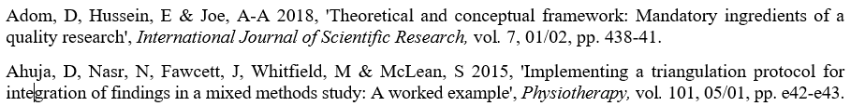

**Here are some issues resolved**



* Capitalisation is needed for the second listed American College
* No Italics for the title or publisher
* Publication details missing



* Incomplete details, needs journal or book chapter title and other publication details



* This seems a book chapter with Salkind the editor. Need details of book chapter and book title.
* California is abbreviated to CA
* I found:   No need for chapter number, just add the page numbers at the end. Thus the reference should look like this:

Armstrong, J 2010, ‘Naturalistic inquiry’, in NJ Salkind (ed), *Encyclopedia of research design*, SAGE Publications, Inc, Thousand Oaks, CA, pp. 881-5.

* This reference list refers to California in three ways – California, Calif. and CA. CA is correct.

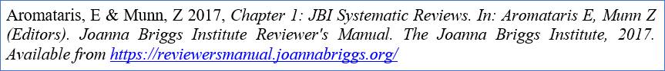

* Aromataris, E & Munn, Z 2017, ‘JBI systematic reviews’, in E Aromataris & Z Munn (eds), *Joanna Briggs Institute reviewer’s manual*, viewed 7 August 2017, [*https://reviewersmanual.joannabriggs.org/*](https://reviewersmanual.joannabriggs.org/).



* Only one page? Surely this should be page ranges!



* Open-learning … no space after the hyphen
* Use en dash (twice the length of a hyphen) for number range



* Lowercase ‘c’ for ‘Contribution’



* Be consistent with inserting URLs, as here you have < … > but not in others!
* Victoria State Government, [remove . and space]



* Use capital case for the journals like this *International Journal of Women’s Health*



* Spelling ‘Applied’

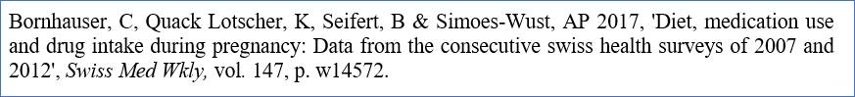

* Capital letter for Swiss because a proper name ‘… from the consecutive Swiss health surveys of 2007 …

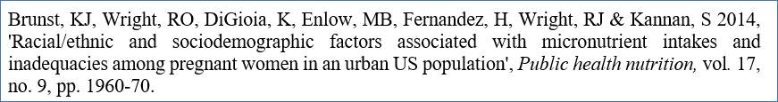

* Capital case for the name of the journal *Public Health Nutrition*



* Missing reference elements i.e. journal no. and page numbers

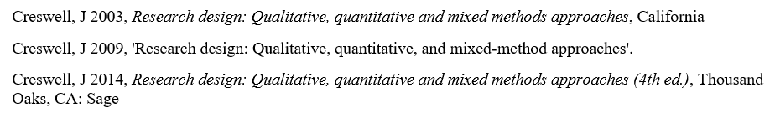

* Why use 3 editions of the same book? Why not just use the most recent one?
* References is incomplete. Books have Publisher 🡪 Place.

Creswell, J 2014, *Research design: Qualitative, quantitative and mixed methods approaches* (4th edn), SAGE Publications Inc, Thousand Oaks, CA.

**This resource was produced by Monica Behrend.**