Writing learning objectives for midwifery placements

Table of Contents

Table of Contents 2
Introduction 3
SMART Framework 3
3 important elements of a learning objective 5
Learning skills using a stepwise process 5
Linking the objective to relevant criterion or standards 5
Clinical Assessment Tools (CATs) 6
Resources to promote and support learning 6
Table 1: Course relationship 7
Table 2: Theory courses (Year 1) 7
Table 3: Theory courses (Year 2) 8
Table 4: Theory courses (Year 3) 8
Learning objectives in PebblePad 9
Exemplars of learning objectives 9
Abdominal assessment 10
Artificial rupture of membranes (ARM) 10
CTG management and interpretation 11
Collaboration 11
Documentation 12
Infant feeding (breast feeding) 12
Infant feeding (artificial feeding) 13
Mental health assessment 13
Newborn blood sampling 14
Newborn examination 14
Vaginal examination 15
Venepuncture 15

Introduction

Before students commence each 2-week block of their clinical placements, they are required to write a minimum of two learning objectives. The learning objectives should relate to the learning they have experienced so far and should help them to apply the theory learned, to the application of clinical practice. Course Coordinators of the Experiential Learning Activities (ELAs) will log onto each student’s ELA workbook on PebblePad to ensure that the student has completed a minimum of two learning objectives prior to their placement. Course Coordinators may provide guidance to help the student improve the way their learning objectives are written, by leaving feedback directly in their PebblePad ELA workbook. Clinical Facilitators will review the student’s learning objectives on the first day of their placement and will support the student to work toward achieving their objectives through their placement.
The learning objectives which students write for each ELA should provide them with clear and specific direction to achieve their goals. It is important that students write their learning objectives by considering very specifically, what they need to achieve. While the end goal is important, a well written learning objective should provide critical direction for the student to help them understand the process which is involved in learning the skill.
This resource has been developed to assist Course Coordinators and Clinical Facilitators to work effectively with students to develop meaningful and clear learning objectives. This resource will outline the SMART Framework, which is used in the UniSA midwifery program to help students to develop learning objectives that are specific, measurable, achievable, relevant, and timed. In addition, it will include several exemplars of learning objectives, written to the standard that is expected of students. It is important to note that the learning objectives forms part of the student’s assessment for each ELA, hence they must meet the required standard.
As everyone’s learning is individual, each student will have their own way of articulating what and how they want to learn. The exemplars are there simply to support course coordinators and clinical facilitators to understand the standard which is expected. They may also be able to be used to provide feedback to help students improve.

SMART Framework

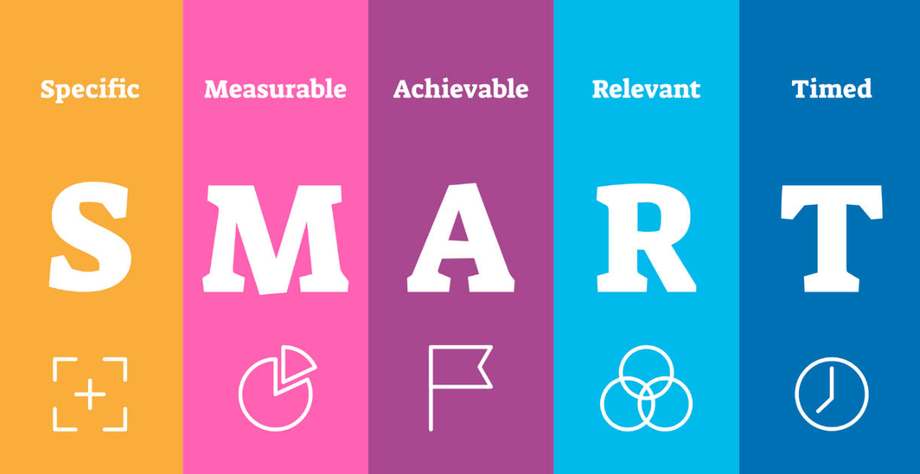

Students are encouraged to use the SMART Framework to develop their learning objectives.

SPECIFIC | A learning objective should specify clearly WHAT you want to achieve.  A learning begins with an action verb like:  - Apply  - Demonstrate  - Execute  - Implement  - Record  - Articulate  - Assess  - Examine  - Establish  - Conduct | Questions to help you think about this:  - What exactly am I going to achieve?  - What strategies have I identified?  - Is the objective clear and understandable?  - Have I used an ‘action’ verb?  - Is it clear what needs to happen?  - What are the steps involved in the skill?  - Is the outcome clear?  - Will this objective lead to the desired result?
MEASURABLE | A learning objective should be about developing new knowledge and make clear how your progress can be measured. | - How will I know that I have achieved my learning goal?  - How can the changes be measured?
ACHIEVABLE | A learning objective must be possible to achieve both in terms of your previous knowledge and skill base, the opportunities that the placement will provide and the amount of time on placement. | - Can I achieve this objective within the stated timeframe?  - Have I considered any limitation or constraints?  - Can I achieve this objective by using the resources that I have identified?  - Is this objective possible?
REALISTIC | A learning objective must be realistic in terms of the resources you have available to you as a student. | - Do I have access to the resources that I need to achieve this objective?  - Have I learned the theoretical concepts to support my learning?  - Do I need to review my learning needs or adjust my learning objective?  - Is this objective possible?
TIMEFRAME | A learning objective must include a timeframe for when a measurement can be taken to show progress and it must take account of the timeframes possible during your placement. | - When will this objective be accomplished?  - Is there a stated deadline for achieving this objective?  - Is this objective achievable in the timeframe stated?

3 important elements of a learning objective

A learning objective should incorporate three important elements to ensure that it provides clear direction for learning.
- Performance or skill – what the student wants to be able to do – what attitudes, behaviours and skills will they need to demonstrate to meet the outcome?
- Criterion or standard – how success can be measured or how student performance will be evaluated. This may relate to accuracy, quality, speed or to professional standards.
- Conditions – the conditions under which the learner will be expected to perform in the evaluation situation – this can include the time and place.

Learning skills using a stepwise process

Any task we complete or skill that we demonstrate is usually made up of a series of steps, or small tasks or skills. When students write their learning objectives in a stepwise manner, they need to first consider how the larger goal can be broken down into smaller, more achievable steps. This can make the goal seem less overwhelming and easier to accomplish, but in addition, allows the student to clearly know when they have achieved each step, hence have met the objective. When students think about each of the steps involved in a skill or task, they visualise the process and this can help them to stay motivated and focused on the result. Sometimes too, the student may not reach the final goal, however, may achieve some of the steps along the way. Any learning can be viewed as positive, and each step may give them something to build upon, so that they can eventually meet the objective.
A first-year student may want to learn how to assess a woman’s vital signs - Here is an example of a learning objective which considers the steps and process of completing the skill:
To develop my ability to assess a woman’s observations and vital signs by articulating the rationale for the procedure, providing clear explanation to gain informed consent, by gathering all required equipment and using it appropriately, and undertaking the assessment while maintaining the woman’s comfort. I will ensure that I know the normal parameters of the vital signs and if findings are identified outside of the ‘normal’ parameters I will alert my supervisor. I will finally document findings and outcomes appropriately.
The student has considered all the steps involved in being able to achieve the goal of assessment of vital signs. They will know the rationale for the assessment and will be able to explain this clearly to gain informed consent. They have thought about the equipment they might need and have considered how to use it. They will need to know the normal ranges and will be able to identify anything that is not normal. It highlights that they know what to do when there are abnormal findings and finally that they understand the importance of documentation.

Linking the objective to relevant criterion or standards

We ask that students link their learning objectives to the ELA Course Objectives and the Nursing and Midwifery Board of Australia, 2018 Midwife Standards for Practice. This relates to the second element of the learning objective as it provides benchmarking and a way to measure student success. The NMBA Midwife Standards for Practice are important to use for such benchmarking as these are the standards that a graduate midwife must attain to register, hence this is what our students are working toward.
Any midwifery care that we provide will often incorporate elements of many of the NMBA Midwife Standards for Practice, however it’s important that students identify most specifically the criterion of the standards that relate to their learning objective. By doing this, the student can easily see how they can achieve the standard within the provision of care.
If we consider the previous example of a student wanting to learn how to assess a woman’s vital signs, these are the NMBA Midwife Standards for Practice that are directly relatable:
- 1.3 uses health assessment and health education to support birth and reproductive health, and minimise the potential for complications
- 3.5 engages in timely consultation, referral and documentation
- 4.2 uses assessment techniques to systematically collect relevant and accurate information
- 4.3 analyses information and data and communicates assessments and anticipated outcomes as the basis for midwifery practice
- 5.1 interprets assessment data and best available evidence to develop a plan for practice
- 6.3 is responsible for consultation and referral and/or escalation in situations that are outside the individual’s scope of practice
Each ELA includes 7 course objectives. The Course Objectives from ELA1 that most relate to this learning objective are:
- CO1: Demonstrate safe and effective woman-centred midwifery care throughout the normal childbirth continuum in accordance with legislation and professional regulation in the context of a multicultural society.
- CO2: Accept accountability and responsibility for own actions and recognise the significance of respectful professional partnerships within the healthcare team.
- CO3: Develop the ability to use appropriate communication strategies to promote an optimal physical, psychosocial, cultural and spiritual environment for women and their families.
- CO7: Develop beginning skills in documenting professional practice and learning through an e-portfolio

Clinical Assessment Tools (CATs)

UniSA midwifery students are required to complete 26 Clinical Assessment Tools (CATs) over the duration of their program. These tools relate to midwifery skills and care over the entire childbirth continuum. The student is required to undertake the care and/or skill in the clinical area under supervision, while being assessed. Each of the ELAs includes several CATs that the students studying the ELA must complete during their placement. The CATs link in with the theoretical learning that the student has experienced prior to the placement. Sometimes students may write a learning objective which is based on the skill of one of the CATs that they will complete during placement. This is acceptable as the CATs cover areas of learning which are relevant for the specific ELA. For example, our first-year students need to complete CAT 3 Abdominal Assessment in ELA1. This is an important midwifery skill that is relevant for them to focus on learning.

Resources to promote and support learning

When writing their learning objectives, students must include a list of specific resources, strategies, or activities that they can use to promote their learning. We ask them to be very specific here. If they can refer to a textbook, we want them to include the chapter and page number. If a current clinical guideline might be helpful, they should include the name, date, and URL if online. If they want to refer to knowledge learned through their theory courses or HHHS workshops, they should include the name of the content and the week of the course it was taught. If a student includes specific detail here, the resources will be easily accessible should they need them.

Table 1: Course relationship
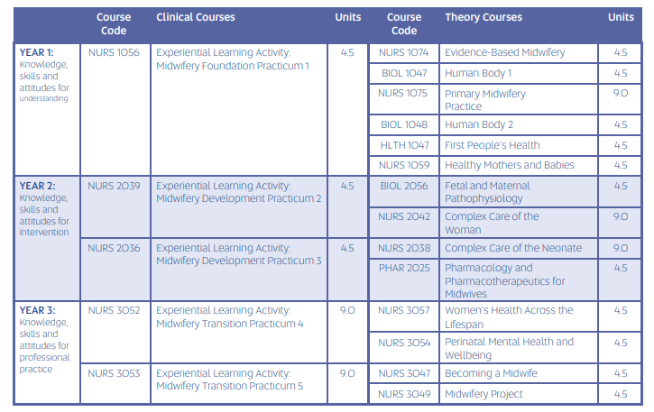
The following table outlines the theory courses that support clinical learning in each of the ELA courses.

Table 2: Theory courses (Year 1)
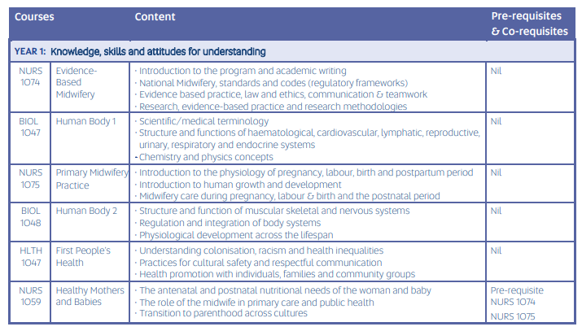
The following tables outline the content presented in each of the theory courses. This can be used to help students to understand where they learned theoretical concepts that may support their clinical learning.

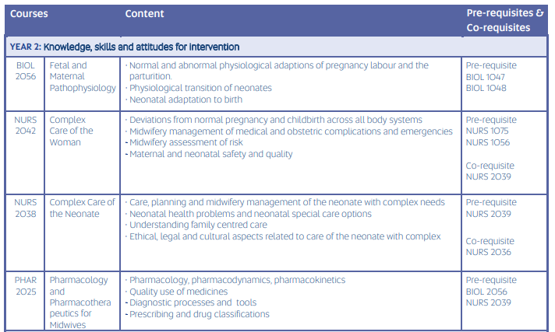
Table 3: Theory courses (Year 2)

Table 4: Theory courses (Year 3)
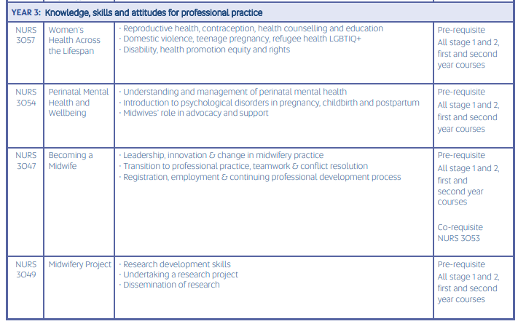

Learning objectives in PebblePad
Students will write their learning objectives directly into a table in their ELA workbooks in the PebblePad platform. The table below explains what the student is expected to include in each box.
What are you going to learn? Include knowledge/skills/attitude
This is where the student will write a statement about what they hope to achieve. It will include clear direction and be written in a stepwise manner, outlining each of the processes that will be completed to achieve the objective.
Resources, strategies and activities – How do you plan to learn?
Students will include resources or strategies which they can use to support their learning. The need to be specific and this may include:
- Textbooks (referring to the name, chapter and page numbers
- Course content (referring to the course name and the week where the content was presented)
- Simulated learning (referring to the specific skill and the workshop in which it was practiced)
- Clinical guidelines (referring to the name, date and URL where appropriate)
- Videos (referring to the specific name and location of the video)
- Hospital protocols or policies (refer to specific names, dates)
- Knowledge gained from supervising clinicians
- Knowledge gained from women
Course Objectives/ NMBA Midwife Standards for Practice (2018)
Students will identify the ELA Course objectives and the criterion of the NMBA Midwife Standards for Practice (2018) that most directly relate to their learning objective.
Time line – When and where do you plan to learn?
This will generally be specific to end of their 2-week placement in their allocated midwifery area.
Evidence – How will you demonstrate your learning? What evidence will be included in your portfolio?
Students need to determine specifically what evidence they will use to demonstrate that they have achieved their learning objective. This may include:
- Verbal and/or written feedback from supervising clinicians
- Successful completion of the associated Clinical Assessment Tool (CAT)
- Successful completion of the associated clinical experience record in their PebblePad workbook
- Feedback directly provided from the woman receiving care
Outcome – Provide evidence of how you achieved your objective.
This is completed by the student generally at the end of their placement or once they have achieved the learning objective. They are expected to provide a brief account of an episode of care where they undertook care, realizing that they had achieved the objective. Linking the outcome to a specific event will help to make it more meaningful. Alternatively, the learning objectives are not always achieved – the student would then provide an account of why this was the case and reflect on aspects that prevented success and plan to achieve the objective at a later date.

Exemplars of learning objectives

The following pages include exemplars of some learning objectives which are written in a way that defines the steps the student will need to consider and complete to achieve the objective. These exemplars may be used to gain understanding of the level of detail we require students to include in their learning objectives. They may also be used to provide feedback to students, to give them ideas about how they can improve learning objectives they have written. The exemplars also include an indication of the ELAs where the objective may be relevant, the CATs that the student may use to demonstrate the skill or those that are linked to the ELA requirements, and the NMBA Midwife Standards for Practice (2018) which most directly relate to the objective.

Abdominal assessment

- Relevant for ELA1 placement
- CAT 3 Abdominal Assessment (ELA1)
To perform abdominal assessment by articulating the rationale for the procedure, providing clear explanation to gain informed consent, by gathering all required equipment, and undertaking the procedure using a woman centred, safe and systematic approach to correctly identify fetal position, growth, and wellbeing. Any findings which are outside of normal parameters will be identified and actioned appropriately by reporting, collaborating, and referring as needed. Finally, the procedure and findings will be documented as per legal requirements.
The following NMBA Midwife Standards for Practice are directly related to this skill:
- 1.3 uses health assessment and health education to support birth and reproductive health, and minimise the potential for complications
- 3.5 engages in timely consultation, referral and documentation
- 4.2 uses assessment techniques to systematically collect relevant and accurate information
- 4.3 analyses information and data and communicates assessments and anticipated outcomes as the basis for midwifery practice
- 4.4 assesses the resources that are available to inform planning.
- 5.1 interprets assessment data and best available evidence to develop a plan for practice
- 6.3 is responsible for consultation and referral and/or escalation in situations that are outside the individual’s scope of practice

Artificial rupture of membranes (ARM)

- Relevant to ELA4 and ELA5 placements
- CAT 12 Care of the woman and baby during induction of labour (ELA4)
To perform artificial rupture of membranes (ARM) by articulating the rationale for the procedure and providing clear explanation to gain informed consent. Appropriate equipment will be gathered and prepared. Relevant assessments of abdominal palpation, fetal assessment and vaginal examination will be undertaken prior to the ARM. The procedure will be performed using a woman centred, safe and systematic approach. Following the procedure, assessment of the woman, her baby and liquor will be undertaken. Any findings which are outside of normal parameters will be identified and actioned appropriately by reporting, collaborating, and referring as needed. Finally, the procedure and findings will be documented as per legal requirements.
The following NMBA Midwife Standards for Practice are directly related to this skill:
- 1.4 undertakes ongoing processes of reflection to ensure professional judgements acknowledge how personal culture impacts on practice
- 3.5 engages in timely consultation, referral and documentation
- 3.6 uses relevant processes to identify, document and manage complexity and risk
- 4.2 uses assessment techniques to systematically collect relevant and accurate information
- 4.3 analyses information and data and communicates assessments and anticipated outcomes as the basis for midwifery practice
- 5.1 interprets assessment data and best available evidence to develop a plan for practice

CTG management and interpretation

- Relevant to ELA2 - ELA5 placements
- CAT 5 Performing and interpreting an antenatal cardiotocograph (ELA2)
- CAT 7 Performing and interpreting an intrapartum cardiotocograph (ELA4)
- CAT 13 Care of the woman with increased needs in labour (ELA5)
To undertake a CTG by articulating the rationale and providing clear explanation to the woman to gain informed consent. To gather all required equipment correctly, and prepare the woman to ensure correct position, comfort and dignity are considered before performing an accurate abdominal assessment to ensure correct placement of transducers. To communicate to the woman about the relevant findings of the trace and to use a systematic process to interpret the trace taking into consideration relevant maternal history. Any abnormal findings will be acted upon and referred as appropriate, with comprehensive and timely documentation completed as per legal requirements.
The following NMBA Midwife Standards for Practice are directly related to this skill:
- 1.3 uses health assessment and health education to support birth and reproductive health, and minimise the potential for complications
- 3.5 engages in timely consultation, referral and documentation
- 3.6 uses relevant processes to identify, document and manage complexity and risk
- 4.2 uses assessment techniques to systematically collect relevant and accurate information
- 4.3 analyses information and data and communicates assessments and anticipated outcomes as the basis for midwifery practice
- 5.1 interprets assessment data and best available evidence to develop a plan for practice
- 6.3 is responsible for consultation and referral and/or escalation in situations that are outside the individual’s scope of practice

Collaboration

- Relevant to ELA2 - ELA5 placements
To independently collaborate with a multidisciplinary team by referring any complexities outside of my scope of practice to other health care professionals. To convey succinct, appropriate information in a clear and systematic manner using ISBAR and then to document the referral in the woman's notes.
The following NMBA Midwife Standards for Practice are directly related to this skill:
- 2.8 participates in and/or leads collaborative practice
- 3.5 engages in timely consultation, referral and documentation
- 3.6 uses relevant processes to identify, document and manage complexity and risk
- 4.3 analyses information and data and communicates assessments and anticipated outcomes as the basis for midwifery practice
- 5.2 collaboratively develops plans until options, priorities, goals, actions, anticipated outcomes and timeframes are agreed with the woman, and/or relevant others
- 6.3 is responsible for consultation and referral and/ or escalation in situations that are outside the individual’s scope of practice

Documentation

- Relevant to ELA2 - ELA5 placements
To articulate the legal requirements associated with medical documentation and to develop the ability to undertake comprehensive, concise documentation which includes objective language, in the woman's notes and on relevant charts. To use ISBAR as a systematic framework to write notes and to demonstrate correct use of recognized terminology and abbreviations where relevant. To recognise when parameters fall outside of the midwifery scope of practice and to document referral and collaboration accordingly.
The following NMBA Midwife Standards for Practice are directly related to this skill:
- 2.3 practises ethically, with respect for dignity, privacy, confidentiality, equity and justice
- 3.2 practises within relevant legal parameters and professional standards, codes and guidelines
- 3.5 engages in timely consultation, referral and documentation
- 3.6 uses relevant processes to identify, document and manage complexity and risk
- 4.4 analyses information and data and communicates assessments and anticipated outcomes as the basis for midwifery practice
- 5.4 documents, evaluates and modifies plans to facilitate the anticipated outcomes

Infant feeding (breast feeding)

- Relevant to all ELA placements
- CAT 4 Parenting education for the woman and her family (ELA3)
- CAT 17 Facilitating breastfeeding for the woman and baby (ELA4)
- CAT 18 Breastfeeding challenges (ELA5)
To assist a woman to feed her baby by her preferred method. If she chooses to breastfeed, information about the physiology of lactation will be provided so that she is aware of the importance of feeding on demand, baby-led feeding, skin to skin and helping her to ecognize her baby’s feeding cues. A comprehensive and systematic breastfeeding assessment will be undertaken by reviewing maternal and neonatal history and assessing the feed. Assistance will be given to attach baby using only verbal guidance to promote maternal confidence. Evidence-based information and resources will be discussed to provide the woman with ongoing support. Findings will be documented as per legal requirements and collaboration and referral will be undertaken where necessary.
The following NMBA Midwife Standards for Practice are directly related to this skill:
- 1.1 identifies what is important to the woman as the foundation for using evidence to promote informed decision-making, participation in care and self-determination
- 2.2 partners with women to strengthen women’s capabilities and confidence to care for themselves and their families
- 3.5 engages in timely consultation, referral and documentation
- 3.6 uses relevant processes to identify, document and manage complexity and risk
- 4.2 uses assessment techniques to systematically collect relevant and accurate information
- 4.3 analyses information and data and communicates assessments and anticipated outcomes as the basis for midwifery practice
- 5.1 interprets assessment data and best available evidence to develop a plan for practice
- 5.2 collaboratively develops plans until options, priorities, goals, actions, anticipated outcomes and timeframes are agreed with the woman, and/or relevant others
- 6.3 is responsible for consultation and referral and/ or escalation in situations that are outside the individual’s scope of practice

Infant feeding (artificial feeding)

- Relevant to all ELA placements
- CAT 4 Parenting education for the woman and her family (ELA3)
To assist a woman to feed her baby by her preferred method. If she chooses not to breastfeed, her decision will be supported. Information on the importance of feeding on demand, baby-led feeding, skin to skin and recognising her baby’s feeding cues will be provided. A demonstration to assist the woman to prepare and feed formula will be undertaken, taking into consideration equipment, hygiene, and safe preparation and feeding techniques. Evidence-based information and resources will be discussed to provide the woman with ongoing support. Assessments will be documented as per legal requirements and collaboration and referral will be undertaken where necessary.
The following NMBA Midwife Standards for Practice are directly related to this skill:
- 1.1 identifies what is important to the woman as the foundation for using evidence to promote informed decision-making, participation in care and self-determination
- 1.3 uses health assessment and health education to minimize the potential for complications
- 2.2 partners with women to strengthen women’s capabilities and confidence to care for themselves and their families
- 3.5 engages in timely consultation, referral and documentation
- 4.2 uses assessment techniques to systematically collect relevant and accurate information
- 4.3 analyses information and data and communicates assessments and anticipated outcomes as the basis for midwifery practice
- 5.1 interprets assessment data and best available evidence to develop a plan for practice
- 5.2 collaboratively develops plans until options, priorities, goals, actions, anticipated outcomes and timeframes are agreed with the woman, and/or relevant others
- 6.3 is responsible for consultation and referral and/ or escalation in situations that are outside the individual’s scope of practice

Mental health assessment

- Relevant to ELA4 and ELA5 placements
- CAT 16 Wellbeing assessment following birth (ELA4)
To articulate risk factors that contribute to perinatal mental health issues and to describe the forms of assessment and screening tools undertaken to evaluate a woman’s mental health. To undertake an assessment following an open and discussion with the woman to gain informed consent. Following a review of the woman’s history, treatments and medications, a mental health risk assessment will be conducted using validated tools and the scores will be reviewed and acted on accordingly. Documentation as per legal requirements and collaboration and referral will be undertaken as required.
The following NMBA Midwife Standards for Practice are directly related to this skill:
- 1.1 identifies what is important to the woman as the foundation for using evidence to promote informed decision-making, participation in care and self-determination
- 1.3 uses health assessment and health education to minimize the potential for complications
- 2.2 partners with women to strengthen women’s capabilities and confidence to care for themselves and their families
- 3.5 engages in timely consultation, referral and documentation
- 4.2 uses assessment techniques to systematically collect relevant and accurate information
- 4.3 analyses information and data and communicates assessments and anticipated outcomes as the basis for midwifery practice
- 5.1 interprets assessment data and best available evidence to develop a plan for practice
- 5.2 collaboratively develops plans until options, priorities, goals, actions, anticipated outcomes and timeframes are agreed with the woman, and/or relevant others
- 6.3 is responsible for consultation and referral and/ or escalation in situations that are outside the individual’s scope of practice

Newborn blood sampling

- Relevant to all ELA placements
- CAT 20 Newborn blood sampling (ELA1)
To undertake newborn blood sampling by articulating the rationale for the procedure and providing clear explanation to the parent to gain informed consent. Appropriate equipment will be gathered and prepared and the sample will be collected using principles of anatomy and OH@S while ensuring the comfort of the baby. The sample will be labelled using the appropriate identification processes. The procedure will be communicated through verbal and documented means so that prompt follow-up of results is ensured.
The following NMBA Midwife Standards for Practice are directly related to this skill:
- 1.3 uses health assessment and health education to support birth and reproductive health, and minimise the potential for complications
- 3.5 engages in timely consultation, referral and documentation
- 3.6 uses relevant process to identify, document and manage complexity and risk
- 4.2 uses assessment techniques to systematically collect relevant and accurate information
- 4.3 analyses information and data and communicates assessments and anticipated outcomes as the basis for midwifery practice
- 5.1 interprets assessment data and best available evidence to develop a plan for practice

Newborn examination

- Relevant to all ELA placements
- CAT 21 Newborn examination (ELA1 and ELA4)
To perform a top to toe newborn examination by articulating the rationale for the procedure, providing clear explanation to the parent to gain informed consent. Gathering all required equipment correctly and undertaking the procedure using a systematic approach to correctly identify any deviations from normal while actively involving the parent/s. Collaborating and referral will be undertaken if any findings are found which are outside the normal parameters and findings will be accurately documented as per legal requirements.
The following NMBA Midwife Standards for Practice are directly related to this skill:
- 1.3 uses health assessment and health education to support birth and reproductive health, and minimise the potential for complications
- 3.5 engages in timely consultation, referral and documentation
- 4.2 uses assessment techniques to systematically collect relevant and accurate information
- 4.3 analyses information and data and communicates assessments and anticipated outcomes as the basis for midwifery practice
- 4.4 assesses the resources that are available to inform planning.
- 5.1 interprets assessment data and best available evidence to develop a plan for practice
- 6.3 is responsible for consultation and referral and/or escalation in situations that are outside the individual’s scope of practice

Vaginal examination

- Relevant to ELA2 – ELA5 placements
- CAT 15 Vaginal examination (ELA3)
To perform a vaginal examination by understanding the rationale for the procedure and providing clear explanation in order to gain informed consent. The woman’s notes will be reviewed to ensure that there are no contraindications to the procedure. Equipment will be gathered and the woman’s comfort and privacy will be considered prior to undertaking the procedure. Abdominal assessment will be undertaken firstly and then the vaginal examination will be performed, using a systematic approach, to correctly identify fetal presentation, position, cervical position and dilatation and to identify any findings that are outside of normal parameters. Fetal heart will be assessed following the examination and findings will be discussed with the woman and documented clearly as per legal requirements. Collaboration and referral will be undertaken as required.
The following NMBA Midwife Standards for Practice are directly related to this skill:
- 1.3 uses health assessment and health education to support birth and reproductive health, and minimise the potential for complications
- 2.3 practises ethically with respect for dignity, privacy, confidentiality, equity and justice
- 3.5 engages in timely consultation, referral and documentation
- 4.2 uses assessment techniques to systematically collect relevant and accurate information
- 4.3 analyses information and data and communicates assessments and anticipated outcomes as the basis for midwifery practice
- 5.1 interprets assessment data and best available evidence to develop a plan for practice
- 6.3 is responsible for consultation and referral and/or escalation in situations that are outside the individual’s scope of practice

Venepuncture

- Relevant to all ELA placements
To perform venepuncture by articulating the rationale for the procedure and providing clear explanation to gain informed consent. Equipment will be gathered and prepared, the order of draw will be determined by reviewing relevant resources and the identification checks of the woman will be undertaken prior to the procedure. Blood will be drawn taking into consideration anatomy, aseptic technique and OH&S principles whilst maintaining safety and comfort of the woman. Specimens will be labelled appropriately following appropriate identification checks and the procedure will be communicated through verbal and documented means so that prompt follow-up of results is ensured.
The following NMBA Midwife Standards for Practice are directly related to this skill:
- 1.3 uses health assessment and health education to support birth and reproductive health, and minimise the potential for complications
- 3.5 engages in timely consultation, referral and documentation
- 3.6 uses relevant process to identify, document and manage complexity and risk
- 4.2 uses assessment techniques to systematically collect relevant and accurate information
- 4.3 analyses information and data and communicates assessments and anticipated outcomes as the basis for midwifery practice
- 5.1 interprets assessment data and best available evidence to develop a plan for practice

