How to set up your own writing group
Contents:  - Introduction  - Writing groups  - Benefits  - Types of writing group  - What can go wrong and how to make it go right  - Operational norms  - Role of the facilitator  - Constructive participation  - References | 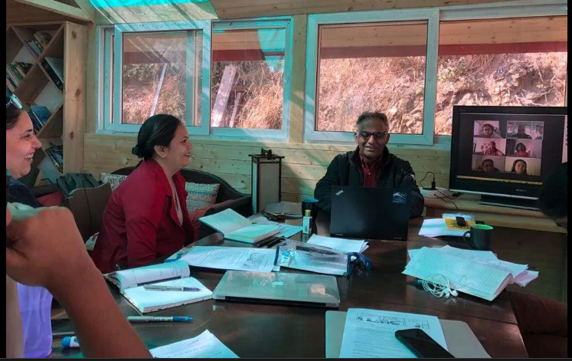

Introduction
Where the object of retreats is to facilitate writing and to encourage positive writing practices, writing groups are designed to facilitate feedback and discussion on writing. Some strategies and considerations for setting up writing groups are discussed in this resource.
Benefits of writing groups
Writing groups can:
- provide a network and sense of collegiality and belonging
- provide support in solving problems arising in the research and writing process
- provide encouragement, and improve confidence and motivation
- reach deep levels of engagement, critique and learning around participant research topics, and reveal any problems early
- give participants multiple sources of input
- improve the quality of drafts
- improve research quality
- provide writing deadlines
- provide feedback and support in preparing for oral presentations, publications, other writing deadlines
- provide editorial assistance
- develop skills in giving and receiving feedback
- develop group facilitation skills
- develop team-building and communication skills
- provide people to celebrate successes with.
Types of writing groups
Writing groups can operate in a variety of ways for a variety of purposes. They can be conducted face-to-face or virtually. Groups can work on short or longer texts, and they can involve group editing or individualised feedback rounds, or some combination of these. Open discussion and social time are often a critical element in the success of writing groups and more or less time can be devoted to this depending on group preferences. Below are some suggestions for working with writing during the structured segments of writing groups.
Working with short texts
Writing groups can involve projecting a draft on a physical or virtual screen and inviting feedback and editing suggestions from the group. This type of feedback activity works best with:
- abstracts
- introductions
- chapter or journal article outlines
- oral presentations
- drafts with specific function of no more than one to three pages.
How the writing group can work:
- The draft is projected on a screen so everyone in the group can see it at once.
- The writer reads the draft. Everyone else listens, reflects and makes a note of any points for discussion.
- The writer or facilitator then invites questions, feedback, and discussion.
- The writer listens and takes notes, answers questions, and asks for specific feedback.
- The writer, facilitator, or other group member (or some combination of these) can edit the text based on the feedback and discussion from the group.
- Track changes can be used to track suggested edits, allowing the writer to accept suggestions at their own discretion later.
- The edited text is forwarded to the writer at the close of the session.
Advantages:
- No pre-reading required.
- Texts can be edited, or notes and suggestions recorded, for all to view, drawing on collective energy and ideas.
- Several participant texts can be covered in a session (10 to 20 minutes each, but can be longer).
- Writers go away with improved drafts.
- Provides practice and discussion around how/whether to revise specific aspects of texts.
- Easy to organise and popular with writers.
Working with longer texts
Working with longer texts (eg research proposals, thesis chapters and journal articles) requires group members to pre-read the text, make written comments, and then come together at a pre-arranged time to discuss the text.
How the writing group can work:
- Drafts are submitted at agreed date before meetings to enable group members to read, reflect and provide written feedback on the draft.
- During the meeting participants take turns to share their feedback.
- Following feedback, open discussion of the draft can proceed.
- At the end of meetings, writer's volunteer to submit text for next meeting.
Considerations for success:
- ongoing, long-term commitment required from group members,
- requires organisation,
- group dynamics and communication skills of group members can impact on the success of the group,
- when members bond, groups can be enduring and provide a deep source of support and learning.

What can go wrong in writing groups, and how to make it go right
What can go wrong:
- poor organisation
- lack of commitment from group members
- lack of preparation
- disruptive behaviour
- incompatibility among group members
- group culture is not 'safe' or conducive to open and deep dialogue.
Most of the things that prevent writing groups from working can be addressed with adequate preparation and good facilitation. Some suggestions and strategies to ensure writing groups function well are explored below.
Operational norms
At the first or second meeting of a new writing group it is useful to decide upon and record how the group intends to operate. Operational norms represent the collective will of the group and ensure that everyone feels they are a part of decision-making about how the group will operate. This ensures both effective operation of the group and the ongoing commitment of members of the group. The ‘norms’ can always be renewed and revised as required.
A list of some common operational norms is provided below to act as a discussion starter for new writing groups, but each group should collectively decide how they would like the group to operate for themselves.
Common operational norms:
• six to eleven members (allowing for different opinions without getting too big to manage),
• fortnightly or monthly meetings,
• members be at a similar level of accomplishment (eg. research degree candidates), from like discipline groups,
• manuscripts circulated before the meeting to allow everyone to provide thoughtful criticism,
• feedback provided in writing on the draft with the reader's name on the top of the page,
• all decisions made collectively,
• designated time before the feedback session to share news and raise any concerns,
• everyone takes a turn to provide and receive feedback,
• participants arrive on time,
• participants let the group know if they will not be able to attend (prevents feeling that the group is flagging),
• drafts submitted within an agreed lead time,
• strict confidentiality (no one outside the group privy to drafts or comments),
• concise feedback, in turn, without interruption,
• avoid asking the writer questions that will elicit long explanations during designated feedback round,
• the writer says nothing, or as little as possible during a feedback round,
• open discussion and responses from the writer following feedback round.
Considerations for doctoral writing groups:
- Consider submitting drafts to the writing group before it goes to supervisor/s so the group can help to improve the draft maximising time with the supervisor.
- Remember it’s not about producing perfect drafts, but work in progress, and you don’t have to produce very long texts that people will find it difficult to find time to read in any case.
- Be brave. Give special congratulations to those who volunteer to go first while you build up group trust.
- In the trust-building phase of the group process, you might focus on hearing from readers what they understood from the words, rather than trying to judge the text and figure out how to make it better.
- You can also allow writers to choose what kind of feedback they want (see ‘fun feedback activities’ in the next resource).
- Try not to get bogged down in resolving different reactions to a text. Disparate reactions are a common occurrence, and it can be helpful for the writer to see how different readers experience their texts.
- If someone hasn’t shown up for a while, get someone in the group to send them an email or give them a ring to check they’re ok.

Role of the facilitator
Writing groups, especially those with more than four members, will usually run better with a facilitator. The facilitator can be the same person every meeting, or group members can take it in turns to facilitate group meetings. The facilitator's role is to foster a sense of community, rather than one of competition, and keep the discussion positive, constructive and task focused.
The role of the facilitator is to:
- raise operational matters (meeting times, food, submission turns and dates, minutes);
- ensure writer's get equal time, or that time is negotiated within the group;
- ensure everyone gets a turn to talk (by calling upon members one at a time, or calling upon quieter members directly);
- use humour and positivity manage digressions, arguments, rehashing, dominating, side conversations and put downs and keep the discussion on track;
- reiterate key points before the group moves on to a new tack;
- stimulate discussion if the group flags (ask open ended questions 'Tell me more about ...');
- remain impartial (no favourites, encourage members to work out any issues with one another directly).

The 'world's worst' workshop participants
Sometimes in order to make something work well, it’s helpful to consider what doesn’t work. When it comes to writing groups, the key to success is in the set-up of the group. When setting group norms, you might consider how not to be the ‘world’s worst’ workshop participant. Joni Cole (2006:134-137) provides a humorous characterisation of the 'world's worst' workshop participants, summarised below.
The shadow—shows up to meetings, but rarely shares or takes a turn.
The dominator—doesn't draw breath, likes to talk about self and pads comments with irrelevant detail.
The star—assumes their work is the best, brags about their achievements, doesn't read other people's work.
The grammarian—obsesses with minor errors, avoids being involved in discussion about substantive themes.
The devil's advocate—contradicts for the sake of contradiction, enjoys stirring up trouble.
The interrupter—impulsive, impatient, cuts people off, runs away with others' ideas.
The outpatient—wants to work out issues and connect with others, not work on writing.
The gossip—talks about other members behind their back, poisons group members against one another.

Constructive group behaviours
- Take your turn.
- Enjoy equal time on the floor.
- Encourage and support others.
- Read and comment on the substance of submitted work.
- Offer alternatives and solutions.
- Build on the comments of others.
- Stay task focused.
- Raise issues about the group dynamic within the group.
One of the most important considerations for an effective writing group is the quality of feedback writers are offered, as well as the ability of writers to receive and utilise the feedback offered. See the next resource for more information about feedback strategies to support your writing group.

References
Cole, Joni B 2006, Toxic feedback, University Press of New England, Hanover.
Le Guin, Ursula 1998, Steering the craft: Exercises and discussions on story writing for the lone navigator or the mutinous crew, The Eighth Mountain Press, Portland Oregon.

