Communication purpose
Teaching Clinical Communication Skills (health professional-patient/client):
Clinical setting
Teacher resources: development plan (recommended to commence prior to first clinical placement)

Lesson plan  Foundation Lesson  Rubric (breaks down communication elements for lesson guidance, formative or summative assessment) | Lesson plan  Quiz  Video scenario (versions A&B)  Rubric (breaks down communication elements for lesson guidance, formative or assessment) | Lesson plan  Rubric (breaks down communication elements for lesson guidance, formative or summative assessment) | Lesson plan  Rubric (breaks down communication elements for lesson guidance, assessment)  Reflection rubric (teacher can set which level of reflection is appropriate for level of student)
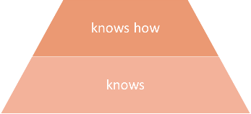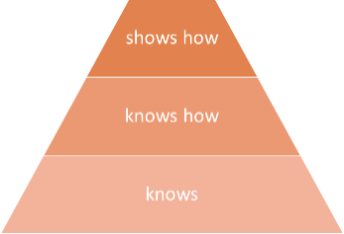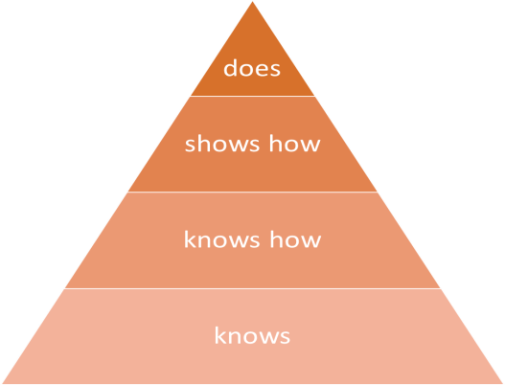
Student resources
Foundation Lesson  Student activity plan (includes rubric used as a checklist for skills development or self assessment) | Student activity plan (includes rubric used as a checklist for skills development or self assessment)  Quiz  Video scenario (versions A&B) | Student activity plan (includes rubric used as a checklist for skills development or self assessment) | Student activity plan (includes rubric used as a checklist for skills development or self assessment)  Reflection rubric (helps students reflect on clinical placement and plan future goals)

Notes for Teacher
- May address one or all communication skills
- Can choose video scenario that
- May use different levels of development plan depending on levels of students
- Many activities can be adapted to online
What this might look on the website:
Put this up as the overview. Then have ‘packages ‘ for each stage of millers pyramid, which includes teacher and student resources, outlined below. Wondering if we shouldn’t break up the rubrics, so that only the relevant levels are shown in each package. Ie for Knows the rubirc would look like below:
Stage of development on Millers Pyramid | Knows
Behaviour demonstrated | Student demonstrates awareness of each aspect of communication that underpins the skill
Attends to patient’s verbal and non-verbal communication to assess understanding
Chooses words and phrases to explain and instruct, adapting them as appropriate for the patient
Uses reflective listening to check patient understanding
Uses proxemics to foster open dialogue
Uses body language to encourage engagement
Employs facets of the voice to support an attentive, empathetic interaction
Uses support materials as appropriate (ie. written texts) to enhance verbal interactions

Student version
Stages of development on Millers Pyramid | Knows
Behaviour demonstrated | Able to demonstrate awareness of each aspect of communication that underpins the skill
Attended to patient’s verbal and non-verbal communication to assess understanding
Chose words and phrases to explain and instruct, adapting them as appropriate for the patient
Used reflective listening to check patient understanding
Used proxemics to foster open dialogue
Used body language to encourage engagement
Employed facets of the voice to support an attentive, empathetic interaction
Used support materials as appropriate (ie. written texts) to enhance verbal interactions
Educator version

Skill A2: builds and maintains rapport and an empathetic relationship and ensures that the patient feels attended and listened to
Stages of development on Millers Pyramid | Knows
Behaviour demonstrated | Student demonstrates awareness of each aspect of communication that underpins the skill
Attends to patient’s verbal and non-verbal communication to assess the development of the relationship
Chooses words and phrases that support the development of rapport and empathy
Uses active listening to develop attentiveness and responsiveness
Uses proxemics to support the establishment and maintenance of relationship
Uses body language to convey attention and empathy
Employs facets of the voice to demonstrate attention and empathy
Uses support materials as appropriate (ie. written texts) to build and maintain relationship

Student version
Stages of development on Millers Pyramid | Knows
Behaviour demonstrated | demonstrated awareness of each aspect of communication that underpins the skill
Attended to patient’s verbal and non-verbal communication to assess the development of the relationship
Chose words and phrases that support the development of rapport and empathy
Used active listening to develop attentiveness and responsiveness
Used proxemics to support the establishment and maintenance of relationship
Used body language to convey attention and empathy
Employed facets of the voice to demonstrate attention and empathy
Used support materials as appropriate (ie. written texts) to build and maintain relationship

Educator version

Skill A3: relates to the patient respectfully including ensuring confidentiality, privacy and autonomy and recognizing the patient as a partner in shaping a relationship
Stages of development on Millers Pyramid | Knows
Behaviour demonstrated | Student demonstrates awareness of each aspect of communication that underpins the skill
Attends to patient’s verbal and non-verbal communication to assess the ongoing success of the interaction
Confidentiality and privacy
Uses equipment (ie. curtains, sheets) as appropriate to maintain confidentiality and privacy
Chooses words and phrases that maintain confidentiality and privacy
Uses proxemics to maintain confidentiality and privacy
Employs facets of the voice (e.g. volume) to maintain confidentiality and privacy
Uses artefacts (e.g. case notes) in ways that maintain confidentiality and privacy
 | Knows
 | Student demonstrates awareness of each aspect of communication that underpins the skill
Autonomy and patient as partner
Chooses words and phrases that assure consent, and allow autonomy and patient involvement
Uses active and reflective listening to respect the patient’s role as partner
Uses proxemics to build and maintain the patient’s role as partner
Uses body language to build and maintain the patient’s role as partner
Employs facets of the voice to demonstrate respect and partnership
Uses support materials as appropriate (ie. written texts) to support the patient’s role as partner

Student version
Stage of development on Millers Pyramid | Knows
Behaviour demonstrated | demonstrated awareness of each aspect of communication that underpins the skill
Attended to patient’s verbal and non-verbal communication to assess the ongoing success of the interaction
Confidentiality and privacy
Used equipment (ie. curtains, sheets) as appropriate to maintain confidentiality and privacy
Chose words and phrases that maintain confidentiality and privacy
Used proxemics to maintain confidentiality and privacy
Employed facets of the voice (e.g. volume) to maintain confidentiality and privacy
Used artefacts (e.g. case notes) in ways that maintain confidentiality and privacy

