How to: Video conference using Zoom
Contents
Register with Zoom 3
Check bandwidth 6
Schedule a Zoom Meeting 9
Connect to a Zoom meeting 13
Test Microphone & Speakers and other settings 15
Adjust Your Microphone & Speaker volume 20
Rename Participants 23
Gallery View and Active Speaker View 24
Mute / Unmute participants 26
Drop Your video, Use Audio only 27
Drop Particpant’s video, Use Audio only 28
Use Chat 29
Drop a participant, go to a phone call 31
Waiting Room 32
Set up Waiting Room 32
Using Waiting Room 32
Enabling or Disabling Waiting Room During a Meeting 32
Admitting Participants During a Meeting 33
Admit All Participants from the Waiting Room 33
Sending Participants to the Waiting Room During a Meeting 33
Troubleshooting: Audio Echo In A Meeting 34
End a Zoom meeting 35
Get the Zoom plugin for Outlook 36
Get the Zoom client for meetings 37
Other ways to Access Zoom 39

Note: This user guide aims to provide an overview of the features and tools available in zoom and is not a step by step business process for the oral defence video conference as each session will be different and not all parts will be required for all sessions.
Screenshots will vary depending on the browser/platform/device you are using and may be superseded by updates from Zoom. Being a web based system, updates are outside of the UniSA’s control and things may therefore change without notice. For example, a button may be labelled ‘Meetings’ in one version and ‘My Meetings’ in another. The system is relatively easy to navigate and intuitively designed and changes/differences are likely to be minor.

Register with Zoom
Go to www.zoom.us
Click on sign up for free
Sign up using your unisa.edu.au email address 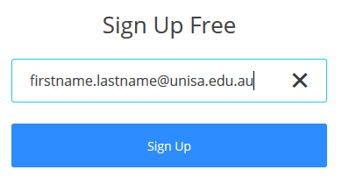

Confirm email by selecting sign up again
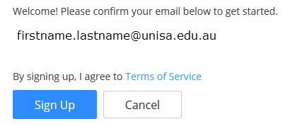
Go to your email, find the email from Zoom (check spam/junk email folders if you don’t have an email from Zoom. If not received within a couple of hours call the IT helpdesk x25000 to see if they can check if it was blocked)
Select Activate Account
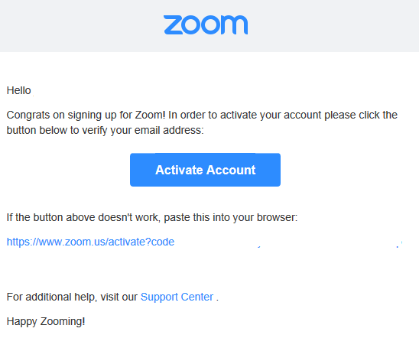

Activation of your account will return you to the Zoom.us home page, where you can set your name and create a password.
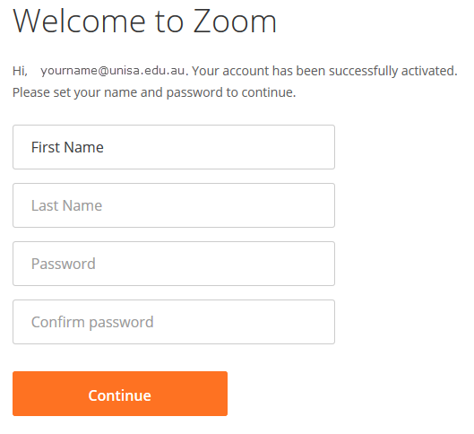

Check bandwidth
We strongly recommend that all parties check their internet speed in advance of video conference participation using the bandwidth analyser at Http://speedtest.net/ to see if the internet connection is sufficient for video conferencing. Just before the video conference session, you may wish to test again to see if there are factors impacting on your bandwidth at that particular time. If speeds are slow you may be able to take steps to improve it or you may prefer to participate via zoom audio only or by phone.
Select the link above. Then select Begin Test.
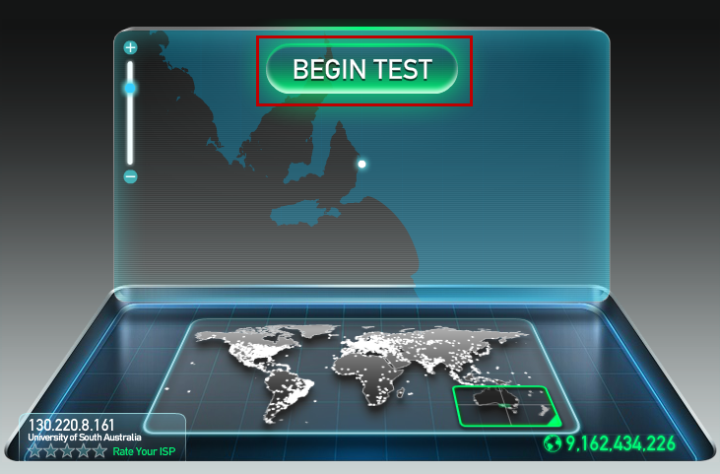
The test will automatically run through the required tests and results will be displayed when completed, they will show something similar to the results below:
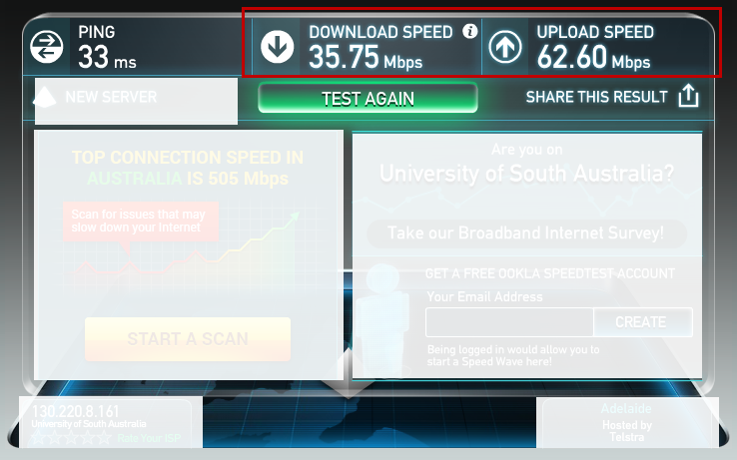
The test above shows that the download speed is 35.75 Megabits per second (Mb/s) and the upload speed is 62.60 Mbps.
The recommended download and upload speeds for a Zoom multiparty video conference are:
Function | Download Mb/s | Upload Mb/s
Zoom multi-party video conference | 1.2-1.5 | 0.6-1.5
Zoom Audio only | - | 0.06 (60 kb/s)
Passable speeds (lesser quality) from past experience | 0.311 (311 kb/s) | 0.219 (219 kb/s)

The bandwidth used by Zoom will be optimized for the best experience based on the participants’ network. It will automatically adjust for 3G, Wi-Fi or Wired environments.
The test results (35.75/62.60 Mb/s) above show that the connection is easily fast enough for video conferencing, given the above recommendations. Home networks are generally much slower and University Hosts may need to provide guidance to participants on how to identify and maximise their bandwidth.
To improve your bandwidth capability try/suggest the following:
- If at your University workplace: contact your IT support to see if there is a problem with your local network (UniSA IT Support x 25000, if participants are not at a UniSA location they should contact their own local IT support).
- For participants at home or locations other than a University: identify if internet use by others could be impacting the bandwidth available. This may be due to services such as Netflix or other streaming services, large email/file downloads, online gaming or general internet usage particularly video download such as YouTube. Shared public networks such as hotels and free Wi-Fi may be significantly limited.

Schedule a Zoom Meeting
You can schedule a meeting several ways, through the outlook plugin or via the desktop client. For this zoom meeting this document will show you how to schedule a meeting from the zoom website. See instructions below on how to access Zoom via the client or Outlook Plugin.
Go to www.zoom.us and sign in with your UniSA email address and password previously set up.
Select Schedule a Meeting either from the landing page or from My Meetings on the left hand menu (depending on browser)
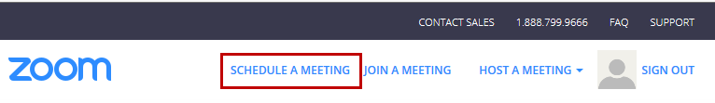
Oral Defence Note: If you are setting up an Oral Defence meeting and you see the following message in the Schedule a meeting page, you will need to have a corporate licence assigned to you, contact the Research Examinations Team (research.examinations@unisa.edu.au) for assistance.
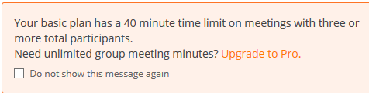
Set the schedule details as appropriate (suggested settings used in the example). Please be aware that the date is in US format (i.e. MM/DD/YYY)
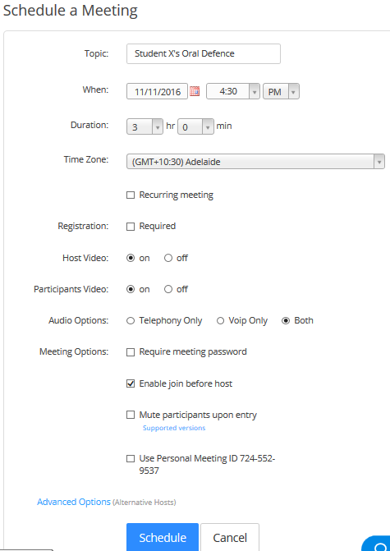
Once you have finished selecting settings, select the Schedule button.
The next screen will allow you to manage the meeting details, including sending the meeting to your calendar. Select the calendar button that suits your calendar type (for the example we will select Outlook)
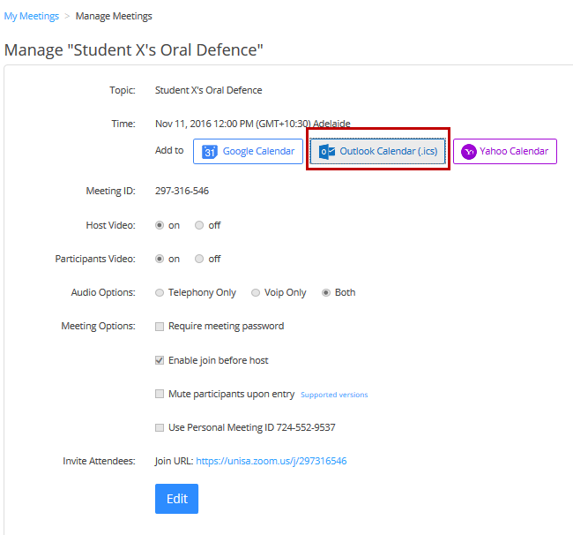
You may see a security op-up window asking if you want to open, save or cancel the meeting action. Select Open.
This opens a regular calendar appointment. Select Invite attendees and invite the other participants and send as you would a regular calendar meeting request. Personalise the calendar appointment as necessary.
Oral Defence Note: To protect the anonymity of examiners early on in the examination process you may need to invite examiners individually. You can return to the above screen multiple times. Prior to emailing the calendar appointment, personalise and add details of the oral defence as appropriate.
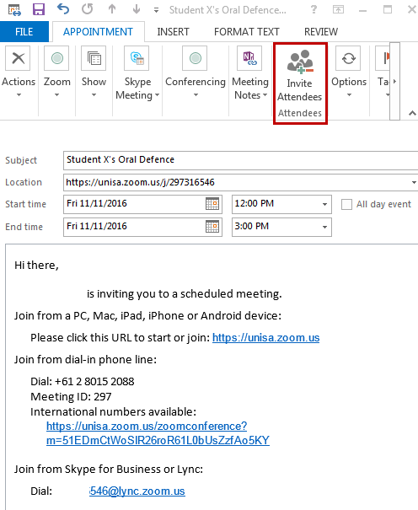

Connect to a Zoom meeting
At the scheduled time you can connect to the meeting via the link in your calendar appointment.
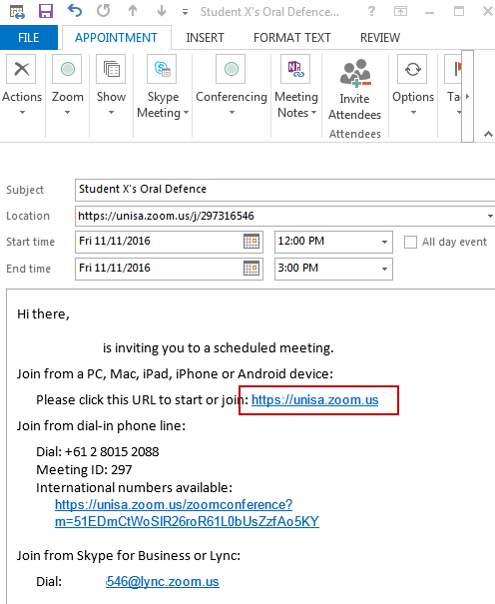
Or you can log in to www.zoom.us if you cannot access your calendar.
Go to Meetings on the Left hand menu and on the first tab: Upcoming meetings, select the meeting name to view details or the start button to start the meeting. Note that if someone has already joined the meeting before you, the start/delete buttons will be replaced with a Join/end buttons. You will, as the host, also receive an email alert to let you know someone has already joined the session.
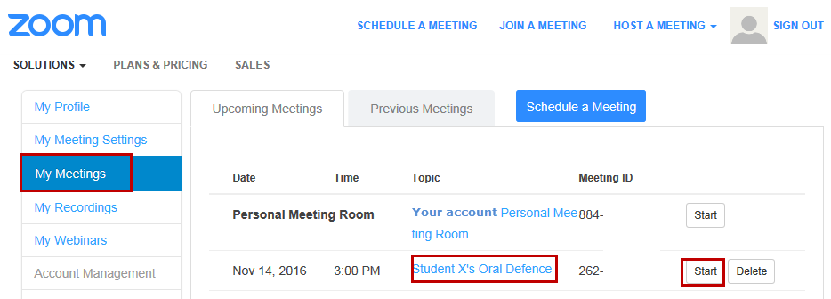
You will then be asked if you want to join or test. Select Join Audio Conference by Computer (we’ll go through how to test later)
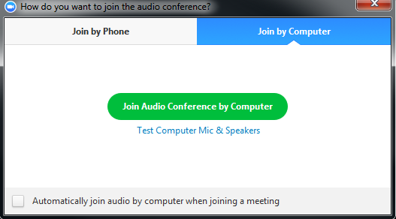
When you move the mouse across the screen you will activate the Zoom toolbar.
You can see the number of participants that are in the meeting so far, mute your microphone, stop your video and open the chat window, see below for more information on these actions.

Test Microphone & Speakers and other settings
If you want to test your Computer mic and speakers before starting the meeting, select the link
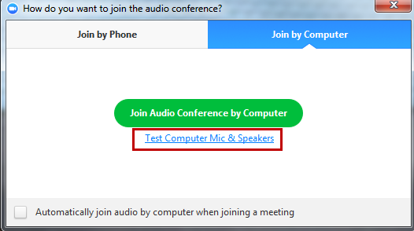
Select Test Speaker first
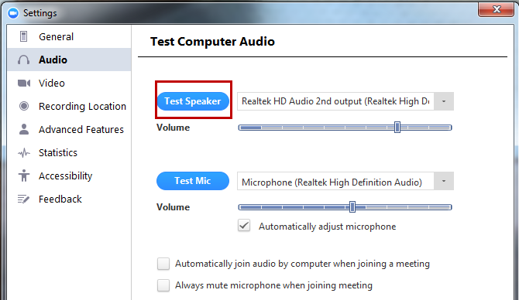
You will hear music playing, if not select another speaker source from the drop down menu
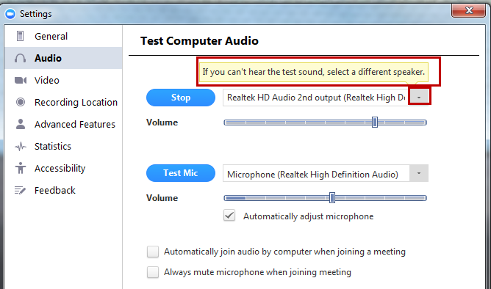
Select Test Mic next
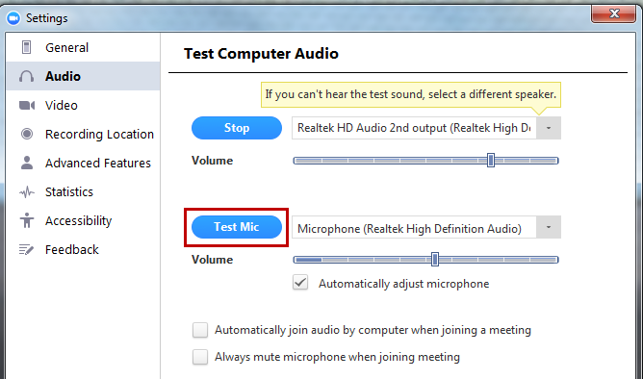
You should see the microphone indicator move when you speak or make a noise
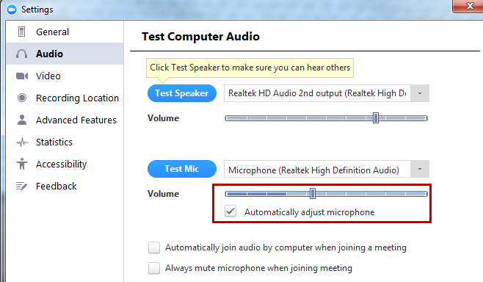
To test your video select Video from the left hand menu
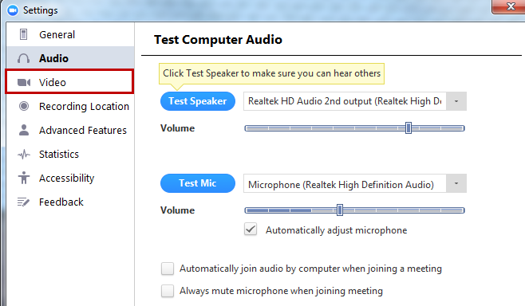
If you don’t see any video you may need to enable a different camera, select another camera from the drop down list.
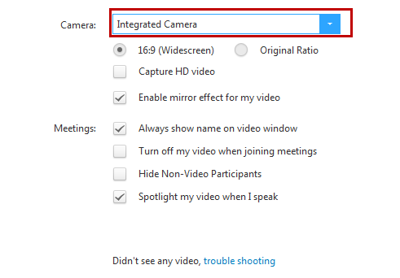
The option to turn of non-video participants may be useful if you need to drop the video for only one participant.

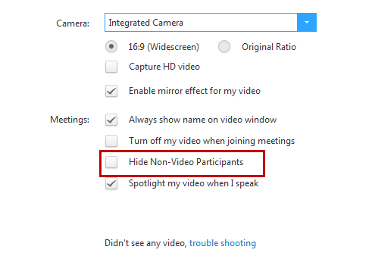
You can view/change other settings by navigating the left hand menu of the Settings screen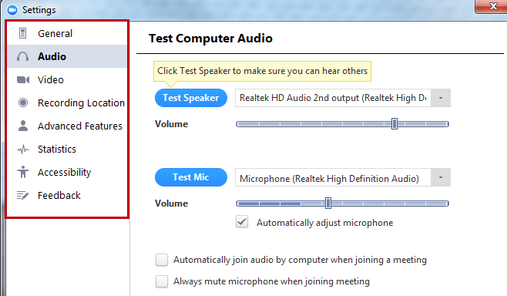

Adjust Your Microphone & Speaker volume
Activate the toolbar by hovering the mouse over the screen and select the up arrow next to the microphone icon
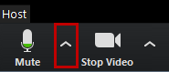
Select Audio options
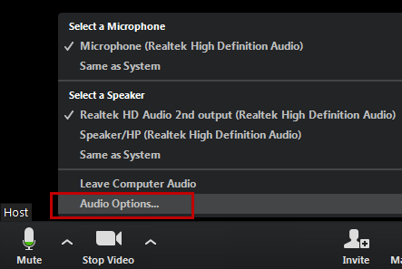
Select Test Computer Mic & Speakers
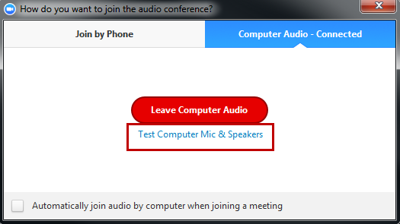
To adjust speakers and microphone, select Audio in the left hand menu. Then to adjust speaker volume, move the slider left or right, this will likely also display your speakers icon (at the bottom, showing volume of 38). The microphone will adjust itself but to adjust the microphone volume manually uncheck the Automatically Adjust Microphone box and move the slider left or right.
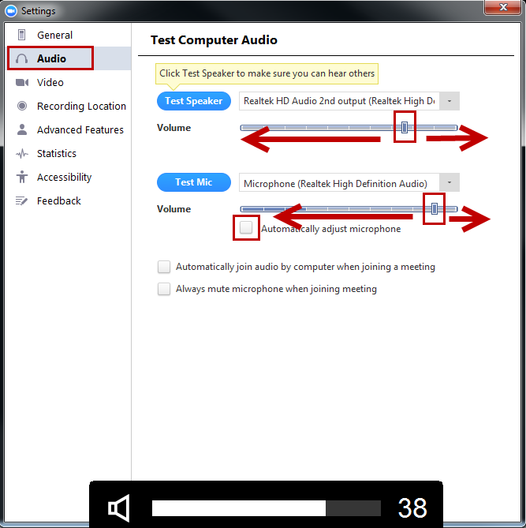
To mute your microphone Click the Mute microphone icon and a red line will cross the icon indicating you are on mute.
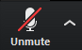
To unmute, simply click on the icon and the red line will disappear, indicating you are transmitting audio again.

Rename Participants
When participants join a video conference, Zoom displays their user name which may not be useful when you need to address participants that you may not have met in person. You can easily rename a participant for the purpose of the session underway. Go to Manage Participants and then select the participant that you want to rename. A rename button will appear, or right click on more to select rename from the menu
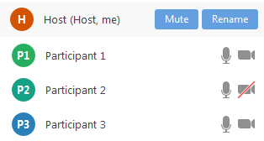
A rename box will appear:
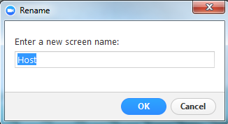
Type a new name, suggest using the name that you will address the participant by.
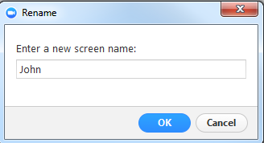
Select OK.

Gallery View and Active Speaker View
When there are multiple participants you can switch between Gallery view and Speaker view.
Gallery view shows all participants with the same sized screen. A green outline will show the active speaker (in the example below it is the Host and the view is Gallery)
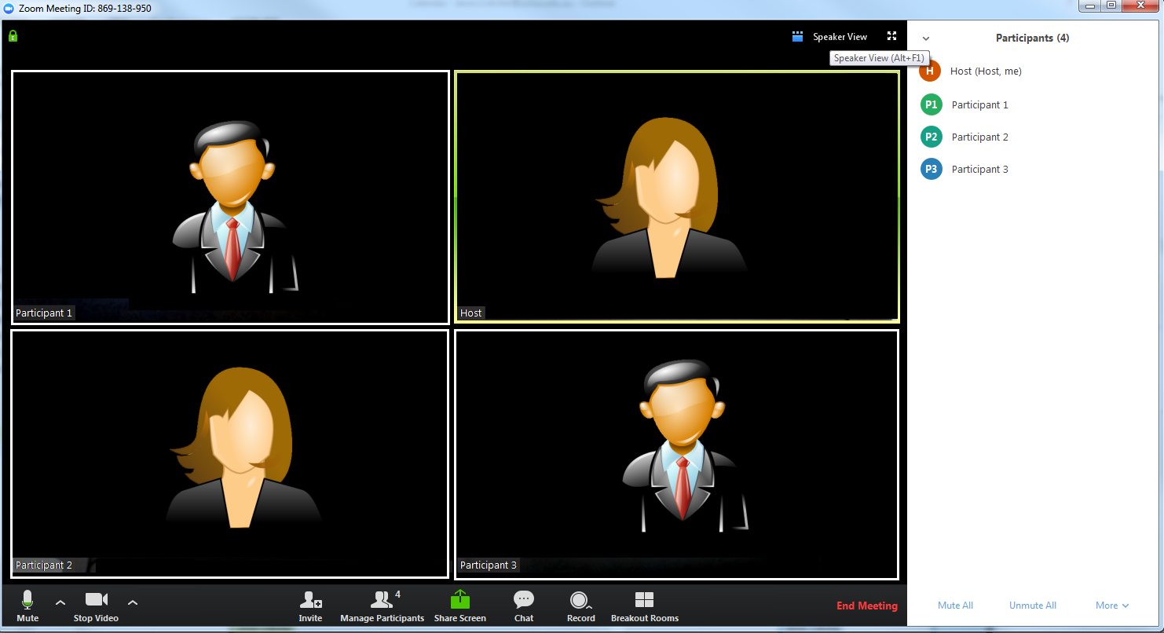
To switch to Speaker view, Select the Speaker View link
The view will now switch to one large screen and several smaller screens, with the Active speaker switching to the large screen, depending on who is talking.
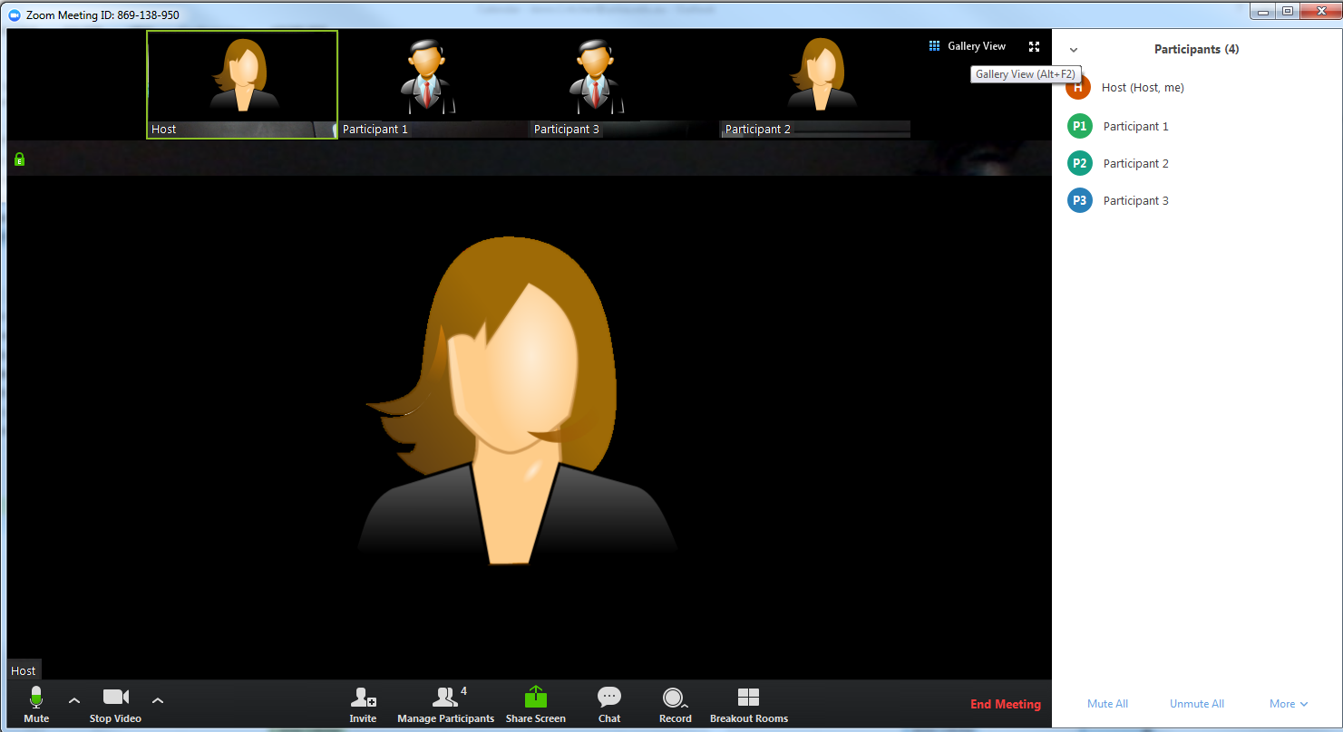
To switch back to Gallery View select the Gallery View link.

Mute / Unmute participants
In the bottom centre of the screen select Manage Participants
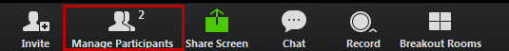
In the manage participants screen, select Mute All
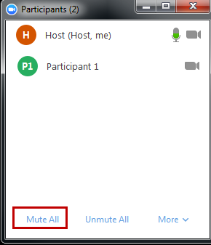
Select Unmute All to return audio to all participants
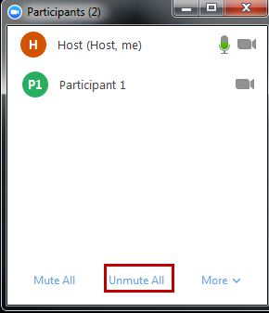

Drop Your video, Use Audio only
In the bottom of the screen Select Stop Video
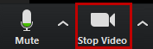
The icon for video will now will cross the icon indicating you are not uploading video
To commence video again, simply click on the icon and the red line will disappear, indicating you are transmitting video again.

Drop Particpant’s video, Use Audio only
In the bottom centre of the screen select Manage Participants
For the participant that you want to stop video, select the participant then the More button next to their name, finally select Stop Video.
This should now switch the participant to audio only you will see that Video is disabled by the line through the icon.
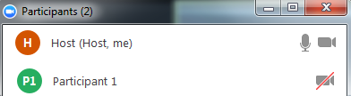

Use Chat
In the bottom centre of the screen select Chat
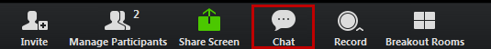
In the window select if you will chat with all, or one of the participants and type in the space provided.
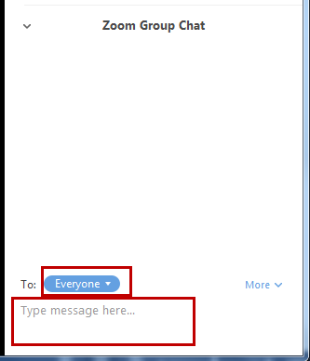

Press enter to send the message
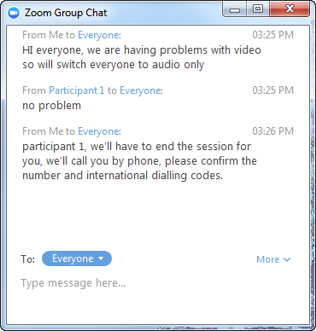

Drop a participant, go to a phone call
In the bottom centre of the screen select Manage Participants
For the participant that you want to drop, select more and then remove.
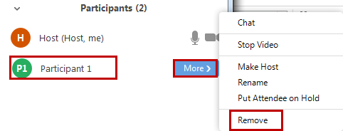
You will be asked to confirm, select yes to remove the participant from the meeting.
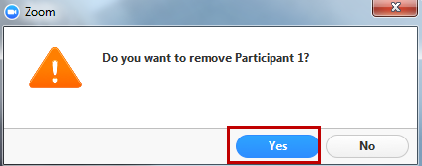
Oral Defence note: if you are dropping a participant prior to the end of the meeting, use chat to ensure you have the participant’s current location phone number to connect via phone.

Waiting Room
The Waiting Room feature allows the host to control when a participant joins the meeting. As the meeting host, you can admit attendees one by one or hold all attendees in the waiting room and admit them all at once.
This feature needs to be used when either the candidate or members of the supervisory panel are attending the meeting via Zoom as there will be portions of the meeting that they are not able to participate in. At those times they will need to be put in the Waiting Room and brought back to the meeting at the appropriate time.

Set up Waiting Room
To enable the Waiting Room feature for a meeting:
- Sign into Zoom (www.zoom.us) using your credentials
- Click on Meetings
- Click on the Topic hyperlink for the relevant meeting
- Click on Edit this Meeting at the bottom of the page
- Click on Enable waiting room in the Meeting Options section and click on Save (this will override the option for participants to join before the host)

Using Waiting Room
When participants join the meeting they will see a notification advising that the meeting host will let them in soon. As a meeting host you can enable or disable the Waiting Room during a meeting, admit participants during a meeting and send participants to the Waiting Room during the meeting.

Enabling or Disabling Waiting Room During a Meeting
- As the meeting host, click Manage Participants.
- Click More at the bottom of the participants' window and choose Put Attendee in Waiting Room on Entry to enable or disable the feature.
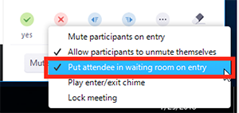

Admitting Participants During a Meeting
- As the meeting host, click Manage Participants.
- Click Admit to have the participant join the meeting.
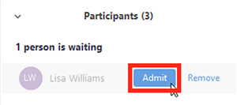

Admit All Participants from the Waiting Room
- As the meeting host, click Manage Participants.
- Click Admit All
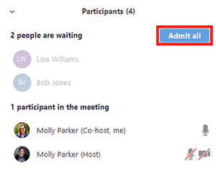

Sending Participants to the Waiting Room During a Meeting
- As the meeting host, click Manage Participants.
- Click More next to the participants name and choose Put in Waiting Room
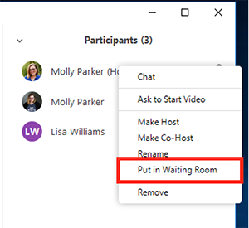

Troubleshooting: Audio Echo In A Meeting
If you hear audio echo or audio feedback during your meeting, there are several possible causes:
- Laptop speakers and microphone are conflicting (the microphone is picking up the sound from the speakers)
- A participant has both the computer and telephone audio active
- Participants with computer or telephones speakers that are too close to each other
- Multiple computers with active audio in the same conference room
Generally, if you are hearing echo, it means that there is a device out there that is channelling your audio back.
To try and resolve the problem:
- suggest participants use headphones to stop the feedback loop
- Suggest participants turn one audio source off, if using multiple
To isolate the attendee:
- Host can mute the attendee one at a time
- Host can mute all, and unmute one at a time
- Attendee can mute him/herself
The source of echo can also be from:
- Speakers (such as TV or soundbar) that are too loud
- Echo cancellation has failed (device or performance issue)
- A bad microphone

End a Zoom meeting
In the bottom right hand side of the Zoom screen, select End Meeting
Confirm that you will End Meeting for All.
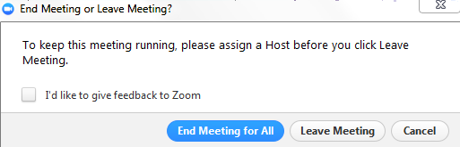

Get the Zoom plugin for Outlook
If you make Zoom meetings regularly, you may want to add the Zoom plugin for Outlook. The plugin allows you to go straight to scheduling a meeting from Outlook.
Go to: https://www.zoom.us/download#outlook_plugin
Select Download and follow Select run to install (you may need admin rights on the computer you are using, if you have problems, contact your IT support)
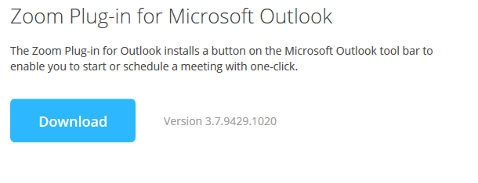

Open Outlook, on the Home tab, you will see the plugin options to schedule or start a meeting
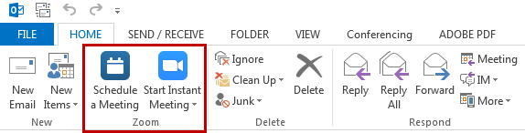

Get the Zoom client for meetings
If you schedule Zoom meetings regularly, you may want to add the Zoom client to your PC. The client allows you to go straight to scheduling a meeting from your desktop.
Go to: https://www.zoom.us/download#client_4meeting
Select Download and follow any additional prompts
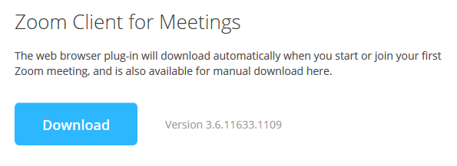

You will now be able to access the Zoom client from PC’s Program list (Start Menu > All programs > Zoom > Start Zoom), once signed in you can start a meeting and then invite others or schedule a meeting for later.
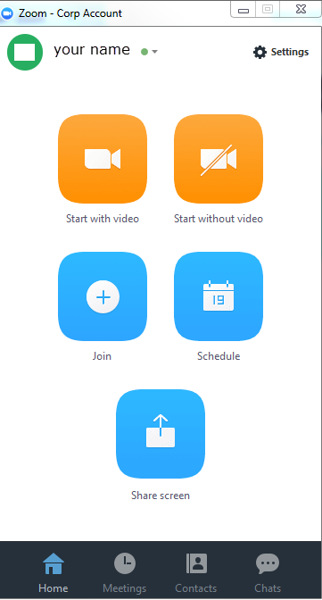

Other ways to Access Zoom
As well as through the Zoom website, Outlook Plugin and Desktop client, Zoom have Android and Apple apps for mobile devices, Extensions for browsers (Chrome and Firefox), Microsoft Lync plugins and more. Go to Zoom’s download centre for more information: https://www.zoom.us/download

