Purpose of assessment
1. Assessment for Learning (Formative)
The purpose of Formative Assessment is to provide students with feedback on how they are going.
The aim is to help students improve their performance and make their next piece of assessed work better. It is developmental or formative in nature.
The feedback students receive is the key component of formative assessment. Feedback is intended to help them identify weaknesses and build on strengths to improve the quality of their next piece of assessment.
The focus is on comments for improvement, not marks, and the awarding of marks in formative assessment can actually be counterproductive.

2. Assessment of Learning (Summative)
The purpose of Summative Assessment is to gather evidence to make a judgment about a student's level of performance; against the specified learning objectives.
Students are usually assessed at the end of an element of learning, such as the end of a module, mid semester or end of semester.
They are awarded results typically as marks or grades to represent a particular level of achievement (high, medium, low).
This judgmental "summative" process formally provides the evidence, to verify or "certify" which students may progress to the next level of their studies.

3. Assessment as Learning (Metacognitive)
The purpose of Assessment for Learning is for students to learn about themselves as learners – to become aware of how they learn – to become metacognitive (to have knowledge of their own thought processes).
Students reflect on their work regularly through self or peer assessment and decide what their next learning will be.
Assessment as learning helps students to take more responsibility for their own learning and monitoring future directions.

Principles for Good Assessment
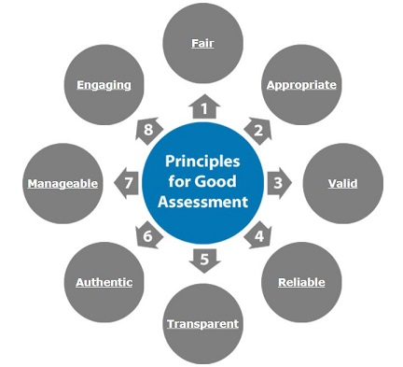
- Fair
Fair assessment provides equal opportunity for all students to demonstrate the extent of their learning.
2. Appropriate
Appropriate assessment is suitable for the type (fit-for-purpose) and the level of learning being assessed.
- Valid
Valid assessment will be a measure of student learning (not something else); and the extent of that learning.
4. Reliable
Reliable assessment will yield consistent results regardless of whom it is marked by or when it is marked.
5. Transparent
Transparent assessment clearly sets out expectations for students with clear task descriptions, criteria and standards and the use of model exemplars.
6. Authentic
Authentic assessments are relevant and reflect what the student will do in the 'real world'.
7. Manageable
Manageable assessment balances the anticipated time an assessment task will take to complete with the time students have available; and considers other concurrent assessments due.
8. Engaging
Engaging assessments emotionally and/or cognitively engage students; encouraging them to spend time on the assessment task

