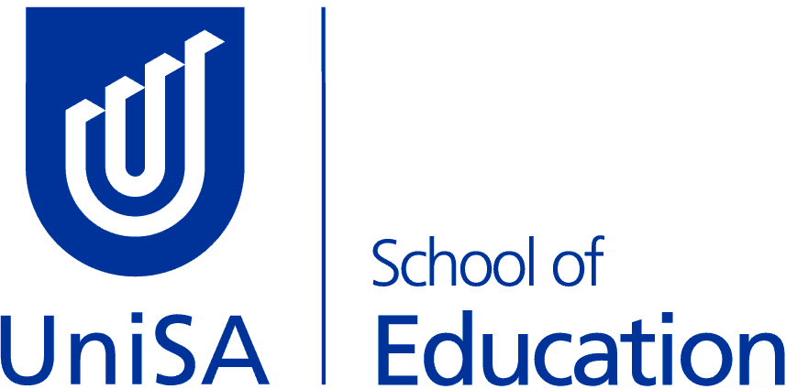 | MBET - Bachelor of Education (Primary & Middle)  Minor Course Options
ENGLISH & CREATIVE WRITING

Students must undertake 4 of the following courses:

English & Creative Writing | Level | Study Period
COMM 1061 – Creative Writing & Literature: An Introduction | Introductory | SP2  (Internal or Online)
COMM 1045 – Creative Writing Workshop | Introductory | SP5  (Internal or Online)
LANG 2042 – Reworking the Canon | Intermediate | SP5  (Internal or Online)
LANG 2005 – The Power of Story | Intermediate | SP5  (Internal or Online)
COMM 2058 – Writing & Reading Fiction & Poetry | Intermediate | SP2  (Internal or Online)
LANG 2015 – Children’s Literature: Picture Books | Intermediate | SP1  (Internal or Online)
LANG 3030 - World Literatures & English | Advanced | SP2  (Internal)
LANG 3042 - The Writer’s World | Advanced | SP2  (Internal)

Enrolment advice / Study Plan Email: EDC-TeachingLearning@unisa.edu.au

