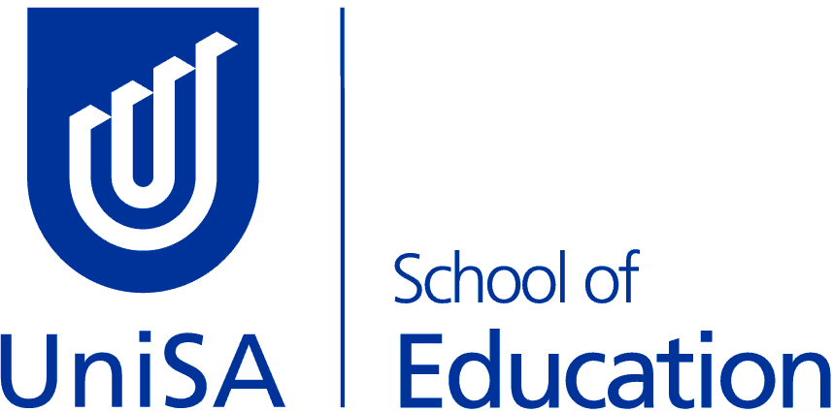 | MBET - Bachelor of Education (Primary & Middle)  Minor Course Options

LOTE (Languages other than English)

UniSA offers courses in:
French
Italian
Japanese

OR

Cross institutional study – Indonesian, Mandarin, Spanish, Modern Greek or Chinese

Note for the Languages Minor the below courses could also be useful:

Course | Study Period
EDUC 2057 – Learning Languages & Cultures | SP5
EDUC 4205 – Developing Languages Programs | SP2  (Online)
LANG 3037 – Language Learning and Assessment | SP5  (Internal & Online)

Enrolment advice / Study Plan Email: EDC-TeachingLearning@unisa.edu.au

