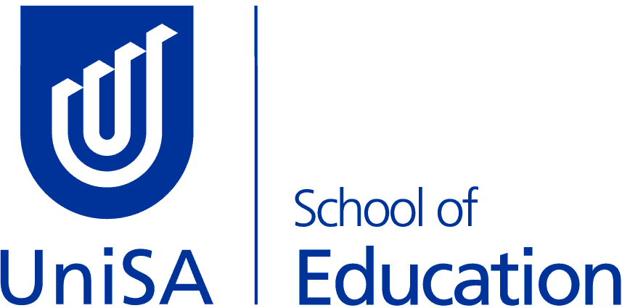 | MBET - Bachelor of Education (Primary & Middle)  Minor Course Options

SCIENCE & SUSTAINABILITY

Prior to 2021 the following courses were part of the Science & Sustainability learning area – if you have completed any of these courses they will still count towards the overall learning area

EDUC 2066 Science & Sustainability 3: Astronomy & the Universe
EDUC 1027 Science & Sustainability 1A: Humans & Environments

 |  | Study Period/s
EDUC 2065 | Science & Sustainability 1B: Atmosphere & Climate | SP5
EART 1010 | Earth Systems | SP2
ENVT 1017 | Caring for Country | SP2
BIOL 1047 | Human Body 1 | SP2
BIOL 1048 | Human Body 2 | SP5
PHYS 1015 | Earth & Space | SP5
BIOL 1014 | Biodiversity for the Environment | SP2
BIOL 1015 | Sustainable Ecosystems (pre-requisite) | SP5
ENVT 1013 | Environment: A Human Perspective | SP2
CHEM 1006 | Chemistry 100 (only if you have done SACE 2 Chemistry or equivalent) | SP2
BIOL 4001 | Coastal Environments | SP1
BIOL 1007 | Biology A | SP2
CHEM 1007 | Chemistry 101 (only if you have done SACE 2 Chemistry or equivalent) | SP5

Students should be aware that some courses have pre-requisites. You should check that you meet pre-requisites prior to enrolling in any course.

Enrolment advice / Study Plan Email: EDC-TeachingLearning@unisa.edu.au

