Grabe and Kaplan (1996) offer a number of dominant traits of a process-oriented approach to writing.
These include:
- Being concerned with the “hows” of writing
- Teaching students the strategies of invention and discovery
- Teaching students how to connect ideas
- Acknowledging the individuality of students in terms of their needs, abilities, cognitive styles, rates of learning and learning styles
- Recognizing the recursiveness of the writing process, and that writing processes overlap and do not occur in an orderly fashion
- Viewing errors as useful indicators of process
- Being student-centred
- Being communicative in nature
- Emphasizing writing for different audiences
- Emphasizing the discovery of meaning while writing
- Viewing writing as a cognitive and intellectual process and one of the most complex human activities
- Contextualizing writing and viewing it as a goal-directed activity
- Linking writing activities to the generation of new ideas
- Acknowledging that skilled writers’ processes are different from the processes of unskilled writers.
(Al-Mahrooqi & Denman, 2015, pp. 79-80)

Process
- Planning and writing the first draft (Draft 1) based on one of three topics provided by the instructor (at this stage, the instructor checks if the students are on topic and also identifies any plagiarism issues in the essays using the Turn-it-in software embedded in the course management system).
- Providing and receiving peer feedback on Draft 1 using a peer-review checklist (See Appendix A) in class.
- Revising Draft 1 within a week based on the peer feedback and/or through self-review and writing Draft 2.
- Receiving feedback on Draft 2 from SEU (YourTutor, Learning Adviser, etc.)
- Revising Draft 2 within a week based on feedback and writing Draft 3 (final draft).
- Submitting the writing assignment in an online folder (student submits all three drafts along with two peer review and tutor verification forms to the instructor).
- Receiving instructor feedback and grade (the instructor grades the essay package using a rubric (see Appendix C) and provides written feedback using EAP Editing Symbols (see Appendix D) as well as oral feedback⁴).
- Optional revision (student is provided with an optional revision opportunity. If the student chooses to revise and resubmit, the original essay score and the score on the revised draft (Draft 4) are averaged. Students are also given opportunities to discuss their final draft with the instructor outside the class).
(Dikli, Jernigan, Bleyle, 2015, p. 57)

APPENDIX A: EAP Essay Peer-Review Checklist
Your Name (Essay Reviewer)_____________________
Partner’s Name (Essay Author)____________________
Directions: Read your partner’s essay and answer the following questions:

Introduction
1. Does the essay have a hook? Is it effective?
2. Is there background information that leads from the hook to the thesis? Is it clear and logical?
3. What is the writer’s thesis? What is the controlling idea of the thesis statement? Are they effective?
4. Do you have any suggestions for improving the introduction?

Body
5. How many body paragraphs are there? Are they logically ordered?
6. Does each body paragraph have a clear topic sentence? Is there unity in the essay (i.e. do all topic sentences support the thesis)?
7. Does each paragraph develop the point presented in the topic sentence with strong support? Is the support convincing and substantial?
8. Do the points overlap in any of the paragraphs? If so, where?
9. Is there coherence in each paragraph (i.e. do all of the ideas fit together in a logical flow)?
10. Do you have any other suggestions for improving the body paragraphs?

Conclusion
11. Is the conclusion complete? Does it reaffirm/restate the thesis and controlling ideas?
12. Does it add a concluding idea (advice, warning, prediction, question, or a new insight)?
13. Do you have any other suggestions for improving the conclusion?

Overall
14. Is the essay on-topic?
15. What does the writer do especially well?
16. Make three suggestions to the writer on how to improve the essay.
(Adapted from Leonhard, B. H. (2002). Discoveries in academic writing. Boston, MA. Heinle & Heinle.)

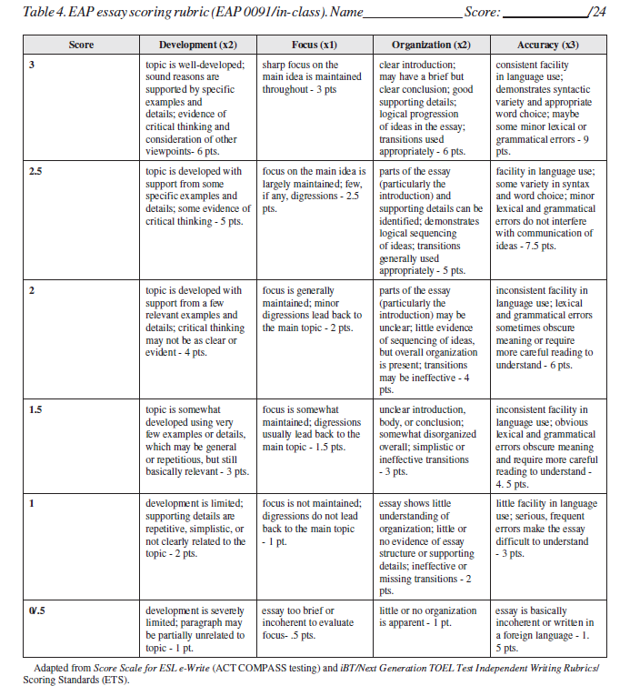
(Source: Teaching critical thinking and academic writing skills to Japanese university EFL learners)

