Email for professional communication

Emails: what are they for?
- Emails are a popular form of communication in many organisations.
- Although emails are usually sent within an organisation, it is common to email someone externally as well.
- Emails are used in professional settings because of their speed and convenience.
- They should not be sent when face-to-face or telephone interaction will solve communication problems more quickly and directly.
- As in other forms of writing, because the reader does not have the aid of other features such as body language, facial expression, etc. it is important to write emails carefully and clearly so as not to create any miscommunication

Email: the text
- Although the writing style for emails is more informal, you still need to consider who you are writing to.
- Abbreviations, slang, colloquialism and jargons are common in emails. However, be cautious about this as this is dependent on how well you know the recipient.
- Emails are quite similar to speech (use of first person, second person pronouns, present tense, etc.).
- Emails are written in unformatted plain text.
- The tone, style and formality of writing will depend on who it is being sent to.

Email: the style – formal vs informal
- The appropriate style of an email (formal/informal) would depend on the receiver or reader.
- A formal style would be used if the receiver holds a more senior position in the organisational hierarchy compared to you.
- A formal style is recommended if the email will be referred to others in the organisation or used as part of other transactions.
- A formal style is usually appropriate if students are emailing their instructors, supervisors, etc.

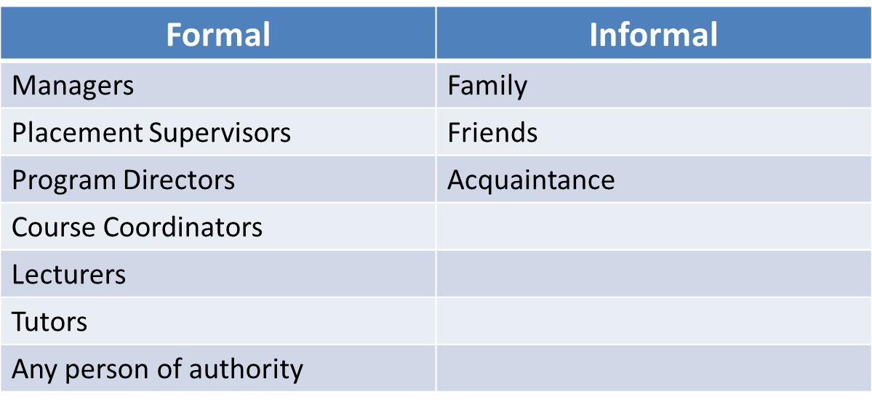

Email: Structure
- Get the message upfront.
- Consider using the MADE structure (Eunson 2012) for formal emails:
  - Message
  - Action
  - Details
  - Evidence

Example formal email

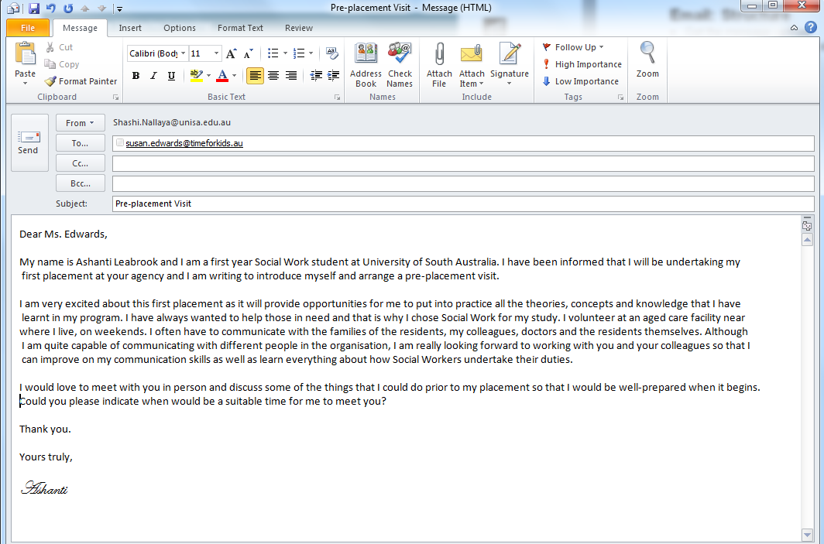
Sign off with a signature (Yours truly can be used with all salutations)
Specify the action you require from the reader and conclude
Introduce yourself and the purpose
Salutation (Dear Sir/Madam if you do not know the name)
Subject details always provided
Note: Always proofread and edit your email for grammatical or spelling errors before sending it off.
Adapted from: Eunson, B 2012, Communicating in the 21st century, 3rd edn, John Wiley,
Milton, Queensland.

