Introduction
Reading is an important capability that needs to be developed in the university as students who efficiently learn how to read will also be able to effectively learn (Pardede 2006). The metacognitive view to reading instruction suggests that readers must constantly make decisions that can influence the understanding of what they read.
Readers must know when to reread particular sections, what and when to deduce from the information they read, what key points are important enough to retain and when to continue with their reading (Griffith & Ruan 2008, p. 5). As it is possible that not all students would have learnt these strategies in their previous context, it is important that their development is scaffolded in study programs.

Process
- The Program Director should:

A. First identify:
- reading skills that students graduating from the program should acquire.
- genres that students in the program should be able to read.
- purpose for which students in the program read.
- different modes and mediums from which the students in the program read.
- language, style of writing and vocabulary that is commonly employed in the discipline.
- the assessment tasks that will be used to measure students’ writing competence.
B. Then map these statements out in their Program Learning Outcomes (PLOs). PLOs often comprise a generic statement about developing communication skills. This generic statement can be broken into more specific reading outcomes for your program and developed in different courses (see the following example).

Example Program Learning Outcomes for developing reading capabilities
By the end of the program, students should:
- understand interactions among ideas or characters in the text which are subtle, involved or deeply embedded.
- appreciate the richness of highly sophisticated information conveyed through data, visual arrays or literary devices.
- perceive structure, following texts or visual materials organized in ways that are elaborate and sometimes unconventional.
- notice style, tone and use of language, visual or digital elements, which they may be intricate.
- comprehend vocabulary, even when the author’s choice of words is demanding and highly context dependent.
- attend to an author’s intent in writing the text, even if it is implicit and sometimes ambiguous.
- be able to summarise main ideas and key details from a text or electronic display.
- analyse, synthesize and evaluate written and/or visual material and integrate that material into their own writing for their own purposes.
(Horning 2007)

2. Unpacking PLOs to develop students reading capability in courses

- Meet as a team and identify which reading skill(s)/strategies will be developed in which course.
  - Identify the purpose for reading in each course.
  - Discuss the readings that students will be assigned in the program and categorise according to difficulty levels, quantity, genres, etc.
  - Students should read easier texts and acquire basic reading skills at beginning courses compared to later levels.
  - Ensure that each course coordinator is teaching only a specified number of reading skills so that students are not overwhelmed by what they are required to do.
    - Draw up a reading rubric for each of the skills that are being developed and clearly explain these to students so that they might know what the expected level is.
  - Teach the different reading strategies and frequently emphasise the importance and value of reading in the program/course.
  - Provide students with enough opportunities for practicing their reading skills in the course.
  - Ask students to reflect about the reading skills they had learnt in other courses and identify how they all link together.
  - Design lectures with a ‘pre-, while- and post-‘ format with reading as a significant component.
  - Provide students with formative tasks (individual, pair, group, etc.) where students are able to demonstrate their reading ability. Provide feedback for improvement if required.

3. Strategies that can be used to develop reading capability in courses

A. Purpose for reading
- Clearly identify the purpose for reading (lecture, tutorial, assignment, presentation, etc.)
  - How students read will be dependent on the context they would be reading for
- Introduce students to the different text types and strategies for reading each one (textbook, journal articles, websites, etc.)
  - This is important as the way students read will vary depending on the text they read.
- Get students to ask these questions: ‘Why am I reading this?’ ‘How should I read this?’

(Burns & Sinfield 2004)
B. Approaches to reading
- Introduce students to terminology related to reading and sections of texts where these apply:
Scanning | When you want to find a particular item of information
Skimming | When you want to gain a quick impression of a text or article
Surveying | When you want to uncover the structure and overview of a text or article
Light study reading | Reading passively for factual information, general background, and/or with no specific purpose
Detailed reading | Reading actively for specific knowledge acquisition or for grasp of pre-determined concepts, procedures, theories
Deep study reading | Reading actively to make connections, meaning, consider implications, and to evaluate argument

(Brown & Atkins 2002, p. 174)

C. Make reading more meaningful
- Evoke students’ background/previous knowledge about their readings.
  - This will help them better connect with the text they read.
- Put together reading lists that are cohesive. Select a few good, quality texts.
- Encourage students to connect to the text.
  - Show students note-taking strategies (underlining/making marks/comments in the margin).
  - Write a commentary on what they think are the key issues.
- Show students how to summarise the reading/visualize key ideas.
  - Show students how to make a visual or graphic organizer to the context of texts they read.
- Get students to maintain a response journal where they write questions/comments about their text.
- Teach students to ask WH questions about the texts they read.
- Suggest that students organize study groups.
  - Two/three students discuss their readings and key concepts. Key ideas are noted and written up.

Example: Mapping reading capability at program level
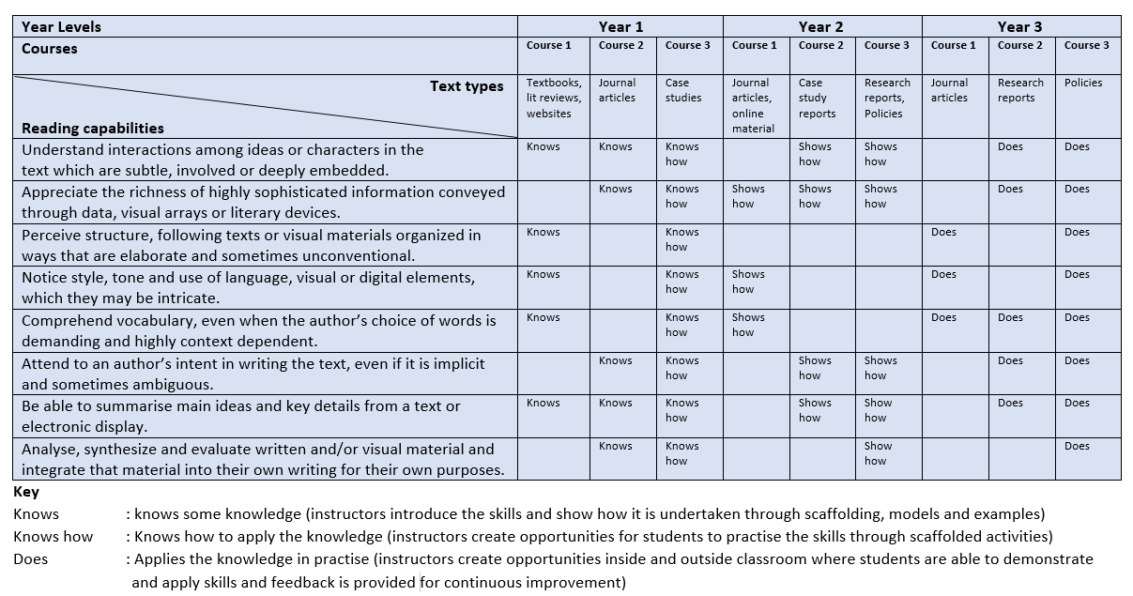

Student Resources
This resource is useful for developing effective and efficient reading strategies:
https://lo.unisa.edu.au/mod/resource/view.php?id=299087

This resource is useful for the development of critical reading strategies:
https://lo.unisa.edu.au/mod/resource/view.php?id=299090

This resource is useful for developing note-taking skills:
https://lo.unisa.edu.au/mod/resource/view.php?id=299091
This resource is useful for developing academic vocabulary:
https://lo.unisa.edu.au/mod/resource/view.php?id=299092

References
Brown, G & Atkins, M 2002, Effective teaching in higher education, Routledge, London.
Burns, T & Sinfield, S 2004, Teaching, learning and study skills: a guide for tutors, Sage Publications, London.
Griffith, PL & Jiening, R 2008, ‘What is metacognition and what should be its role in literacy instruction?’, in SE Israel, CC Block, KL Bauserman & KK Welsch (eds), Metacognition in literacy learning: theory, assessment, instruction and professional development, Lawrence Erlbaum Associates, London, pp. 1-18.
Horning, AS 2007, Reading across the curriculum as the key to student success, The WAC Clearinghouse, viewed 3 August 2016, <http://wac.colostate.edu/atd/articles/horning2007.cfm>
Miller, GE 1990 ‘Miller’s pyramid/prism of clinical competence’, viewed 18 October 2016, <http://www.google.pt/url?sa=t&rct=j&q=&esrc=s&source=web&cd=2&cad=rja&uact=8&ved=0ahUKEwiAmtjk9-fPAhUN02MKHY-nCz8QFggnMAE&url=http%3A%2F%2Fwww.essentialgptrainingbook.com%
2Fresources%2Fchapter_10%2FMillers%2520pyramid%2520of%2520clinical%2520competence.doc&usg=AFQjCNHrAMSoFjLEeZqv-e88KrZfxpJkiw>
Pardede, P 2006, A review of reading theories and its implication to the teaching of reading, viewed 17 October 2016, <https://parlindunganpardede.com/articles/language-teaching/a-review-on-reading-theories-and-its-implication-to-the-teaching-of-reading/>

