Introduction
The metacognitive theory of reading suggests that strategic readers identify the purpose for reading and genre of text they read, its features and structure, the author’s purpose, and use strategies such as selecting, skimming, scanning and reading in detail, predict, infer and make conclusions based on background knowledge as well as information found in the text (British Council n.d.). It is possible that not all students have acquired these skills in their previous learning context. Importance ought to be given to their scaffolding and development in programs and courses.

Process
- Set up the stages of reading (Pre-, While-, Post-)

- Train students to employ the different stages of reading each time they read a text.
  - Pre-reading: Evoke students’ interest about topic, stimulate their background knowledge and make connections about what they already know and what they are going to find out.
    - Introduce unfamiliar language, vocabulary, purpose for reading, etc.
    - Get students to come up with questions they want answered in the text/some broad questions that will help them read the text.
    - Get students to break the text up into different sections so that reading becomes less dense.
      - Teach them what to look for in each section of a text (book, journal article, report, etc.).
  - While-reading: Show students how to identify main ideas, predict about the next idea, make links between ideas, guess meanings of unfamiliar vocabulary, how to skip particular difficult words, how to be critical etc.
  - Post-reading: Teach students to reflect on the text they have read, make connections between the ideas presented and those of others, get them to identify if they agreed with the author’s views and specify the reasons, discuss the presented issues and predict what this could mean for the future.
(Wahjudi n.d.)

- Development of reading capabilities

Pre-reading strategies

- Build a framework. Go through the course outline and help students understand instructional design of the course.
  - Spend time discussing the textbook and why it was chosen. Inform students about the chapter they have to read. Frequently refer to the textbook but also remind students to go beyond. Make links between the textbook and other readings on the list.
  - Ask students particular questions, for e.g. ‘What readings from the list might help you understand this topic?’ ‘Why do you think this topic comes before some others planned later in the semester?’, etc.
- Teach students how to skim and scan. Get them to look at titles, abstract, introductions, etc. and ask them to predict the content, etc.
- Provide student with a glossary of problematic/difficult terms that they may come across in their readings.
  - Suggest that they come up with their own list of vocabulary they find difficult. Get them to look for meanings of these words or discuss them in class.
- Unpack the structure. Analyse a peer-reviewed article together with the students.
  - Get students to look at different sections and their roles. Then ask them how the different sections come together and make a compelling argument.
  - Remind students how they might do this in their own assignments.
- Get students to compare different text types and styles of writing. Get them to reflect on why writing styles might differ in different text types.
(Kucukoglu 2012)

While-reading strategies

- Teach students the following strategies and show them how by using a text from their reading list.
  - Previewing: reviewing titles, section headings and photo captions to get a sense of the structure and content of a reading selection.
  - Predicting: using knowledge of the subject matter to make predictions about content and vocabulary and check comprehension; using knowledge of the text type and purpose to make predictions about discourse structure; using knowledge about the author to make predictions about writing style, vocabulary and content.
  - Skimming and scanning: using a quick survey of the text to get the main idea, identify text structure, confirm or question predictions.
  - Guessing from context: using prior knowledge of the subject and the ideas in the text as clues to the meanings of unknown words, instead of stopping to look them up.
  - Paraphrasing: stopping at the end of a section to check comprehension by restating the information and ideas in the text.
  - Making notes: using preferred method to organize key ideas in note-form.
(The National Capital Language Resource Center 2004)

While-reading strategies for developing comprehension

(Kucukoglu 2012)

Post-reading strategies

- Get students to answer questions about the text.
- Encourage students to maintain learning logs.
  - Get students to put into words what they had learnt from reading activity and to reflect upon their own learning experiences and learning needs.
  - The instructor can prepare a learning log handout that includes the following components:
    - Questions about the content of the reading for students to answer in their own words.
    - Questions about the difficulty level of the reading material and a statement about the time and effort expended by the student in doing the work.
    - A comparison of the actual content of the reading with what the student had predicted in the pre-reading stage.
    - Items related to new vocabulary or terms learnt in the reading.
    - Goal-setting for future learning needs.
  - Encourage students to write a summary of the text they have read.
    - The summary should reflect the major key points of a reading.
    - Should demonstrate the student’s comprehension of the reading.
  - Encourage students to identify what they had learnt from their reading.
(Rochester Institute of Technology 2014)

Reading log example
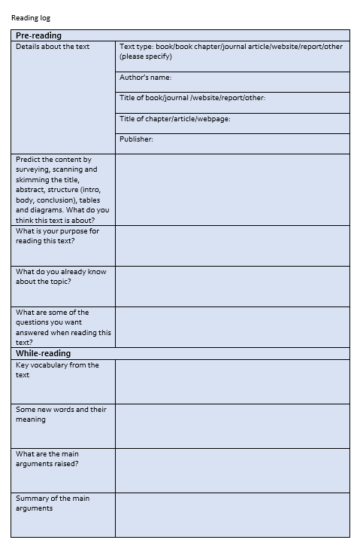

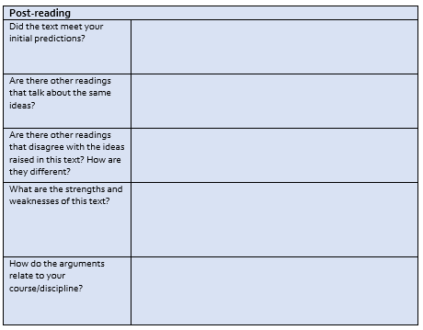

3. Make reading activity active and efficient

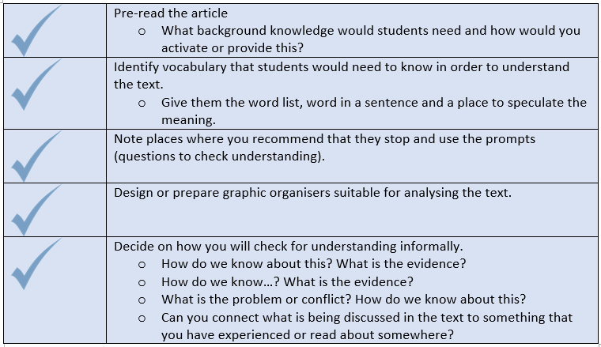
(Tantillo, 2013, pp. 13-28)

Student Resources
This resource is useful for making effective notes:
https://lo.unisa.edu.au/mod/resource/view.php?id=299091
This is a template for taking notes:
https://lo.unisa.edu.au/mod/resource/view.php?id=299088

This resource is useful for developing effective and efficient reading strategies:
https://lo.unisa.edu.au/mod/resource/view.php?id=299087

References
British Council n.d., ‘Theories of reading’, viewed 18 October 2016, <https://www.teachingenglish.org.uk/article/theories-reading>
Kucukoglu, H 2012, ‘Improving reading strategies through effective reading strategies’, Procedia, vol. 70, pp. 709-714.
Rochester Institute of Technology 2014, After reading: tasks and strategies, viewed 3 August 2016, <https://www.rit.edu/ntid/rate/sea/processes/comprehension/process/after>
Tantillo, S 2012, the literacy cookbook: a practical guide to effective, reading, writing, speaking and listening instruction, Wiley, San Francisco.
The National Capital Language Resource Center 2004, Teaching reading: strategies for developing reading skills, viewed 3 August 2016, <http://www.nclrc.org/essentials/reading/stratread.htm>
Wahjudi, A n.d. Interactive post-reading activities that work, Jurnal Online UM, viewed 1 August 2016, <jurnal-online.um.ac.id/data/.../artikel759653BD5A6458C0ED5EC0D0F78E9DE0>

