Note the variety of terms and phrases that describe the capability
Terminology associated with reading: Purpose for reading, prior knowledge, skimming, scanning, surveying, light study reading, directed reading, deep study reading, active reading, efficient reading, critical reading, pre-reading, while-reading, post reading

Note how the capability relates to UniSA graduate attributes and other important outcomes (resilience)
GQ1. Operates effectively with and upon a body of knowledge of sufficient depth to begin professional practice.
GQ2. Is prepared for life-long learning in pursuit of personal development and excellence in professional practice
GQ4. Is an effective problem solver, capable of applying logical, critical, and creative thinking to a range of problems.
GQ6. Communicates effectively in professional practice and as a member of the community.

Definition
Critical literacy is best defined as the psycholinguistic processes of getting meaning from or putting meaning into print and/or sound, images, and movement, on a page or screen, used for the purposes of analysis, synthesis and evaluation; these processes develop through formal schooling and beyond it, at home and at work, in childhood and across the lifespan and are essential to human functioning in a democratic society. (Horning in preparation)

Identify how curriculum and assessment should be mapped at program level to develop the capability

- Use the Reading Across Curriculum approach
- Teach reading skills while students are learning the content
- Provide students with multiple opportunities to learn reading strategies in a variety of class settings/courses.

First identify the:
- reading skills that students graduating from the program should acquire.
- genres that students in the program should be able to read.
- purpose for which students in the program read.
- different modes and mediums from which the students in the program read.
- language, style of writing and vocabulary that is commonly employed in the discipline.
- which assessment tasks that will be used to measure students’ reading competence

Then map these statements out in your program learning outcomes. Often Program Learning Outcomes comprise a generic statement about developing communication skills. This could be broken into more specific reading outcomes for your program and developed in different courses. See following example:
By the end of the program, students should:
- Understand interactions among ideas or characters in the text which are subtle, involved or deeply embedded.
- Appreciate the richness of highly sophisticated information conveyed through data, visual arrays or literary devices.
- Perceive structure, following texts or visual materials organized in ways that are elaborate and sometimes unconventional.
- Notice the style, tone and use of language, visual or digital elements, which may be intricate.
- Comprehend vocabulary, even when the author's choice of words is demanding and highly context dependent.
- Attend to an author's intent in writing the text, even if it is implicit and sometimes ambiguous. (adapted from American, 2006, p. 17)
- Be able to summarize main ideas and key details from a text or electronic display.
- Analyze, synthesize and evaluate written and/or visual material and integrate that material into their own writing for their own purposes.
(Horning, 2007)

Consider how program outcomes can be unpacked into course and task learning outcomes for the capability

- Every course coordinator should be responsible for developing their students’ reading skills.
- Meet as a team and identify which reading skill(s)/strategies will be developed in which course.
  - Identify the purpose for reading in each course.
  - Discuss the readings that students will be assigned in the program and categorise according to difficulty levels, quantity, genres, etc.
  - Students should read easier texts and acquire basic readings skills at beginning courses compared to later levels.
  - Ensure that each course coordinator is teaching only a specified number of reading skills so that students are not overwhelmed by what they are required to do.
  - Draw up a reading rubric for each of the skills that are being developed and clearly explain these to students so that they might know what the expected level is.
- Teach the different reading strategies and frequently emphasise the importance of and value of reading in the program/course.
- Provide students with enough opportunities for practising their reading skills in the course.
- Ask students to reflect about the reading skills they had learnt in other courses and identify how they all link together.
- Design lectures with a ‘pre-, while-, and post-‘ format with reading as a significant component.
- Provide students with formative tasks (individual, pair, group, etc.) where students are able to demonstrate their reading ability. Provide detail feedback for improvement if required.

Identify how curriculum and assessment should be planned at course level to develop the capability

- Identify what reading skills associated learning outcomes students need to achieve in the course
- Take students’ literacy needs seriously
- Treat critical reading as course content
- Integrate critical reading exercises into assignments
- Offer abundant formative assessments of reading exercises
- Explicitly guide students in their understanding of the cognitive skills associated with reading proficiency; e.g.
  - Identify the implications of assertions
  - Compare new and old information
  - Think about the meaning of statements
  - Assess the strength of evidence for claims
  - Assess the accuracy and validity of information
  - Consider the potential biases of the author
  - Make note of words they do not know
  - Decide which information is cardinal and which is peripheral
- Explicitly guide students in their use of metacognition while they read
  - Monitor their own understanding
  - Direct their attention
  - Monitor their own emotional reactions
  - Cross examine their own biases
  - Test their own understanding of what they read
  - Think about what might improve their own thinking about the text
- incorporate reading exercises into summative assessments and exams
(Gorzycki n.d.)

List all teaching strategies that can be used in the course to develop the capability

A. Purpose for reading
- Clearly identify the purpose for reading (lecture, tutorials, assignments, presentations, etc.). How students read will be dependent on the context they would be reading for
- Introduce students to the different text types and strategies for reading each one (textbook, journal articles, websites, etc.). This is important as the way students read will vary depending on the text they read
- Get students to ask these questions: ‘Why am I reading this?’ ‘How should I read this?’
(Burns & Sinfield 2004)
B. Approaches to reading
- Introduce students to terminology and sections of texts where these apply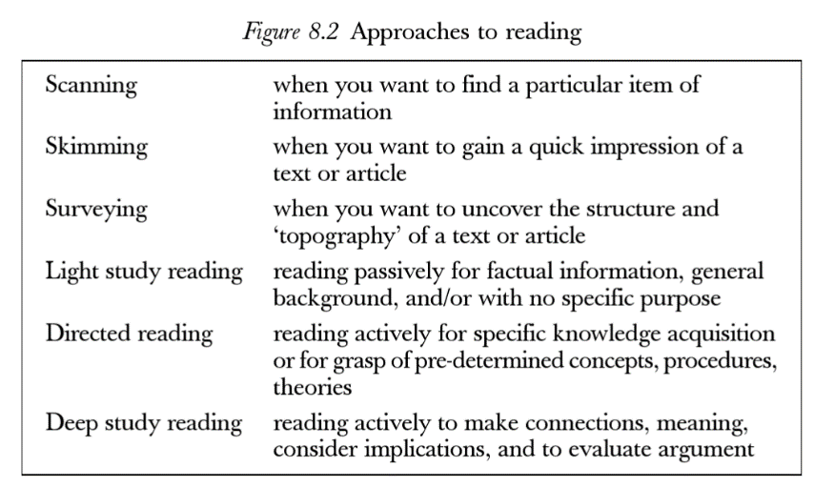
(Brown & Atkins 2002, p. 174)

C. Making reading more meaningful
- Evoke students’ background/previous knowledge about their readings. This will help them better connect with the text they read
- Put together reading lists that are cohesive. Select a few good, quality texts.
- Connect to the text
  - Show students note-taking strategies (underlining/making marks/comments in the margin)
  - Write a commentary on what they think are the key issues
- Summarising the readings/visualising the key ideas. Show students how to make a visual or graphic organiser to the content the text they read
- Maintaining a response journal. Students write questions/comments about their text
- Teach students to ask questions about the texts they read : Wh questions
- Suggest that students organise study groups. Two/three students discuss their readings and key concepts. Key ideas are recorded and written up

D. Make reading activity active and efficient
Use the following checklist as a guide:
- Pre-read the article
  - What background knowledge would students need and how would you activate or provide this?
- Identify vocabulary that students would need to know in order to understand the text.
  - Give them the word list, word in a sentence and a place to speculate the meaning.
- Note places where you recommend that they stop and use the prompts (questions to check understanding)
- Design or prepare graphic organisers suitable for analysing the text.
- Decide on how you will check for understanding informally.
  - How do we know about this? What is the evidence?
  - How do we know….? What is the evidence?
  - What is the problem or conflict? How do we know about this?
  - Can you connect what is being discussed in the text to something that you have experienced or read about somewhere?
(Tantillo, 2012, pp. 72-73)

E. Teach key critical reading skills
- Paraphrasing
  - Explain the comprehension process and how paraphrasing fits in.
  - Strengthen their knowledge of root words.
  - Teach transition and signal words.
  - Teach students how to use academic language effectively.
  - Teach grammar and syntax, especially clauses and phrases.
  - Teach students how to infer meanings from idioms.
  - Teach students how to paraphrase strategically.
    - Circle proper nouns, statistics, etc. that you don’t want to change.
    - Underline words or phrases that you want to change.
- Inference
  - Get students to predict, extrapolate, hypothesise, deduce, analyse, explain, surmise,
  - Design assignments that require students to infer
  - Constantly ask students ‘Why’ so that students get practice in inferring.
- Vocabulary in context
  - Teach students how to figure out words in context.
(Tantillo, 2013, pp. 13-28)

F. Stages of reading (Pre-, While-, Post-)
- Train students to employ the different stages of reading each time they read a text.
  - Pre-reading: Evoke students’ interest about the topic, stimulate their background knowledge and make connections about what they already know and what they are going to find out.
    - Introduce unfamiliar language, vocabulary, purpose for reading, etc.
    - Get students to come up with questions they want answered in the text/ some broad questions that will help them read the text.
    - Get students to break the text up into different sections so that reading becomes less dense. Teach them what to look for in each section of a text (book, journal article, report, etc.)
  - While-reading: Show students how to identify main ideas, predict about the next idea, make links between ideas, guess meanings of unfamiliar vocabulary, how to skip particular difficult words, hoe to be critical, etc.
  - Post-reading: Teach students to reflect on the text they have read, make connections between the ideas presented and those of others, get them to identify if they agreed with the author’s views and specify the reasons, discuss the presented issues and predict what this could mean for the future.
(Wahjudi, n.d.)

G. Some more reading activities for the different stages
G1. Pre-reading strategies
- Build a framework. Go through the course outline and help students understand instructional design of the course.
  - Spend time discussing the textbook and why it was chosen. Inform students about the chapter they have to read. Frequently refer to the textbook but also remind students to go beyond. Make links between the textbook and other readings on the list.
  - Ask students particular questions, for e.g. ‘what readings from the list might help you understand this topic?’ ‘Why do you think this topic comes before some others planned later in the semester?’ etc.
- Teach students how to skim and scan. Get them to look at titles, abstract, intro, etc. and ask them to predict the content, etc.
- Provide students with a glossary of problematic/difficult terms that they may come across in their readings
  - Suggest that they come up with their own list of vocabulary they find difficult. Get them to look for the meanings of these words or discuss them in class
- Unpack the structure. Analyse a peer-reviewed article together with the students.
  - Get students to look at different sections and their roles. Then ask them how the different sections come together and make a compelling argument.
  - Remind students how they might do this in their own assignments.
- Get students to compare different genres and styles of writing. Get them to reflect on why writing styles might differ in different genres.
G2a. While-reading strategies for developing comprehension
Teach students how to:
- Predict
- Visualise
- Make connections
- Summarise
- Question
- Infer
(Kucukoglu 2012)

G2b.While-strategies for developing speed
Teach students the following strategies and show them how by using a text from their reading list
- Previewing: reviewing titles, section headings, and photo captions to get a sense of the structure and content of a reading selection.
- Predicting: using knowledge of the subject matter to make predictions about content and vocabulary and check comprehension; using knowledge of the text type and purpose to make predictions about discourse structure; using knowledge about the author to make predictions about writing style, vocabulary, and content.
- Skimming and scanning: using a quick survey of the text to get the main idea, identify text structure, confirm or question predictions.
- Guessing from context: using prior knowledge of the subject and the ideas in the text as clues to the meanings of unknown words, instead of stopping to look them up.
- Paraphrasing: stopping at the end of a section to check comprehension by restating the information and ideas in the text.
- Making notes: using preferred method to organise key ideas in note form.

(The National Capital Language Resource Center 2004)
G3c. Post-reading strategies
- Get students to answer questions about the text.
- Get students to maintain learning logs.
  - Get students to put into words what they had learnt from the reading activity and to reflect upon their own learning experiences and learning needs.
  - A teacher can prepare a learning log handout that includes the following components:
    - Questions about the content of the reading for students to answer in their own words.
    - Questions about the difficulty level of the reading material and a statement about the time and effort expended by the student in doing the work.
    - A comparison of the actual content of the reading with what the student had predicted in the before-reading stage.
    - Items related to new vocabulary or terms learned in the reading
    - Goal-setting for future learning needs.
  - Encourage students to write a summary of the text they have read.
    - The summary should reflect the major key points of a reading.
    - Should demonstrate the student’s comprehension of the reading.
  - Encourage students to identify what they had learnt from their reading
(Rochester Institute of Technology 2014)

References
Brown, G & Atkins, M 2002, Effective teaching in higher education, Routledge, London.
Burns, T & Sinfield, S 2004, Teaching, learning and study skills: a guide for tutors, Sage Publications, London.
Gorzycki, M n.d. Literacy, critical reading and the curriculum [Powerpoint], viewed 5 August 2016, <https://ctfd.sfsu.edu/content/advancing-student-literacy-and-reading-comprehension>
Horning, AS. (In preparation). The literacy marvel. Book manuscript in preparation.
Horning, AS 2007, Reading across the curriculum as the key to student success, The WAC Clearinghouse, viewed 3 August 2016, <http://wac.colostate.edu/atd/articles/horning2007.cfm>
Kucukoglu, H 2012, ‘Improving reading strategies through effective reading strategies’, Procedia, vol. 70, pp. 709-714.
Rochester Institute of Technology 2014, After reading: tasks and strategies, viewed 3 August 2016, <https://www.rit.edu/ntid/rate/sea/processes/comprehension/process/after>
Tantillo, S 2012, the literacy cookbook: a practical guide to effective, reading, writing, speaking and listening instruction, Wiley, San Francisco.
The National Capital Language Resource Center 2004, Teaching reading: strategies for developing reading skills, viewed 3 August 2016, <http://www.nclrc.org/essentials/reading/stratread.htm>
Wahjudi, A n.d. Interactive post-reading activities that work, Jurnal Online UM, viewed 1 August 2016, <jurnal-online.um.ac.id/data/.../artikel759653BD5A6458C0ED5EC0D0F78E9DE0

