In brief | Languages | Academic English | Intercultural Learning | Knowledge Exchange
 | Multilingual students use their languages to support learning. | Developing and using academic English can be challenging for students. | Students seek effective and meaningful intercultural learning. | Students place high value on knowledge exchange.

What do students say? | Languages | Academic English | Intercultural Learning | Knowledge Exchange
 | Academic materials in diverse languages support:  - diverse perspectives  - understanding content  - understanding assessment tasks and academic text types  - peer collaboration.  Students want materials in these languages:  - Mandarin Chinese  - French  - Indigenous Languages  - Japanese  - Vietnamese  - 18 more languages. | 72% of students have experienced challenges with academic English.  Main challenges are:  - academic writing  - using subject specific terminology  - general writing (e.g. grammar, paragraphing)  - academic activities (e.g. group work, research, referencing)  - comprehending assignments and academic text types  - academic speaking. | Students gave mixed and negative assessments of the quality of intercultural learning in courses.  Students perceived:  - intercultural learning is generally limited to specific language and culture courses  - course content and readings are biased towards Anglo and Western perspectives  - intercultural learning is not incorporated into core content and assessments. | 93% of students believe knowledge exchange between international and domestic students benefits everyone.  Students seek to learn from the diverse experiences of staff and peers.  Students seek purposeful, planned knowledge exchange activities through:  - purposeful grouping  - facilitated discussions  - in-class, online and social forums.

What does this imply? | The need to think differently about language, culture and knowledge systems in learning:  - understand that academic English is just one form of language amongst many  - consider carefully the current and possible use of language in learning and teaching  - rethink knowledge beyond static notions of disciplinary content or the Western canon  - rethink culture beyond static notions limited to ethnicity, nationality, cuisine and customs  - understand that all students and staff bring different resources to teaching and learning, including language, culture, knowledge systems and experience  - acknowledge that knowledge exchange is multidirectional, involving students and staff  - recognise that contexts of linguistic, cultural and faith-based diversity do not in themselves guarantee knowledge exchange  The need to develop approaches for using diverse linguistic, cultural and knowledge resources in teaching:  - scrutinise, adjust and explicitly teach language demands in courses  - provide language support through multilingual academic materials, exemplars and pathways to support programs and resources  - foreground the diverse cultural and knowledge perspectives that students bring to their learning  - create opportunities and develop strategies for facilitating purposeful and effective knowledge exchange  - support reflection and reflexivity for both students and staff to develop intercultural learning capabilities
The university can respond across various domains:
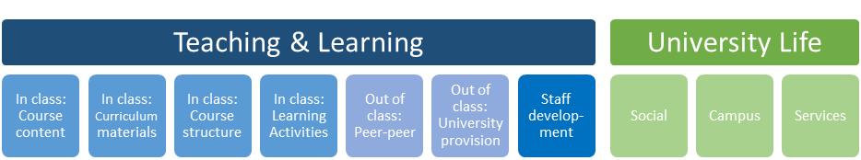
What should we do? | Languages | Academic English | Intercultural Learning | Knowledge Exchange
 | - Incorporate academic materials in a range of languages into course content and reading lists  - Promote opportunities for language learning  - Develop a diverse campus linguistic landscape (signage, print, art, design & soundscapes)  - Include bi-/multilingual inward and outward facing UniSA websites | - Audit academic English language demands of courses and assessments  - Explicitly teach academic language within courses, including topic specific language, academic registers, text types  - Provide helpful feedback to students on their academic English in assessments  - Promote English language courses, learning support, peer study groups and online resources  - Provide staff training in multilingual and English language teaching approaches including writing, speaking and feedback | - Incorporate intercultural content into core curriculum and assessment of a range of courses  - Develop staff training in intercultural learning  - Develop intercultural workshops for students and staff  - Support exchanges and intercultural experiences for students and staff  - Promote intercultural campus ecology and events | - Develop policy to identify, recognise and make maximum use of staff and student knowledge diversity in teaching & learning  - Address class size and composition to support purposeful interaction & knowledge exchange  - Develop staff training for purposeful grouping, facilitating interactions & knowledge exchange  - Construct groups purposefully to facilitate interactions that support international knowledge exchange  - Develop & promote peer support, study groups & online forums  - Promote campus events & student clubs  - Promote services including financial help & student representation to support student participation.

Nallaya, S., Heugh, K., Fazakerley, R., French, M. & O’Neill, F. 2019. ‘English Language, Intercultural Learning and Knowledge Exchange’ Executive Summary – Study 3.

