Report Writing for Psychology

Reports in the discipline of Psychology usually present on empirical research. They consist of clear sections that reflect stages in the research process.
The different sections in the report appear in the sequence of the stages:
- Title: informs the reader about the study.
- Abstract: provides a comprehensive summary about the investigation.
- Introduction: presents the development of the problem under investigation and statement
of the purpose of investigation.
- Method: describes the method used to conduct the investigation.
- Results: illustrates the results that were found.
- Discussion: interprets and discusses the implications of the results.
- References
- Appendix
A sample report for Psychology

Peer and teacher bullying/victimization of South Australian secondary school students: Prevalence and psychosocial profiles
Abstract

A title should summarise the main idea of the report, identify the actual variables/theoretical issues under investigation and the relationship between them (Should be between 10-12 words).
This study examined the nature and prevalence of bullying/victimization by peers and teachers reported by 1,284 students (mean age=15.2 years) drawn from a representative sample of 25 South Australian government and private schools. Students completed a self-report survey containing questions relating to teacher and peer-related bullying, measures of psychosocial adjustment, and personality. The results showed that students could be clearly differentiated according to the type of victimization they had experienced. Students reporting peer victimization typically showed high levels of social alienation, poorer psychological functioning, and poorer self-esteem and self-image. By contrast, victims of teacher victimization were more likely to be rated as less able academically and had less intention to complete high school.

The abstract should describe the problem under investigation, characteristics of the participants/subjects, the method (apparatus, procedures, etc.) and findings (should not exceed 120 words)

1.0 Introduction
Since the pioneering work by Olweus in Sweden and Norway in Bjorqvist, Lagerspetz and Osterman (Olweus, 1977, 1980), school bullying has become a topic of increasing concern in many countries (Hazler, 1998; Olweus, 2003; Rigby, 2002). According to most of these writers, bullying can usually be defined as a repeated pattern of aggressive behaviours directed towards another person who has less status or power (Rigby, 1977). Such aggression need not be physical, and can include a variety of non-physical forms such as emotional and verbal abuse, threats as well as exclusion in which a person directly or indirectly ostracizes another person from a social group.
Within this research, it is consistently found that boys are much more likely to be bullied than girls (Olweus, 1993; Rigby, 2000). Rigby, for example, found that approximately 1 in 5 boys in South Australia reported being bullied by peers compared with only 1 in 10 girls. This finding has also been observed in Sweden (Bjorqvist, 1992)…
For these reasons, the aim of this research was to provide a comparative analysis of teacher as opposed to student bullying to investigate the hypotheses outlined above. Included in this study is a detailed comparison of the psychological and social well-being of students’ subjected to each form of bullying and/or victimization.

2.0 Method
2.1 Participants
A total number of 1,284 (M=517, F=767) secondary school students with a mean age of 15.2 years (SD=0.51) were sampled from 25 schools around rural and metropolitan South Australia. Participants from metropolitan Adelaide comprised 74% (N=947) of the sample and included participants from 19 schools…
2.2 Procedure
The data were collected from questionnaires administered to a representative sample of Year 10 (third year of secondary school) students from rural and urban South Australia. The schools were sampled in such a way to ensure proportional representation of government and private schools and schools representing different levels of socio-economic status…
2.3 Measures
2.3.1 Demographic/background variables
Participants were asked to report their gender, age, and ethnicity/cultural identity (as defined by language other than English spoken at home or as being of Aboriginal or Torres-Strait Islander descent)…

The introduction should highlight why the problem is important, indicate how the hypothesis and the experimental design relate to the problem, consider the theoretical implications of the study, its relevance to previous work in the area and specify what theoretical propositions are tested and how they are derived. The writer should develop the background to the study by discussing the literature and demonstrating continuity between previous and present work. Then they should state the purpose and rationale for each hypothesis.

The method section is usually divided into subsections and will include descriptions of the participants/subjects, the apparatus (or materials) and the procedure. Appropriate identification (selection procedures) of subjects is important in Psychology

2.3.2 Academic variables
Teachers were asked to rate each participant in terms of their level of academic achievement according to three categories (1=definitely capable of tertiary study, 2=possible capable, 3=definitely not capable). Students were asked to indicate whether or not they intended to complete secondary schooling before Year 11/12 (the final year of secondary schooling in South Australia).
3.0 Results
3.1 Overall prevalence of different forms of victimization
The total percentage of participants who reported being bullied often for each of the 10 kinds of victimization were examined after collapsing the response categories of ‘pretty often’ and ‘very often’. The percentage of respondents who reported that they had experienced victimization (never, sometimes and often) across the 10 items are shown in Table 1.
Table 1
Percentage of boys and girls who report often, seldom or never experiencing the 10 forms of victimization
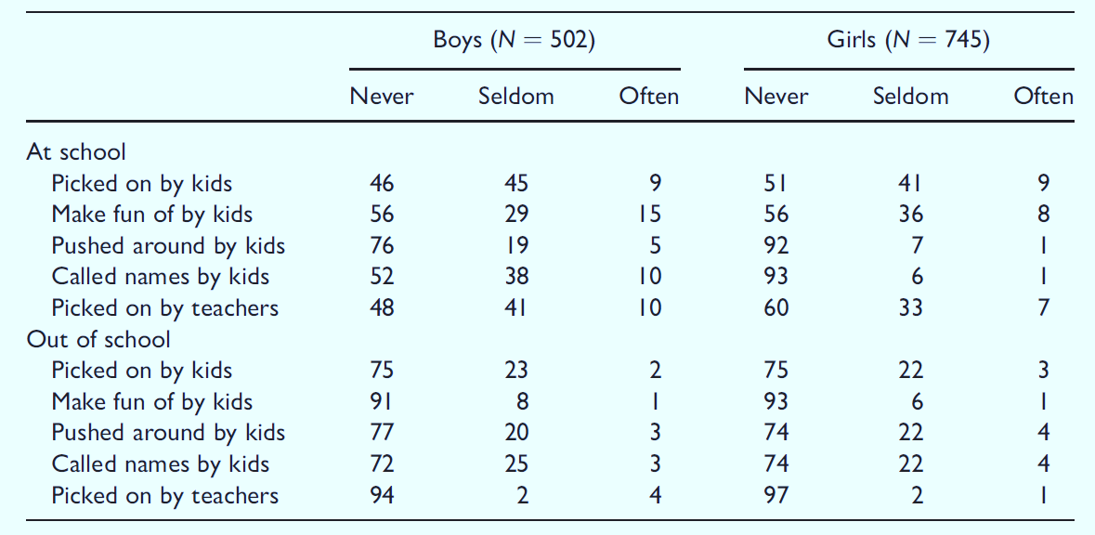
As indicated in Table 1, some forms of victimization occur much more frequently than others. For example, ‘being made fun’ is more commonly reported than are forms of physical maltreatment such as being hit and pushed by other students.
4.0 Discussion
Although this study was not specifically designed to estimate the prevalence of bullying in South Australian schools, the results are remarkably similar to those obtained in many national and international studies (e.g. O’Moore & Kirkham, 2001; Rigby, 1997, 1998; Ortega, 1994; Olafsen & Viemero, 2000; Solberg & Olweus, 2003). Approximately 50% of secondary school students report being subject to some form of bullying from their peers while they are at school and that approximately 10% experience this on a regular basis.

The results section summarizes the data collected and the statistical or data analytic treatment used. All relevant results including those that run counter to the hypothesis should be included. The implications of the results should not be discussed here.

Tables commonly provide exact values and if well prepared can present complex data and analyses in a format that is familiar to the reader. Tables must be mentioned in the text and must be supplemented with text as they cannot communicate the message on their own.

The discussion section is used to evaluate and interpret the implications of the result in relation to the hypothesis

The report must include a reference list. All citations in the report must appear in the reference list and all references must be cited in the text. The American Psychological Association or APA style is the referencing convention used in Psychology.
References
Bjorqvist, K., Lagerspetz, K. M. J., & Osterman, K. (1992). The direct and indirect aggression scales. Vasa, Finland: Abo Akademi University, Department of Social Sciences.

Hazler, R. J. (1998). Promoting personal investment in systematic approaches to school violence. Education, 119, 222–231.

Olafsen, R. N., & Viemero, V. (2000). Bully/victim problems and coping with stress in school among 10 to 12-year old pupils in Aland, Finland. Aggressive Behavior, 26, 57–65.

Olweus, D. (1977). Aggression and peer acceptance in adolescent boys: Two short-term longitudinal studies of ratings. Child Development, 48, 1301–1313.
Olweus, D. (1980). Familial and temperamental and peer acceptance of aggressive behavior in adolescent boys: A causal analysis. Developmental Psychology, 16, 644–660.

Appendix

An appendix is helpful if the detailed description of certain material is distracting in, or inappropriate to, the body of the paper. Some examples of material suitable for an appendix are: a) a new computer program specifically designed for the research, b) an unpublished test and its validation and c) a list of stimulus materials.

Note 1: The discipline of Psychology often employs scientific writing which differs from literary writing. The ideas and findings should be presented directly in a compelling manner that reflects the researcher’s involvement with the investigation.
Note 2: Scientific writing often contrasts the positions of different researchers. Differences should be presented in an objective manner

Source adapted from:
American Psychological Association. (2005). Publication manual (5th ed.). Washington: American Psychological Association.
Delfabbro, P., Winefield, T., Trainor, S., Dollard, M., Anderson, S., Metzer, J., & Hammarstrom, A. (2006). Peer and teacher bullying/victimization of South Australian secondary school students: Prevalence and psychosocial profiles. British Journal of Educational Psychology, 76, 71-90.

