
Referencing: Direct Voice: Quoting

The aim of Direct Voice is to:
- provide you with an awareness of the different techniques that can be used to cite the source that you use in your writing.
- Show you an example as to how you can do this.
1) In academic writing you have to distinguish your voice from the author’s. You can do this by quoting, paraphrasing or summarising.
a) Quoting: A word or group of words taken from another source.
• A quote may be words you read or heard.
• The words of the original source must be copied exactly.
• The quoted words must be enclosed in quotation marks (i.e., ‘...’).
The words from the original source are copied directly within quotation marks
• The quote must be accompanied by a citation. (Mott-Smith 2011)
- Direct quotes are usually followed by a page number.

Example:

The critical orientation popularised in the 1970s and linked to the rise a host of other reform movements like feminism, gay liberation and postcolonialism, ‘aims to engage students more actively in social issues and action’ (Kemmis et al. 1983, p. 129).

The first author’s family name. This must be the second time the authors are mentioned and that is why et al is used. This is followed by the year of publication and the page number

When you quote, you are using the author’s direct voice. The direct voice is used when you decide, what the author says in the original text is very important to your argument. The direct voice is often used when you want to justify a strong claim or opinion.
Mott-Smith, JA 2011, ‘Establishing textual authority and separating voices: a new approach to teaching referencing’, English Teaching Forum, vol. 2, pp. 16-33.

Look at the following text. Assume that you have to use the text in your essay. How would you use the direct voice (Quote) in your writing?
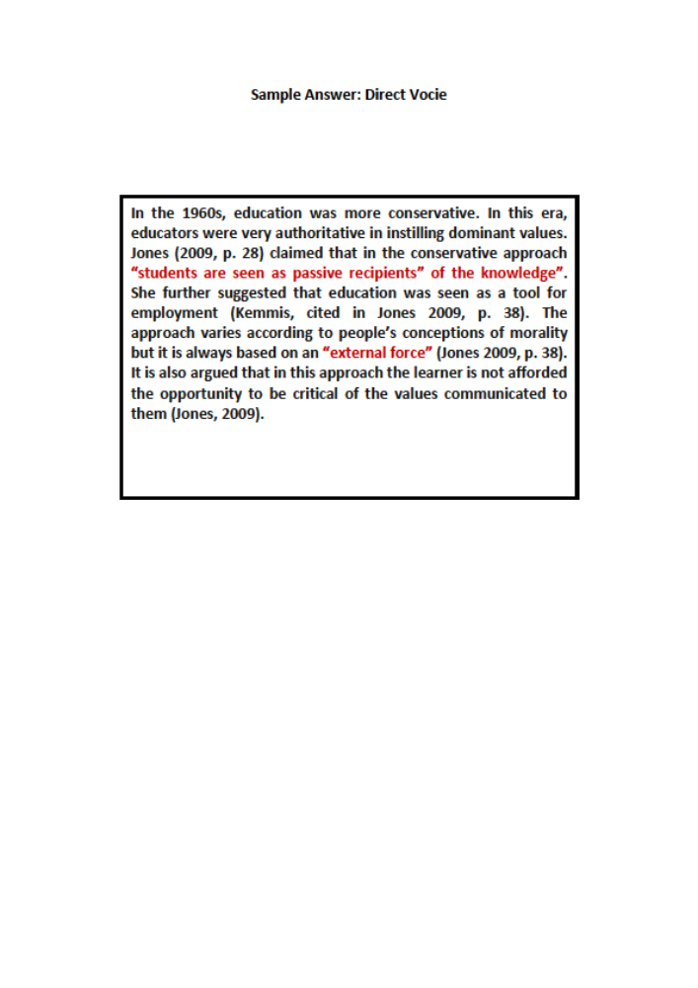
Conservative
The conservative orientation to education prevailed before the 1960s, with schools and teachers taking an authoritative approach and inculcating students with the dominant values, beliefs and practices of the time. Students are seen as passive recipients of this knowledge. Basically, education is understood as preparation for work (Kemmis et al. 1983). Conservative values education approaches vary. They can be based on religious or secular conceptions of morality, for example. However, they can be distinguished by their focus on preparing the student to fit or follow the conventions of the social, civic, religious or local community. In all cases, values frameworks are predetermined by an exterior force—an authority—whether derived from the natural order of the universe, an omnipotent creator, or politically or culturally determined. Students have no bearing on these values, and are not actively afforded opportunities to experiment with alternative or resistant options, analysis or reframing of their morality. Some of the common methodologies in conservative values education include republican conceptions of civics and citizenship education, religious monopolism and values inculcation manifest this orientation, direct teaching, service learning, teacher modelling, reward and punishment and use of rules and guidelines for behaviour. Values education discourses such as character education, civic republican conceptions of civics and citizenship education, religious monopolism and values inculcation manifest this orientation (pp. 38-39).

Jones, TM 2009, ‘Framing the framework: discourses in Australia’s national values education policy’, Educ Res Policy Prac, vol. 8, pp. 35–57.
What are some of the key points addressed by the author with regard to the conservative orientation to education? How would you use the direct voice in your argument?
_____________________________________________________________________________________________________________________________________________________________________________________________________________________________________________________________________________________________________________________________________________________________________________________________________________________________________________________________________________________________________________________________________________

,

