Doing Assignments
You will be asked to produce different types of assignments, for example:
- Essays
- Reflections/journals
- Reports
- Critical reviews
- Annotated bibliography
The structure, purpose and language for each of these assignments would be different.
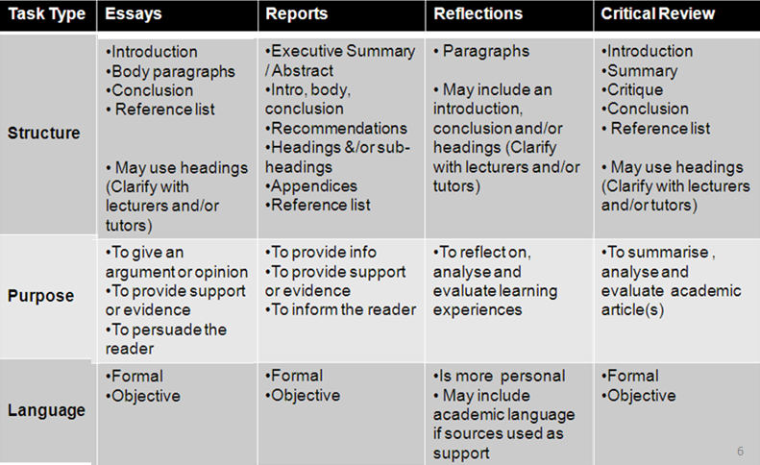
What to consider?
- Lecturer’s expectations
- Use of terminology
- Requirements of the task
- Any other instructions from the instructor/tutor
How to get started?
1. Analyse the task question
- what do you need to address in your answer?
2. Think about your approach
- what are some possible directions you could take?
3. Search for readings
- identify readings which are relevant
4. Critically read, take notes & include source details
- read effectively, engage with your readings and take notes (record sources)

5. Identify your proposition and narrow your scope
- what is your stand and how would you present your argument?
6. Plan the structure
- what will the content be, in what order, and with what support?

Tip:
Always start early so that you are able to revise the first draft and have enough time to edit and proofread your work.

