Essay Writing
Whatever type of text you are asked to write, you need to ask yourself:
- What is the purpose of this text?
- Who is the audience for this text?
- What is the structure of this text?
How is the essay structured? The essay comprises the following:
- Introduction
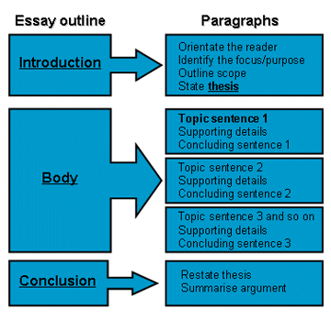
- Body
- Conclusion
The function of the introduction is to:
- introduce the general topic
- provide background which puts the topic in a broader context
- indicate the importance of an issue
- identify something that the reader does not know
- state the position that the author will argue
- provide an overview of what is to come
- explain how the discussion is organised
- define important terms used in the essay
The body of the essay:
- develops the position presented in the introduction
- is divided into a number of sections, each dealing with an argument or part of an argument
- comprises different paragraphs and is clearly linked to the overall position
- has paragraphs that are clearly linked together
- has topic sentences that are expanded with evidence and justification from research
- comprises quotes, paraphrases and summaries from your research that are referenced according to the referencing convention of your school
The Conclusion:
- restates the position that has been presented in the introduction
- summarises the major arguments supporting the position
- does not include any new points that were not raised or discussed in the body
- concludes with a final sentence linking the essay back to the wider context
Source adapted from: Brick, J 2011, Academic culture: a student’s guide to studying at university, 2nd edn, Macmillan, Australia.

