Learning Style
Scientists argue that all human beings prefer a particular way of learning. Some of us favour a visual (sight-based) learning style while others prefer auditory (sound-based) or kinaesthetic (touch-fell or movement-based) learning styles. To make our learning effective, we should favour our personal learning style. But, to guarantee complete learning, we should utilise all the learning pathways, hence the success of see, hear, say and do techniques
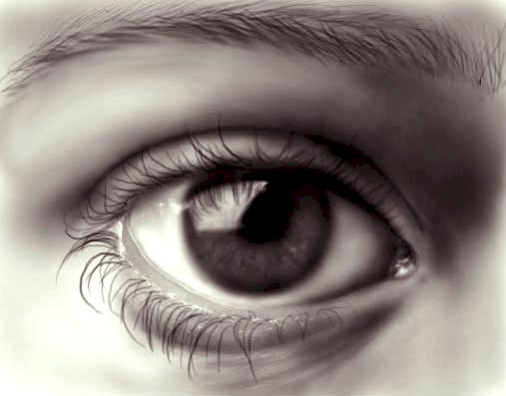
Visual learners may prefer to:
- see the lecturer – their body, language and facial expressions
- sit near the front with nothing blocking their view
- learning through visual media, film, television and video and the visual aids that a lecturer will use in their teaching
- take detailed notes but will learn best by adding colour, pictures and cartoons to make notes funny, bizarre or unusual
- learn how to make key-word, pattern notes that are visually stimulating and memorable
Auditory learners may prefer:
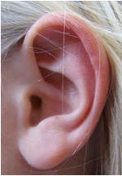
- verbal lectures, listening carefully
- tuning in to the nuances of voice: tone, pitch, speed, passion
- taping lectures (and making shorter versions to revise from)
- rather than reading, finding audio versions of books
- learning by discussion and explanation, talking and listening
- making their own audio-tapes of things that they want to remember, utilising silly voices, tunes, rhythm and rhyme
Kinaesthetic (touch-or feeling based) learners may prefer:
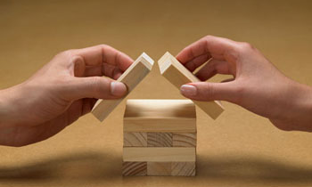
- hands-on learning – engaging with the real world –typically
preferring practical courses
- experiments, activity and role-playing in their learning
- to care about or ‘feel’ something for the subject
- to move about as they study, or move from room to room for different parts of assignments
- to make diagrams and charts of the key things that they need to remember
Tip: As you cannot roam around in a lecture or class, have an object to squeeze (e.g. a rubber ball) to allow some movement

