Making the most out of face-to-face time
There are different modes of study in the university:
- Lectures: led by instructors, large number of students, handouts, PPT
- Tutorials: directed by students, small group discussions, preparation & participation (discussion of key topics, concepts, etc. with tutor)
- Seminars: small group, runs for 1-3 hours, presentation, preparation, participation (giving a paper, answering questions, discussion, etc.)
- Workshops: introduction to a problem by tutor, discussion and activities to investigate, analyse and formulate solution to problem
What do you do for a lecture?
- Read any readings for the topic
- Read the chapter on the topic in the assigned textbook
- Skim and scan the handout
- Attend the lecture, listen and take notes
- Identify any questions that need clarification
- See the lecturer immediately after the lecture to clear any doubts
- Review notes and condense them
What do you do for a tutorial?
- Read tutorial tasks and answer questions
- Discuss the topic with other students
- Work through a series of problems with the help of a tutor
- Take part in practical sessions in a workshop, etc.
- Make a presentation on a specific topic
- Clarify any doubts about the lecture content/topic
What do you do for a seminar?
- Prepare a paper and circulate it in advance
- Present the paper
- Do not just read the paper aloud
- Capture the key aspects of the paper
- Lead the discussion
- Ensure that the audience engage with your ideas

Participation in the sessions
- Participation in the sessions is important:
  - as it allows everyone to develop critical and analytical skills
  - You do not have to show that you are a master of analysis
  - You do not have to put forward a carefully thought out position
  - You do need to develop your critical and analytical skills
  - You learn this by practising to make comments and asking questions
Processes for effective participation
Before
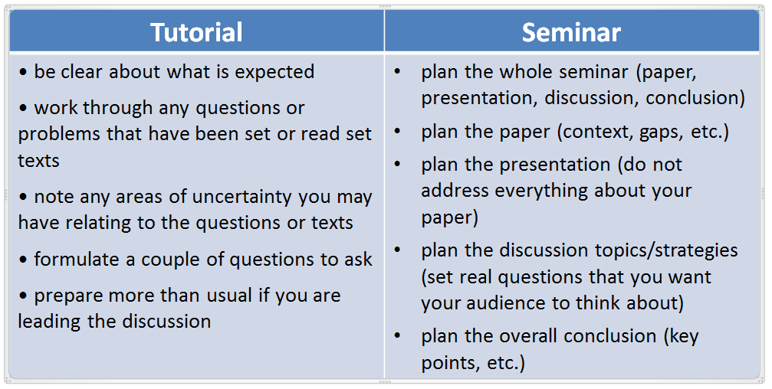
During
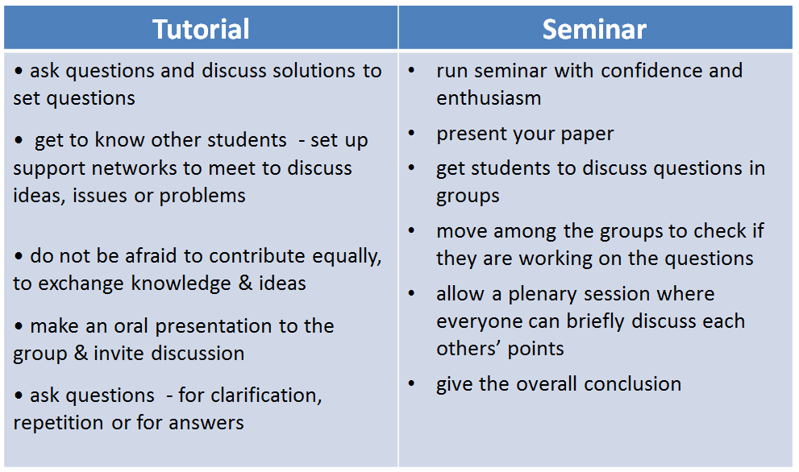
After
