Referencing
What is referencing? Referencing is a convention in academic writing that is used to:
- acknowledge sources
- show where evidence comes from
- encourage the reader to verify information
- enable the reader to consult the source
- demonstrate that the discussion and arguments are based on expert and reliable information
Why is referencing important?
- Demonstrates good research practice
- Shows a range of ideas and approaches found and thought about
- Emphasises that you have sought expert and reliable sources
- Prevents circumstances where plagiarism can occur
When to reference?
Provide in-text reference when you:
  - include someone else’s words, ideas or information in your assignment
  - paraphrase or summarise someone else’s ideas in your own words
  - quote someone else’s ideas in their exact words
  - copy or adapt a diagram, table, statistics or any other visual material
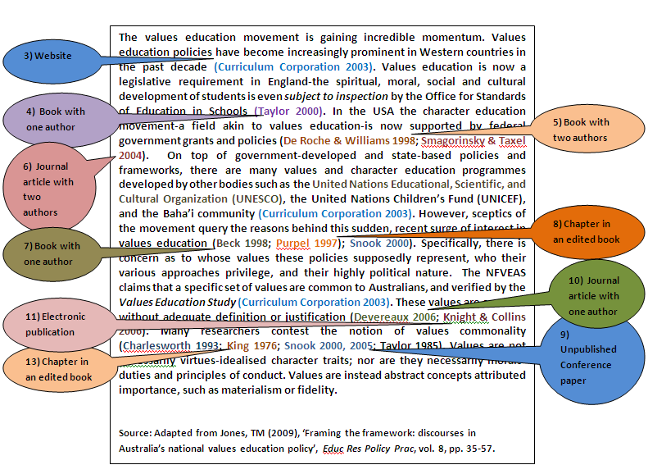
How to reference?
- You insert in-text reference each time you refer to ideas or information from other sources
  - You need to include the following details:
    - the author’s family name (do not include first name)
    - the year of publication
    - page numbers when appropriate

