Time Management: Creating a balance
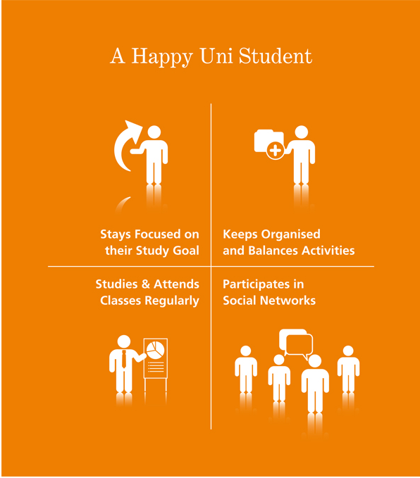
The key to being a successful student is to:
- have clear goals
- write a list of things to do to achieve these goals
- include all activities that are often taken for granted but still need to be done
- have someone to discuss all of this
Planning your time
- Estimate the amount of time you would spend on each activity
- Consider when you might do these activities
- Enter your weekly commitments into a weekly planner
- Don’t forget to include travel, eating, sleeping and other regular daily living activities
- Leave some uncommitted time for any unexpected issues
Prioritising Conflicting demands
You need to prioritise your activities and take into account both the relative importance and the relative urgency of each. See the example below:
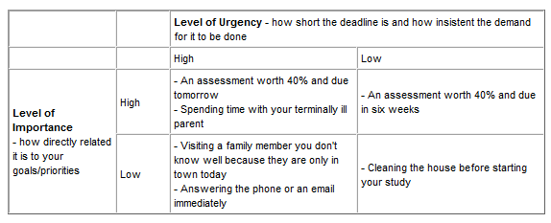
Time Management Quiz
No
YES
Do you often:
- Feel there is just not enough time in a day?

- Go to study for a test or work on a project and discover it is
going to take twice as long as you thought?

- Feel like you rush from one thing to another, yet never accomplish
a thing?

- Over-extend yourself socially and/or volunteer-wise?

- End up "cramming" the night before a test?

- Know there's a million things you have to do but can't seem to get
any of them done during the day?

- Feel constantly time-pressured?

- Set goals and then never achieve them?

- Put off difficult or disliked assignments until the last minute?

- Spend a lot of time doing things you don't enjoy?

To see if you are in control of your time or if it is in control of you, total the number of
"YES" and compare to the following:

Score: If your total number of ‘Yes’ answers was:

0 - Great! You're highly organized, know your limits, and plan your time accordingly,
Well done!

1-3 - You manage your time pretty well now but may be slipping up in some areas. You
usually stick to a schedule but sometimes over-extend yourself. You need to polish your
scheduling skills.

4-6 - Watch Out! Your time is slipping away from you! Your time management schedule is
sporadic, and before you know it, things are piling up so fast you can't keep track of
them. You definitely need to organize your time more carefully.

7-10 - Uh-Oh!! You're the typical "where did all the time go?!" candidate. It's "time" for you
to learn some time management skills and get in control of your life. Don't wait until it's
too late.

