Time Management

**Time management is important for:**

* success at university
* meeting deadlines
* managing your studies
* spreading workload over a study period

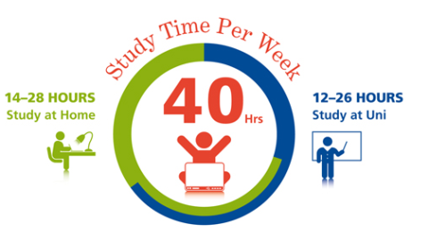

**Your instructor’s expectations are that you will:**

* be an independent learner
* dedicate approximately 40 hours a week to your studies
* attend lectures, tutorials, seminars and other learning activities
* read widely and critically and use the information to produce quality assignments

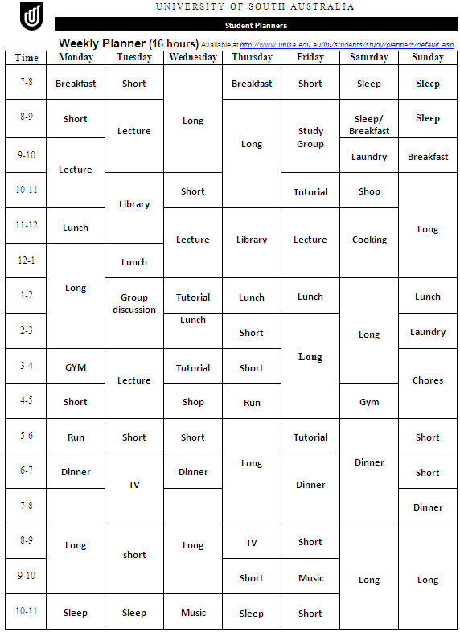

**How to manage your time?**

* Plan ahead and prioritise
  + Decide which task is more important
  + Decide which task should be completed first
  + Use a study planner
    - Long-term planning
    - Short-term planning
  + Long-term planning:
    - Write assignment due dates
    - Specify when the exam is scheduled
    - Identify a time frame to complete a task
    - Allow for extra workload
    - Set a start day for each task
    - Draw a line from the ‘due date’ to the ‘start date’
  + Short-term planning:
    - Divide this into short, medium and long time slots
    - **Short time slots**: review lecture notes, complete short readings, preview long readings, solve problems, revise for exam, jot down essay plan and proofread an assignment
    - **Medium time slots (1 hour with breaks)**: do detailed note reviewing, read for courses/assignments, take notes from readings, draft/edit an assignment and revise for exams
    - **Long time slots (1 to 3 hours with breaks)**: work on an assignment, complete extensive amount of reading, do research for assignments and revise for exam