**UniSA STEM Showdown**

Presented by UniSA Education Futures

Bag-Tag-arama

**Name:_________________________________________**

*The STEM Showdown is a series of STEM challenges to solve by the end of the season. You can complete the tasks individually or in small groups (up to 3 people). Make sure you write all the names of the people in your group above. The student with the most tasks completed over the season will be crowned the UniSA STEM Showdown Champion. Good Luck.*

**What is 3D printing?**

3D printing work is different from other manufacturing processes. Making things usually involves a subtractive process: you start with a block of material – aluminium for instance – which you then machine (i.e. remove material) until you get the shape and size you’re after. But 3D printing does the process in reverse. Instead of removing material, the “printer” dispenses it. The technology gradually deposits the material via a controlled nozzle, layer by layer, building up to a fully formed product.

3D printing has many uses including being used to manufacture custom hearing aids and braces. Body parts, including ears, hips and even organs, in exact proportions to fit the patient.

3D printing has also been used to reconstruct fossils and replicate ancient artefacts!

**Bag-Tag-arama**

There was a special at the shops on backpacks and everyone in your class has purchased the same one. To avoid confusion, you need to design 3D printed bag tag with your name on it using Computer Aided Design (CAD) with Tinkercad.

**Your Task**

Using either Chrome or Firefox browser go to tinkercad.com



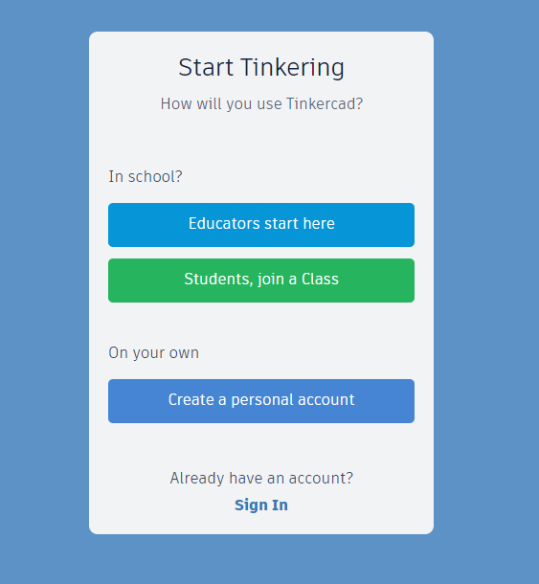Click on the Join Now icon at the top right of the screen

Click on “Students, join a Class”

Enter the **class code** provided by the teacher, write a copy of the code here so you can access it again.

___________________________________

Join with the **nickname** provided by the teacher, write a copy of the name here so you can access it again later

___________________________________

You can now access the “Learn” section and work through some tutorials to help you navigate the program.

Once you feel confident about using the program you can start your own project by clicking on the Create Design Button.

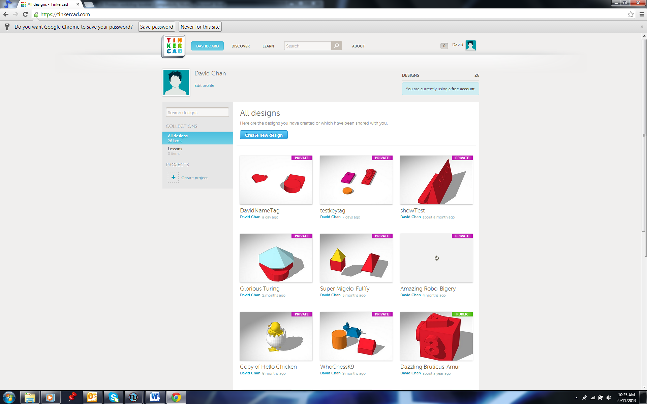

Your design will automatically save as you work on it.

Once you have completed your design, show umpire.

|  |  |
| --- | --- |
| STEM Showdown Umpire Comments | Completed (STEM Showdown Umpire to sign) |
|  |  |

**Make sure you hand up your signed sheet to the umpire at the end of the session to have your points allocated to the leader board.**

**Extension Task**

|  |  |  |
| --- | --- | --- |
| **Extension Task** | STEM Showdown  Umpire Comments | Completed (STEM Showdown Umpire to sign) |
| Change your key tag to have rounded edges |  |  |
| Indent your name |  |  |
| Change the shape of the key tag |  |  |
| Make a tube with a centralised hole using the align feature |  |  |
| Image result for jigsaw pieceDesign a 3D jigsaw puzzle that interlocks |  |  |

**Make sure you hand up your signed sheet to the umpire at the end of the session to have your points allocated to the leaderboard.**