Task 1: worksheet
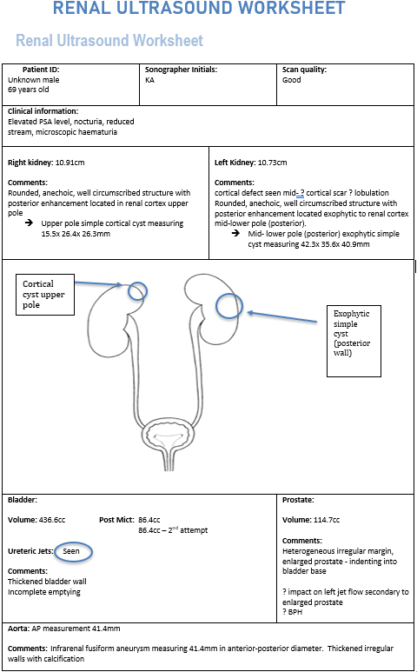

Task 2
Abdominal aortic aneurysm
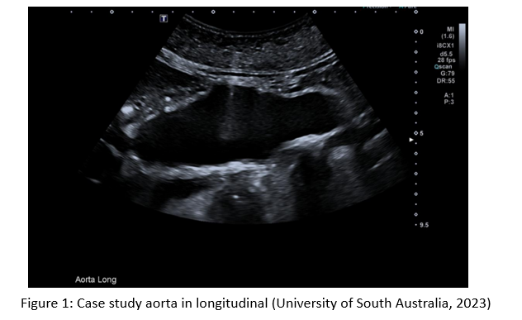
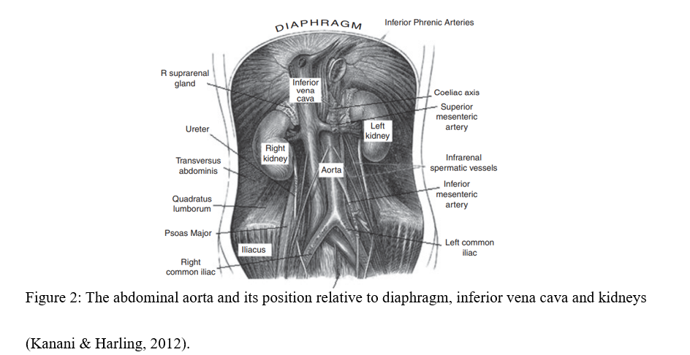

The aorta is the main artery that carries oxygenated blood away from the heart; it ascends from the left ventricle and is comprised of the aortic root, aortic arch, descending thoracic and abdominal aorta (AA) (Figure 3) (Porth, 2002). Major arterial branches arise off the aorta including the renal arteries, superior mesenteric artery (SMA), celiac axis and inferior mesenteric artery (Aggarwal et al., 2011).
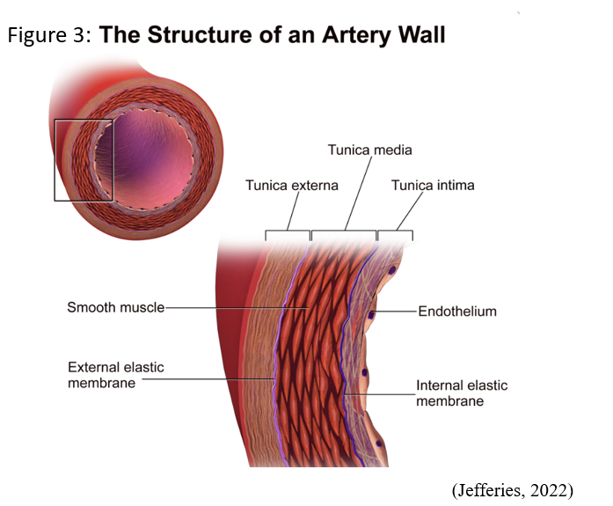
The aorta wall is comprised of three layers: Tunica Intima, Media, and Adventitia, shown in Figure 3 (Dave et al., 2022). Each plays a role in the maintence of structural integrity and function of the aorta (Dave et al., 2022). Endothelial cells provide a barrier; elastic laminae increase vessel compliance; smooth muscle cells (SMC) regulate vessel diameter; and the extracellular matrix (ECM) provides structural support and elasticity (Figure 4) (Rastogi et al., 2022). Kuivaniemi et al. (2019) state the AA undergoes less remodelling during embryology than the thoracic aorta, resulting in 50% fewer elastic laminae within the tunica media, making it susceptible to aneurysms (Figure 5).
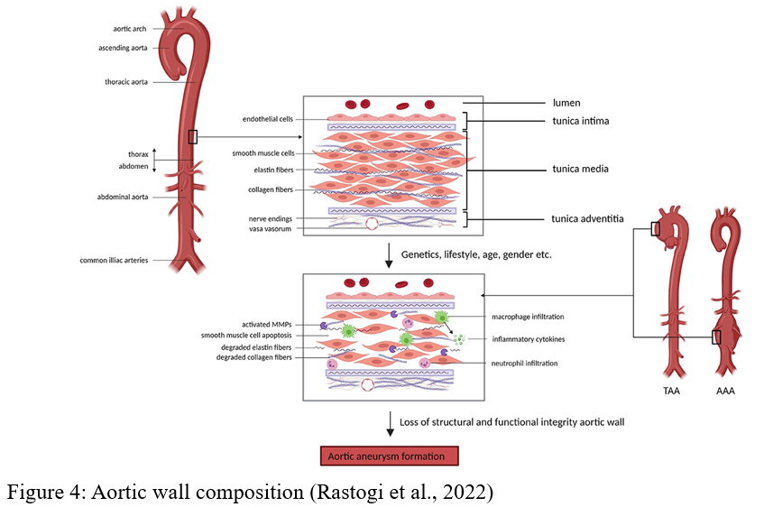
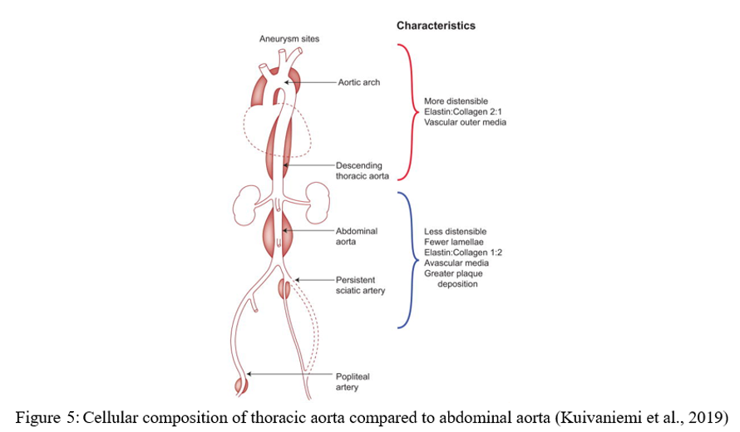

An abdominal aortic aneurysm (AAA) is a focal or diffuse distention and structural degradation of the arterial lumen, involving all three layers of the arterial wall, resulting in an increase of ≥50% above normal diameter or ≥3cm (Rumack et al., 2018). Peak systole; outer wall-to-outer wall measurement should be assessed (Rumack et al., 2018). A false aneurysm or pseudoaneurysm does not involve all layers of the aorta wall (Sander & Hall-Terracciano, 2016).

Kanani & Harling (2012) state up to 75% of patients may be asymptomatic, while others present with a pulsatile mass, abdominal bruit, or central chest pain. Left untreated, this results in progressive thinning of the vessel wall, potentially resulting in rupture (Rastogi et al., 2022). Surgical intervention is usually considered when diameter reaches ≥5cm, with average increase in diameter 2mm annually (Sander & Hall-Terracciano, 2016).

AAA can further be classified by shape and location. Figure 6 shows location descriptors; however, infrarenal AA are said to account for 80% of all AAA. If an AAA is seen to start within 1.5cm of the SMA or 2cm of the celiac axis (Figure 6), the renal arteries are likely to be involved (Rumack et al., 2018).
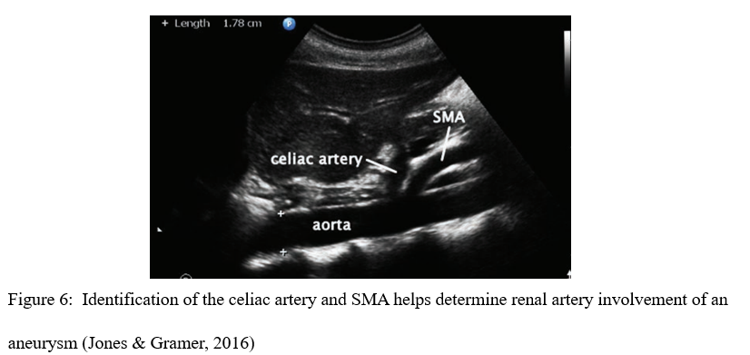
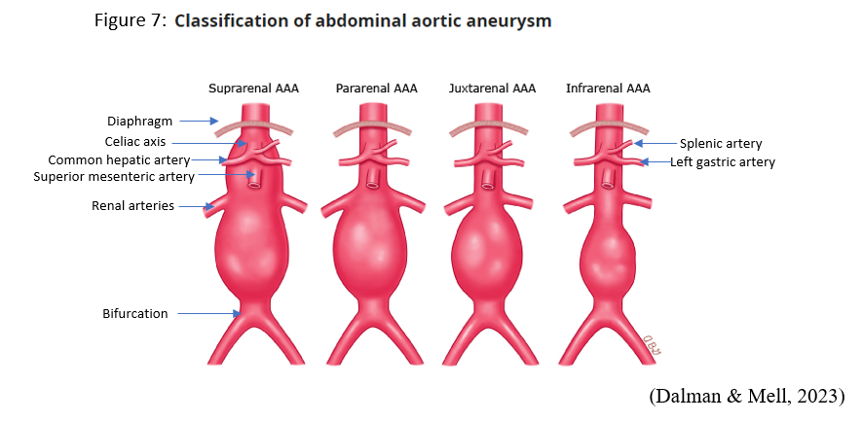
Figure 8 shows common shape descriptors; 80% of all AAA are said to be infrarenal fusiform (Virmani et al., 2022).
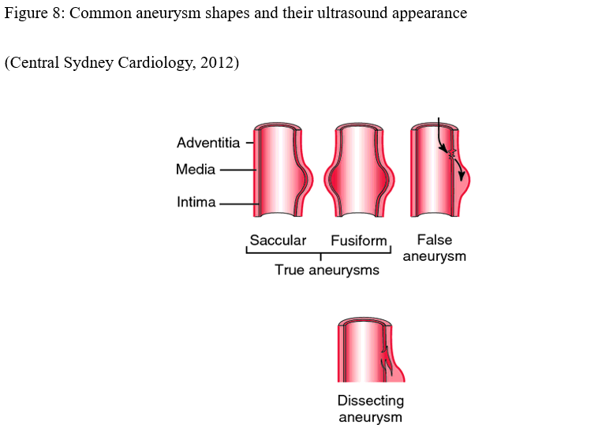
The formation of a AAA may relate to a combination of environmental or hereditary factors and systemic vascular disease (Torres-Fonseca et al., 2019). Genetically SMC apoptosis, inflammation, cytokine activation, ECM destruction and oxidative stress all lead to a reduction in compliance of the arterial wall due to remodelling of collagen fibres (Torres-Fonseca et al., 2019). Environmental and hereditary risk factors are shown in Figure 9.
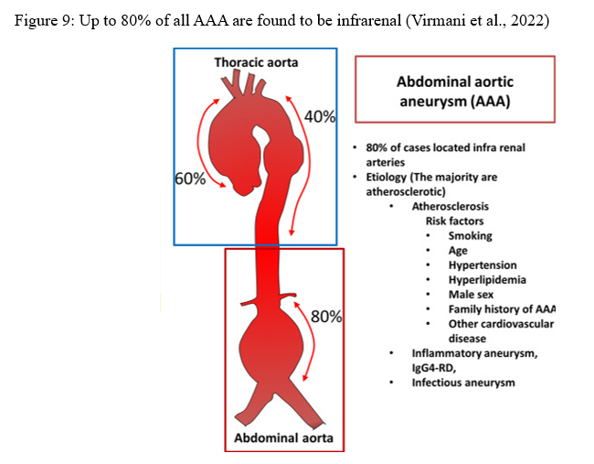
Atherosclerosis formation results in SMC recruitment from the media into the intima layer, impacting structural integrity of the vessel, and reducing compliance (Virmani et al., 2022). Plaque formation results in inflammatory cascade activation and compression of blood supply, decreasing tunica media oxygenation, leading to necrosis and fibrosis of the ECM and SMCs (Virmani et al., 2022). Combined, this causes weaking of the vessel wall as shown in figure 10.
Hypertension causes vessel constriction, leading to ischemia and cellular damage or death (Torres-Fonseca et al., 2019). Cells are replaced with fibrotic tissues which lack elastic properties and impair blood supply, reducing oxygenation, weakening the vessel wall further (Jana et al., 2019). Mycotic aneurysms, although rare, are caused by circulating organism infection of the aortic wall, leading to activation of the inflammatory cascade, weakening the vessel wall (Virmani et al., 2022).
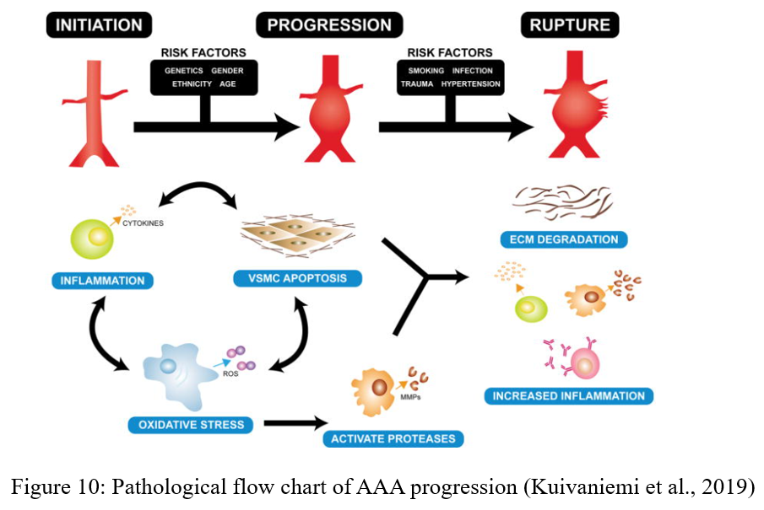
Prevalence
Jana et al. (2019) state, AAA is the “12th leading cause of death in the aged population in developed countries”. Total prevalence over 65-years is estimated as 1.3-8.9% in males, compared to 1-2.2% in females (Virmani et al., 2022). According to Rumack et al. (2018), 80% of all AAs are intrarenal in location. It is estimated 9-16% of patients with atherosclerosis will develop a AAA (Virmani et al., 2022). Total mortality in the instance of rupture is estimated to be 85-90% (Rumack et al., 2018).
Case study sonographic findings
A curved array low frequency transducer is used to show an anechoic vessel in longitudinal representing the AA. The liver can be seen anterior to the vessel with the spine posteriorly. Abnormal findings include an increased vessel diameter of 41.4mm with thickened echogenic walls representing calcification. The walls have an irregular appearance.
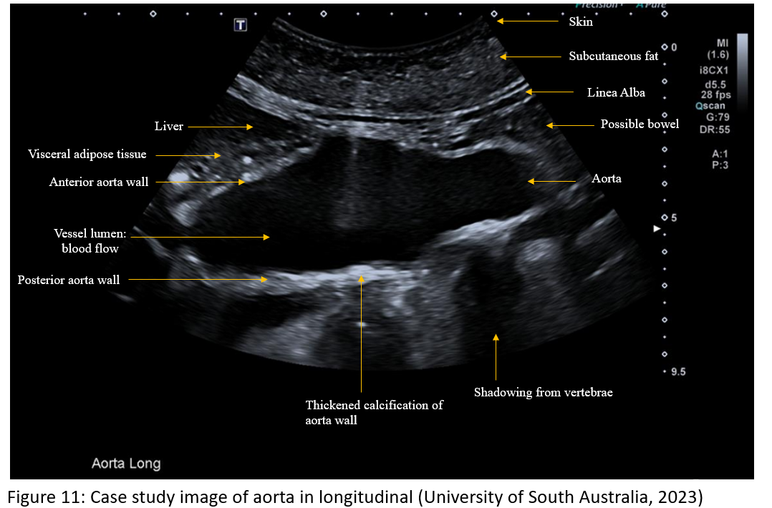
Provisional diagnosis
After discussion throughout this paper on pathophysiology, aetiology, and common ultrasound findings of a AAA we can now collate this for diagnosis for the case study. Longitudinal image shows the dilatated aorta with outer wall-to-outer wall measurement ≥50% of normal aorta vessel diameter and ≥3cm. The aneurysm can be seen to form the fusiform shape. Calcification of the aortic wall is demonstrated by the thickened echogenic wall.
Provisional diagnosis: Infrarenal fusiform aneurysm measuring 41.4mm in anterior-posterior diameter. Thickened irregular walls with calcification.

Task 3
AAA complications include dissection, embolism, thrombotic occlusion, structural compression, compromised blood supply to distal tissues or limbs and rupture, causing bleeding into the peritoneal cavity or retroperitoneal cavity and possible death (Kuivaniemi et al., 2019). According to Aggarwal et al. (2011), risk of rupture is commonly associated with expansion rate, gender, and diameter (Figure 12).
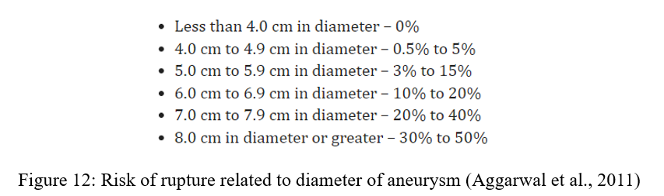

Where a AAA is identified, ultrasound assessment of the entire infrarenal aorta through to aortic bifurcation and common iliac arteries (CIA) should occur (Rumack et al., 2018). CIA images including doppler traces allow for assessment of aneurysmal extension; CIA ≥2cm is considered aneurysmal (Sander & Hall-Terracciano, 2016). Renal assessment should occur for perfusion, scarring, size, and echogenicity as structural compression of the ureter may cause hydronephrosis or decreased renal perfusion (Rumack et al., 2018). Ensure through assessment at the level of the celiac axis, SMA, renal arteries and aortic bifurcation (Sander & Hall-Terracciano, 2016).

It is vital the sonographer ensures correct outer wall-to-outer wall calliper placement to avoid aneurysm false reporting (Rumack et al., 2018). Surgical intervention is normally considered once a AAA reaches ≥5cm or when growth between surveillance scans is greater than anticipated (Sander & Hall-Terracciano, 2016). Renal or iliac arteries involvement alters surgical intervention, so should be carefully assessed (Sander & Hall-Terracciano, 2016).

Colour doppler can be used to assess thrombus within the vessel. The presence of thrombus should be carefully assessed to avoid incorrect calliper placement. Additionally, the calibre of the vessel should be assessed for true patency to ensure no vascular compromise to distal structures (13).

When an incidental AAA finding occurs or where routine surveillance shows unexpected change, the sonographer should discuss the findings with the radiologist to ensure no further intervention is required, before the patient leaves the department (Sander & Hall-Terracciano, 2016).

References
Aggarwal, S., Qamar, A., Sharma, V., & Sharma, A. (2011). Abdominal aortic aneurysm: A comprehensive review. Experimental and Clinical Cardiology, 16(1), 11–15. https://www.ncbi.nlm.nih.gov/pmc/articles/PMC3076160/
Central Sydney Cardiology. (2012). Types of aortic aneurysm. Accessed 30th April 2023. Retrieved from https://www.centralsydneycardiology.com.au/heart-conditions/aortic-disease/attachment/types-of-aortic-aneurysm/
Dave, J. M., Saito, J., Mottola, G., & Greif, D. M. (2022). Chapter 8 - Out to the tissues: the arterial side (arteries, arterioles—development, structure, functions, and pathologies). In The Vasculome (pp. 89–98). Elsevier Inc. https://doi.org/10.1016/B978-0-12-822546-2.00015-0
Dalman, R., & Mell, M. (2023). Classification of abdominal aortic aneurysm. Accessed 1st May 2023. Retrieved from https://www.uptodate.com/contents/image?imageKey=SURG%2F904598
Jana, S., Hu, M., Shen, M., & Kassiri, Z. (2019). Extracellular matrix, regional heterogeneity of the aorta, and aortic aneurysm. Experimental & Molecular Medicine, 51(12), 1–15. https://doi.org/10.1038/s12276-019-0286-3
Jones, B., & Gramer, D. (2016). POC ultrasound for AAA. Phillips
https://www.ultrasoundtraining.com.au/wp-content/uploads/2020/07/AAA-_-Philips.pdf
Jefferies, C. (2022). Aortic dissection. Accessed 9th May 2023. Retrieved from https://geekymedics.com/aortic-dissection/
Kanani, M., & Harling, L. (2012). The abdominal aorta and abdominal aortic aneurysms. In MRCS Revision Guide: Trunk and Thorax (pp. 74–79). https://doi.org/10.1017/CBO9781139097208.011
Kuivaniemi, H., Ryer, E., Elmore, J., Tromp, G. (2015). Understanding the pathogenesis of abdominal aortic aneurysms. Expert Review of Cardiovascular Therapy, 13(9), 975-87. doi:10.1586/14779072.2015.1074861.
Porth, C. (2002). Control of renal function. Pathophysiology: concepts of altered health states (6th ed. pp. 443-445). Lippincott Williams & Wilkins
Rastogi, V., Stefens, S. J. M., Houwaart, J., Verhagen, H. J. M., de Bruin, J. L., van der Pluijm, I., & Essers, J. (2022). Molecular Imaging of Aortic Aneurysm and Its Translational Power for Clinical Risk Assessment. Frontiers in Medicine, 9, 814123–814123. https://doi.org/10.3389/fmed.2022.814123
Rumack, C. M., & Levin, D. (2018). Diagnostic ultrasound / [edited by] Carol M. Rumack, Deborah Levine. (Fifth edition.). Elsevier.
Sander, R & Hall-Terracciano, B. (2016). Clinical Sonography: A practical guide (5th Edition). Wolters Kluwer.
Stepien, K. L., Bajdak-Rusinek, K., Fus-Kujawa, A., Kuczmik, W., & Gawron, K. (2022). Role of Extracellular Matrix and Inflammation in Abdominal Aortic Aneurysm. International Journal of Molecular Sciences, 23(19), 11078. https://doi.org/10.3390/ijms231911078
Torres-Fonseca, M., Galan, M., Martinez-Lopez, D., Cañes, L., Roldan-Montero, R., Alonso, J., Reyero-Postigo, T., Orriols, M., Mendez-Barbero, N., Sirvent, M., Blanco-Colio, L. M., Martínez, J., Martin-Ventura, J. L., & Rodríguez, C. (2019). Pathophysiology of abdominal aortic aneurysm: biomarkers and novel therapeutic targets. Clínica e Investigación En Arteriosclerosis (Internet, English Ed.), 31(4), 166–177. https://doi.org/10.1016/j.artere.2018.10.003
University of South Australia. (2023). Case study assignment: Part B scenario. [PowerPoint slides]. Canvas@FNU. https://lo.unisa.edu.au/pluginfile.php/3916312/mod_book/chapter/370072/Case%20Study%20Assignment%20-%20CS%20PART%20B.pdf
Virmani, R., Sato, Y., Sakamoto, A., Romero, M. E., & Butany, J. (2022). Chapter 9 - Aneurysms of the aorta: ascending, thoracic, and abdominal and their management. In Cardiovascular Pathology (Fifth Edition, pp. 353–406). Elsevier Inc. https://doi.org/10.1016/B978-0-12-822224-9.00009-8

