RADY5015: Superficial Parts Sonography – Case Study Presentation: Choroidal/Uveal Melanoma

- Title Page: Name & Module
Ultrasound of the Eye – Choroidal (Uveal) Melanoma

2. Introduction: Relevance To Learning
Choroidal Melanoma is the most common intraocular cancer of the adult eye (Allan et al., 2011; Glasson et al., 2021; Singh & Singh, 2012; Solnik et al., 2022). For this reason, it is vital to have a basic understanding of this pathology, particularly as ocular ultrasound is quite an infrequently performed examination. Choroidal melanoma makes up 85% of uveal melanomas, which may also manifest as ciliary body or iris melanomas (Allan et al., 2011).

3. Eliciting Patient History & Patient Preparation
Patient Presentation/History: Choroidal Melanoma can be clinically difficult to diagnose as they typically do not have clear signs or symptoms, nor are clearly externally visible (Glasson et al., 2021). That being said, some non-specific symptoms may include blurred/poor vision, loss of peripheral vision, dark patches in the eye, specks or ‘floaters’ in vision, flashing in vision or changes in pupil shape (Glasson et al., 2021). It is important to assess any relevant family history of melanoma, skin conditions (such as dysplastic naevus syndrome) and occupational exposures (such as UV radiation or particular welding chemicals) (Glasson et al., 2021).

Patient Preparation: In preparation for an ocular ultrasound, particular sensitivity should be used as the examination may be uncomfortable. Always provide a thorough explanation prior to commencement, and informed consent should always be obtained.

4. Normal Scan Technique / Protocol
To perform an ocular ultrasound, the patient is laid supine, and warm sterile gel is applied to the closed eyelid as seen in Image 1. A short-focus high-frequency (7.5-10MHz) small parts transducer (linear or hockey-stick) is used with appropriate depth, focus, gain, TCG, dynamic range and power (Allan et al., 2011). Transverse and sagittal images are obtained of both the right and left eyes, and a dynamic assessment is performed with various gazes (up/down/left/right) (Allan et al., 2011). A brief assessment of the optic nerve in B-Mode and Colour Doppler should also routinely be performed. In cases where you need be conscious of reducing scan time (i.e. children), cine loops can be highly beneficial (Allan et al., 2011).

Safety: Particular care should be taken in regards the risk of thermal and non-thermal effects during ocular investigations, with the close monitoring of power, and thermal and mechanical indexes. (Allan et al., 2011).

Image 1 (Lusby, 2023):
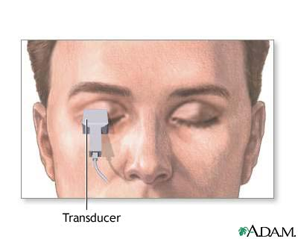

5. Normal Anatomy of the Eye
Image 2 shows the anatomy of the eye, with the transparent anterior segment and opaque posterior segment, made up primarily of the aqueous humour and vitreous humour respectively (Allan et al., 2011). The anterior segment contains lens, cornea, iris and ciliary bodies (Allan et al., 2011). The iris and ciliary bodies separates the anterior and posterior chambers of the anterior eye, and is a less common site for uveal melanomas (Allan et al., 2011; Singh & Singh, 2012). The posterior segment of the eye contains the choroid, retina, sclera and optic nerve (Allan et al., 2011).

Image 2 (Allan et al., 2011):
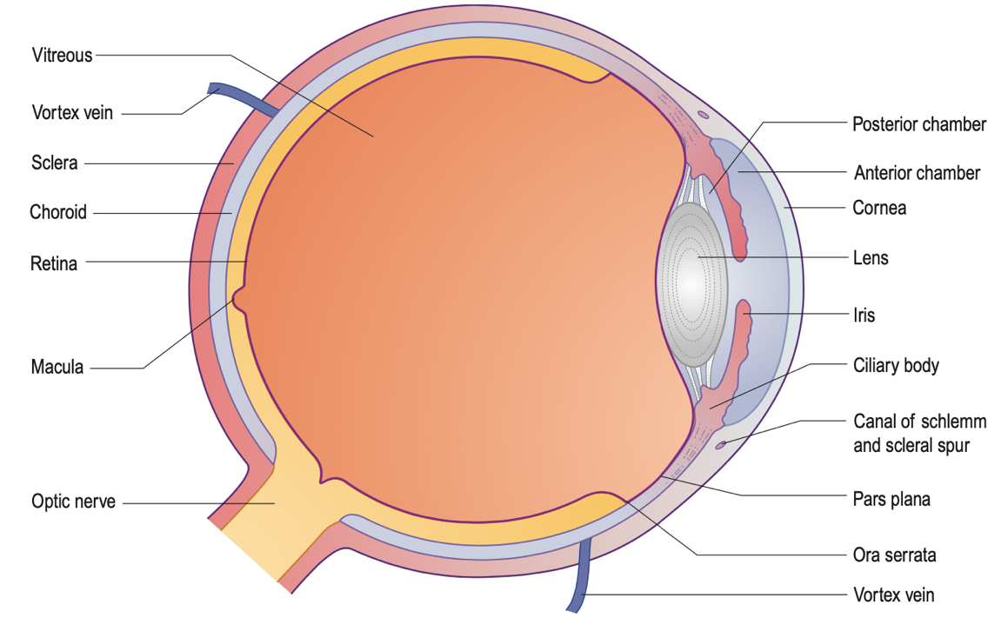

6. Normal Ultrasound Appearances of the Eye
The sonographic anatomy of the eye closely replicates the anatomy shown previously (Allan et al., 2011). The cornea is the most superficial thin, convex, echogenic membrane (Southern, 2009). Posterior to that is the anechoic anterior chamber, and the next thin echogenic line posteriorly represents the iris. The lateral hyperechoic thickening of the iris represents the ciliary bodies, and deep to this we see the hyperechoic linear lens surrounded by the anechoic fluid of the posterior chamber (Southern, 2009). The echogenic thick outer membrane of the eye is made up of the inner retina, middle choroid and outer sclera layers (Southern, 2009). On ultrasound, these three layers are indistinguishable and is the origin of uveal melanomas (Allan et al., 2011; Southern, 2009). Deep to the most posterior aspect of the eye, a hypoechoic line represents the optic nerve (Allan et al., 2011).

Image 3 (Nickson, 2020):
Lens
Cornea
Iris

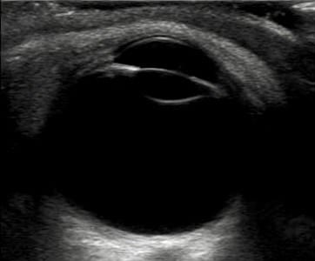
Anterior Chamber
Aqueous Humour

Ciliary Bodies
Vitreous Humour

Posterior Chamber

Retina
Uvea (Entire membrane including retina, choroid and sclera)
Choroid
Sclera

Optic Nerve

7. Background of Choroidal/Uveal Melanoma

Background: In 1826, Thomas Fawdington published ‘A Case of Melanosis’ and first referred to a young patient developing a melanoma after a blow to the eye (Vito et al., 2012). It is believed that the word ‘melanoma’ was wasn’t used until Sir Robert Carswell in 1838 (Vito et al., 2012).

Definition/Physiology: Uveal melanoma is the most common cancer of the eye (Allan et al., 2011; Glasson et al., 2021; Hilborn et al., 1993; Singh & Singh, 2012). Melanoma is a cancer of the melanin-producing cells which produce pigment, and can arise from the uvea, which is the wall of the eye (Glasson et al., 2021). The uvea consists of three layers, the iris, choroid and ciliary body, and 85-90% of uveal melanomas manifest as choroidal melanomas (Allan et al., 2011; Solnik et al., 2022). Iris and ciliary body melanomas are still seen, as demonstrated in Image 4.

Uveal or choroidal melanoma is derived from melanocytes and dominated by epithelioid and spindle cells (Solnik et al., 2022). A point to note is that the most common site of metastasis occur in the liver (Solnik et al., 2022).

Aetiology: The cause of ocular melanoma is often not known, but some risk factors can include pale skin, light eye colours, family history of melanoma, any eye growths, age, skin conditions (such as dysplastic naevus syndrome) and occupational exposure to UV radiation or certain welding chemicals (Glasson et al., 2021; Solnik et al., 2022).

Epidemiology: Despite being the most common intraocular cancer, uveal or choroidal melanoma is still an uncommon disease, with an incidence of around 6 in a million cases in the Australia and USA (Glasson et al., 2021; Singh & Singh, 2012; Solnik et al., 2022). Choroidal melanoma most commonly affects Caucasians and is rarely found in children, with a median age of diagnosis around 55 years old (Singh & Singh, 2012).

Image 4 (Glasson et al., 2021):
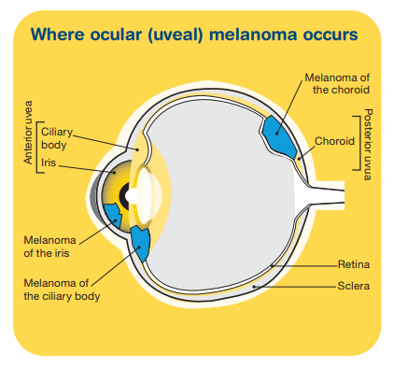
8. Ultrasound Appearance of Choroidal/ Uveal Melanoma
On ultrasound, uveal or choroidal melanoma will appear as a homogenous solid mass with low to medium echotexture and internal vascularity (Byrne & Green, 2002; Solnik et al., 2022). It commonly appears in the “collar button” or “mushroom” shape as seen in Image 5, and may be irregular, lobulated or dome-shaped as in Image 6 (Byrne & Green, 2002; Solnik et al., 2022). An echolucent focus within the lesion may also be present (Southern, 2009). Additional sonographic features that may be seen include scleral bowing, retinal detachment, choroidal excavation or subretinal/vitreous seeding (Byrne & Green, 2002). The spatial resolution of ultrasound makes it the optimal imaging modality to assess lesions less than 3mm (Byrne & Green, 2002)
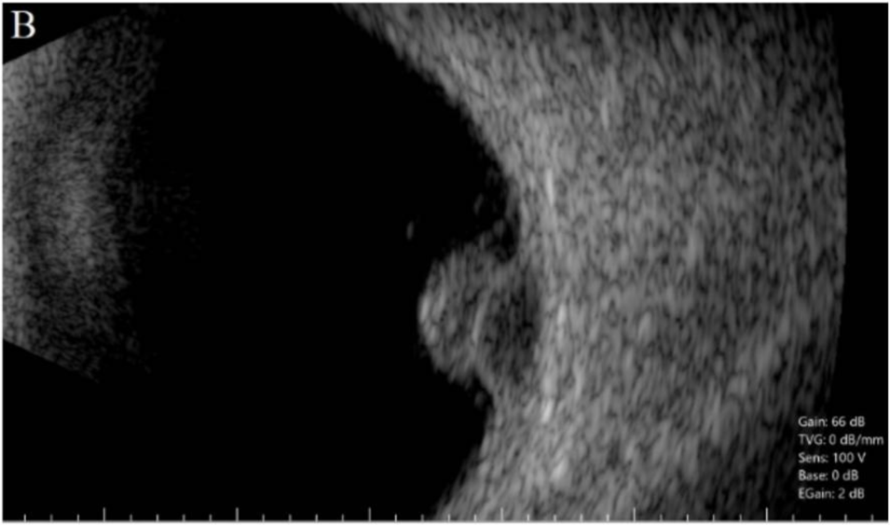
Image 5 (Solnik et al., 2022):

Image 6 (Solnik et al., 2022):
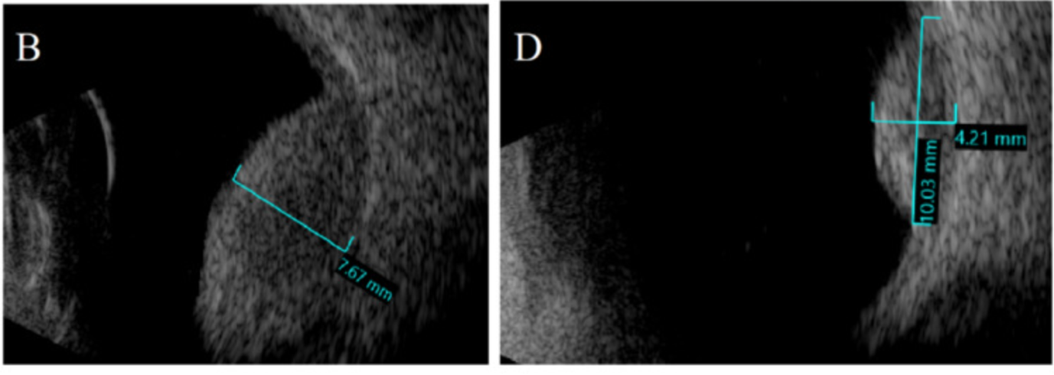

9. Differential Diagnosis
Some differential lesions and diagnoses include (Byrne & Green, 2002; Singh & Singh, 2012):
- choroidal metastasis, nevus, hemangioma or osteoma
- melanocytoma
- benign lymphoid tumour
- choroidal hemangiopericytoma or leiomyoma
- extra-macular disciform lesion
- ruptured arteriolar microaneurysm
- detachment of the choroid or retina
- retinal pigment epithelial hypertrophy
- posterior scleritis
- retinal glioma or significant retinal gliosis

10. Other Investigations & Follow-up
Further tests that may be conducted could include (Glasson et al., 2021):
- Ophthalmoscopy: a large microscope assesses the internal structures of the eye
- Colour fundus photography: a photograph of the back of the eye for pre and post treatment
- Transillumination: a bright light used to locate the melanoma prior to surgery
- MRI or CT: contrast-enhanced multiplanar imaging
- Biopsy: tissue sample removed to be histologically assessed

After the diagnosis of ocular melanoma, treatment may involve surgery, radiation therapy, laser treatment or immunotherapy (Glasson et al., 2021).

11. Summary
My three most important point are:
- Choroidal melanoma is the most common cancer of the adult eye.
- Always thoroughly assess both eyes in two planes (transverse and sagittal) and all gazes (up/down/left/right) to ensure the visualisation of the eye’s entirety.
- Be tactful: Eye ultrasounds can be uncomfortable for the patient, so make a conscious effort to try and make it a pleasant experience.

12. Other Images:
(Fawdington, 1826)

(Carswell, n.d.)


13. Reference List
Allan, P., Baxter, G., & Weston, M. (2011). Clinical Ultrasound (3rd ed.). Edinburgh: Churchill Livingstone.
Byrne, S., & Green, R. (2002). Ultrasound of the eye and orbit. Mosby Inc. https://www.worldcat.org/title/ultrasound-of-the-eye-and-orbit/oclc/606749582
Carswell, R. (n.d.). Robert Carswell.
Fawdington, T. (1826). A Case of Melanosis: With General Observations On the Pathology of This Interesting Disease. https://www.mightyape.co.nz/product/a-case-of-melanosis/36282268
Glasson, A. W., Mcgrath, D. L., Nienaber, C., Palmer, J., Potter, K., Vine, S., Webber, A. M., & Wong, D. W. (2021). Ocular (uveal) melanoma. Cancer Council Victoria. https://www.cancervic.org.au/cancer-information/types-of-cancer/eye_cancer/eye-cancer-overview.html
Hilborn, M., Munk, P., Lin, D., Vellet, D., & Poon, P. (1993). Sonography of Ocular Choroidal Melanomas. American Journal of Roentgenology, 161, 1253–1257.
Lusby, F. (2023). Eye and orbit ultrasound (Image). Mount Sinai. https://www.mountsinai.org/health-library/tests/eye-and-orbit-ultrasound
Nickson, C. (2020). Ocular Ultrasound Challenge (Image). Life in the Fastlane. https://litfl.com/the-ocular-ultrasound-challenge/
Singh, P., & Singh, A. (2012). Choroidal Melanoma. Oman Journal of Opthamology, 5(1), 3–9. https://doi.org/10.4103/0974-620X.94718
Solnik, M., Paduszynska, N., Czarnecka, A., Synoradzki, K., Yousef, J., Choragiewicz, T., Rejdak, R., Damiano Toro, M., Zweifel, S., Dyndor, K., & Fiedorowicz, M. (2022). Imaging of Uveal Melanoma—Current Standard and Methods in Development. Cancers (Basel)., 14(13), 3147. https://doi.org/10.3390/cancers14133147
Southern, S. (2009). Ultrasound of the eye. Australasian Journal of Ultrasound in Medicine, 12(1), 32–37. https://doi.org/10.1002/j.2205-0140.2009.tb00005.x
Vito, R., Sondak, V., & Smalley, K. (2012). A Brief History of Melanoma: From Mummies to Mutations. Melanoma Research, 22(2), 114–122. https://doi.org/10.1097/CMR.0b013e328351fa4d

