SAMPLE EXAM Paper
Health Sciences
EXAMINATION
RADY5015 Superficial Parts Sonography
This paper is for External Central Exam Venue (External) and External Exam Venue (External) students.

Examination Duration: 120 minutes (Sample only)

Reading Time: 10 minutes (Sample only)

Exam Conditions:
Extra time and bilingual dictionary provision allowed for ENTEXT eligible students
This exam is closed book

Materials Permitted In The Exam Venue:
(No electronic aids are permitted e.g. laptops, phones)
none
Instructions to Students:
Short answer questions and image interpretation incorporating short answers
- Read the questions carefully

- Answer all the questions in the examination booklet(s) provided

- Marks for each question is as indicated.
Good luck

Question 1

The image below is from a patient referred for a thyroid scan.
a) Label the structures A to E. [2.5 marks]

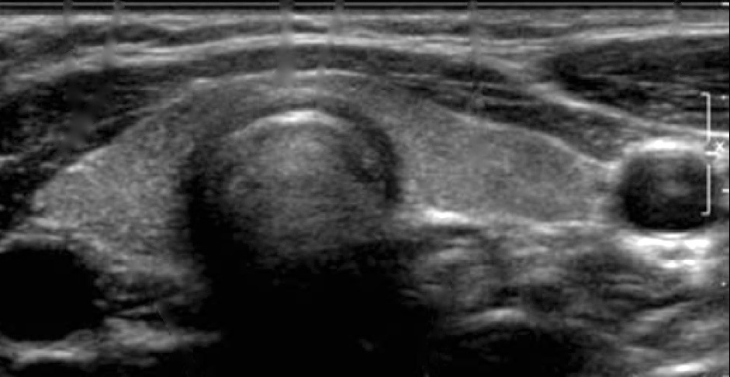

D

E

C

B

A

Total 2.5 marks

Question 2
A 22-year-old male presents to the emergency department with acute severe left sided scrotal pain. The images below are from this patient. Image A is the right testis & image B is the left testis. They have been produced with the same technical settings.

A
B

a) Compare the B-mode sonographic features of both these images. [2 marks]

When colour Doppler was applied the following image was obtained. [Image on next page]

b) Based on the history and the information obtained from the images, what is the most probable diagnosis? Justify your answer. [3 marks]
c) Explain the significance of early diagnosis in the above case. [2 marks]

Total 7 marks

Question 3

The following image is from a 25 year old lady who presents for an evaluation of a painless lump in the right breast.
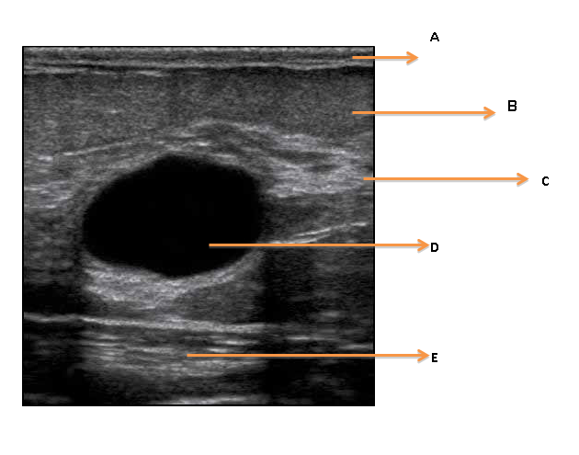

Label the structures A to E as indicated by arrows [0.5 mark each]
Total 2.5 marks

Question 4
A 50-year-old-lady has a breast scan to assess a palpable lump in the right breast. Below is one of the images from her scan.
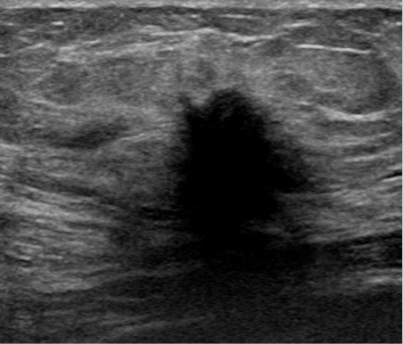
a) What is the most probable diagnosis? [1 mark]
b) Justify your answer by listing 6 abnormal sonographic features in the given image. [3 marks]
c) How would you extend the scan in this case once you have visualised the above pathology. [3 marks]
d]
- What anatomic structures does the “Terminal Ducto-Lobular Unit” [TDLU] consist of?
- Depict the TDLU in a labelled diagram.
- What is the significance of TDLU? [4 marks]
Total 11 marks
Question 5
Below is a B-mode image of a cervical lymph-node.
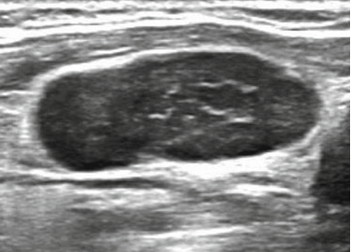
a) Describe any 4 morphological characters that can aid in the characterization of lymph nodes [4 marks]
b) Draw labelled diagrams to represent
- normal lymph node
- malignant lymph node [1.5 marks each]
Total 7 marks
Question 6
A 45-year-old female patient presents for a thyroid scan. The referral mentions decreased TSH, increased T3 and increased T4 levels, weight loss, fatigue and tachycardia.
a) Draw a feedback-loop diagram to demonstrate a basic understanding of the normal regulation of thyroid hormones. [3 marks]
b) What disease process would you expect to find associated with the thyroid based on the clinical details? [1 mark]
c) Describe the B-mode and colour Doppler sonographic appearances. [3 marks]
d) Briefly describe the relevance of the increased levels of T4 and T3 with decreased levels of TSH. [2 marks]
Total 9 marks

Question 7
This image represents a mass in the testis. The patient has no history of trauma or illness.
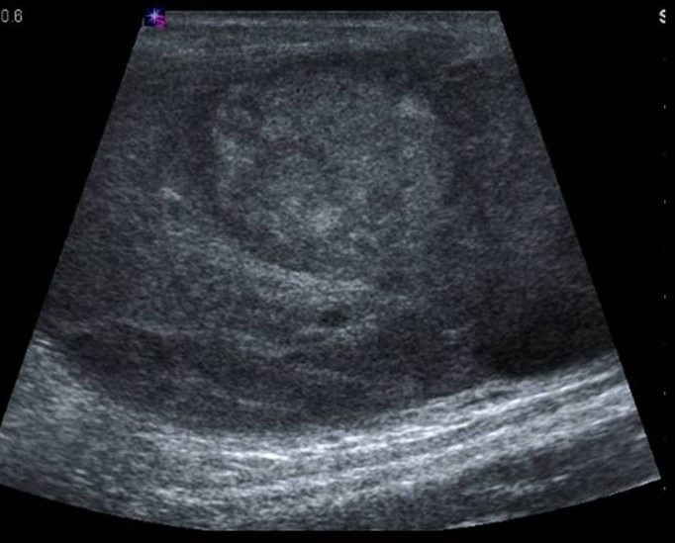

a) Describe the mass [2 marks]
b) Do you think the mass is malignant or benign? Justify your answer? [1.5 marks]
c) What is the most common type of testicular tumour? [1 mark]
d) List any 2 risk factors for testicular tumour. [1 mark]

Total 5.5 marks

Question 8
You have been asked to provide ultrasound guidance for a fine-needle aspiration biopsy of a mass in the thyroid.
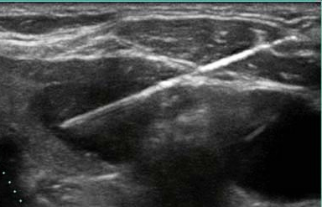

- Comment on the choice of transducer. [1 mark]
- How would you apply “standard precautions” in this scenario? [2 marks]
- Briefly compare FNA vs core-biopsy. [ 2 marks]

Total 5 marks

Question 9
The image below is a from a normal neonatal lower spine sonographic study.
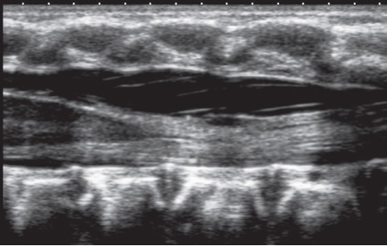A
C
A
E
D
B
A
F

- Label the structures A to F [3 marks]
- Mention any 2 methods to determine the vertebral level in a neonatal spine study. [2 marks]
- Briefly outline the embryological process that leads to focal fusion defect in the spine. [3 marks]

Total 8 marks

Question 10
The images are from an eye ultrasound in the emergency department in a man who sustained ocular trauma in the left eye and experienced sudden visual loss.
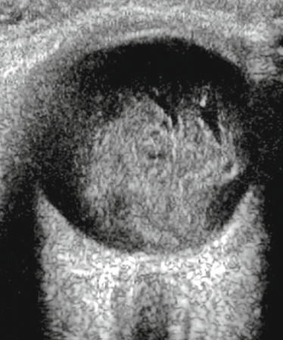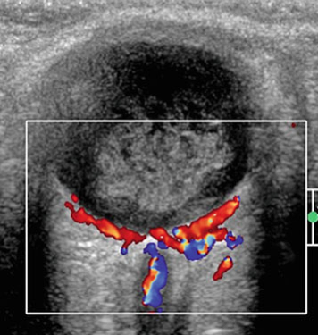
Y
X

a) Describe the images. [2 marks]
b) Mention any 2 possible causes of visual loss in this case? [1 mark]
c) Will the use of colour Doppler add to the information gained? Justify your answer. [2 marks]
d) How would you extend your examination to arrive at a diagnosis in this case? [2 marks]

Total 7 marks

Question 11
The sonograms below represent a coronal section through the brains of 2 infants who present with an acute increase in head circumference. The images demonstrate intracranial bleed.

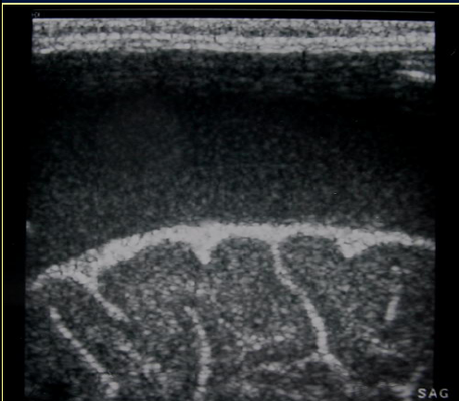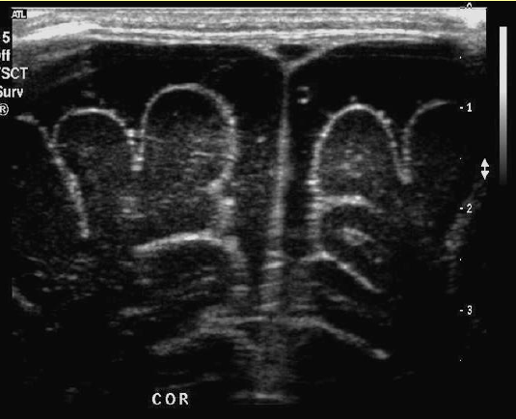
B
A

a) What type of bleed is demonstrated in image A? Justify your answer. [2 marks]
b) What type of bleed is demonstrated in image B? Justify your answer. [2 marks]

Total 4 marks

Question 12
- Briefly describe the normal function of the parathyroid hormone and mention the 2 substances that it controls. [3 marks]
- Which of the parathyroid glands are more likely to be in an ectopic location? [1 mark]
Total 4 marks

Question 13
The sonograms below are from a 30-year old male presenting with pain in the right submandibular region.
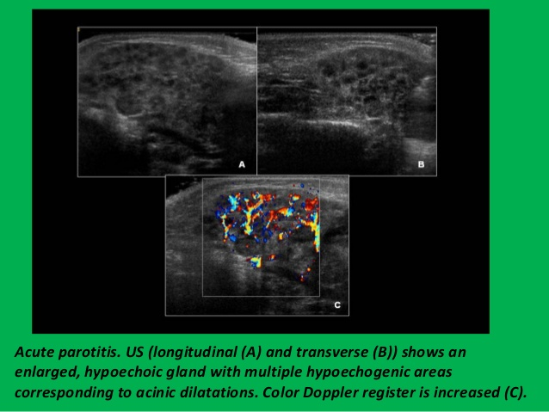
a) Describe the sonographic appearances in the above images [3 marks]
b) What is the most probable diagnosis? [1 mark]
c) Where is the orifice of the Stenson’s duct? [1 mark]
d) Where is the orifice of the Wharton’s duct? [1 mark]

Total 6 marks

Question 14
The following images are depictive of 2 ocular pathologies
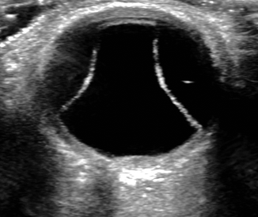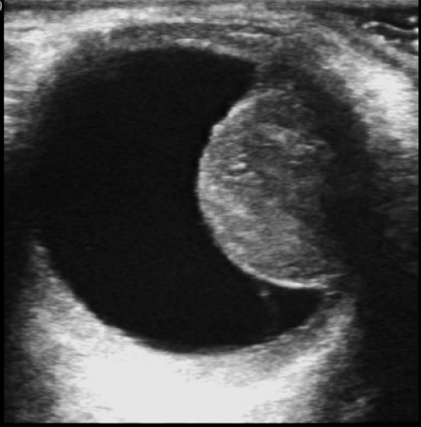

B

A
a) Name the pathology in image A. [1 mark]
b) Name the pathology in image B. [1 mark]
c) Which layer of the eye is involved in the above images? [1 mark]

Total 3 marks

Question 15
- Define the term “developmental dysplasia of the hip” [DDH]. [2 marks]
- At what age is it ideal to schedule an infant for a hip ultrasound examination to rule out DDH? Justify your answer. [2 marks]

Total 4 marks

Question 16
This is a coronal image through the brain of a 7-day old preterm infant.
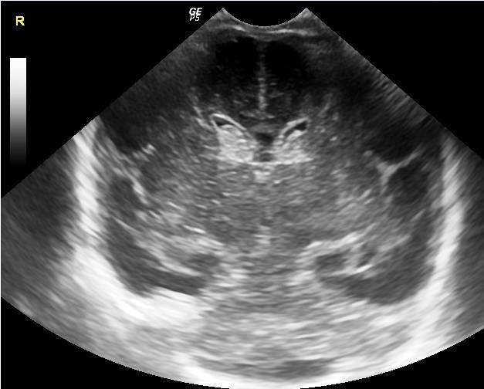

a) Comment on the abnormal sonographic features in this image? [2 marks]
b) What is the likely diagnosis? [1 mark]
c) What clinical history would you specifically elicit from the nurse/parents before the scan in this case? [2 marks]
Total 5 marks

Question 17
a) Define erectile dysfunction. [2 marks]
b) Name the artery that is evaluated for diagnosis of erectile dysfunction. [1 mark]
c) Mention any 2 causes of erectile dysfunction that can be assessed with ultrasound. [1 mark]
Total 4 marks

END OF EXAMINATION

