Sup parts answers
1)
a. Briefly describe the normal function of the Parathyroid Hormone. [1.5 marks]
b. List 2 minerals that is regulated by the parathormone. [0.5 mark]
[Total Marks: 2]
Answer
A. Parathyroid hormone is an important regulator of extracellular calcium concentrations. PTH secretion is stimulated by hypocalcaemia and inhibited when exposed to elevated levels of calcium. In turn, PTH regulates serum calcium concentrations through direct mechanisms in the kidney (enhanced calcium reabsorption and phosphate excretion) as well as in bone (release of mineral from bone). PTH also exerts its effects on calcium metabolism indirectly through vit D metabolism.
B. Calcium and phosphate.

2) A scrotal ultrasound scan of a 29-year-old man shows an intra-testicular mass.
a) Is this considered clinically significant? Justify your response. (2 Marks)
Answer
It is clinically significant.
Any intratesticular mass must be considered malignant, unless otherwise proven.

3) Discuss limitations in diagnosis while scanning dense breasts and how you will overcome some limitations. (2 marks)
Answer
Dense breasts can mask the visualisation of small lesions, which may be early malignancy
Technically difficult to scan.
Try different settings and frequency to achieve a reasonable penetration.

4) a. Which pair of parathyroid glands are more likely to be located within an ectopic location? Why? [1 mark]
b. What are the limitations in visualising normally positioned parathyroid glands using ultrasound? [1 mark]
[Total Marks: 2]
Answer
A. the inferior parathyroid gland pair. Due to embryological descent.
B. Limitations - normally not seen as they can mimic lymphnodes on ultrasound, small, hypoechoic rounded or oval shaped areas. They can also mimic thyroid nodules due to their locations.
5) a. Discuss the embryological basis of cryptorchidism. [3 marks]
b. Mention any two clinical implications of cryptorchidism? [1 mark]
[total marks: 4]
Answer
A. Cryptorchidism: failure of testicular descent into the scrotum.
True undescended testis: where testis is absent from the scrotum but lies along the line of testicular descent
Ectopic testis: where the testis is found away from the normal path of decent
Under normal embryological development the testis descends from the abdomen to the scrotum, pulled by the gubernaculum, within the processes vaginalis. This process is incomplete in the context of true undescended testis; or tracks to an abnormal position in an ectopic testis.
B. testicular malignancy, infertility, torsion, trauma

6) a. What are the imaging planes that need to be documented in a standard neonatal brain scan? [2 marks]
b. What type of transducer is used for neonatal brain scans? [1 mark]
c. Where is the transducer normally placed to scan the neonatal brain? [1 mark]
[Total marks=4]
Answer
a. 5 coronal and 5 sagittal
b high frequency small curvilinear transducer
c. anterior fontanelle
7) With the help of any two examples, explain how dynamic scanning an essential technique is for diagnosing ocular pathology. [4 marks]
Answer
Eye dynamic scanning
Can distinguish between Vitreous hage and Retinal detacment - VH will swirl or have whirlpool appearance with movement of eye. RD will see attachment points still so won't swirl around with eye movement.
With eye movement you can see if a potential mass is mobile or attached to the wall of the eye.
8) You are asked to perform a scrotal ultrasound on your next patient. The referral states that he has been experiencing pain in his left testicle for two weeks.
a) Describe how you would maintain the dignity and privacy of the patient before and during the scan. [2 marks]
b) What transducer would you use for a scrotal scan? How would you optimise the images? [2 marks]
[total marks= 4]
Answer
A. Make sure that the patient has given informed consent, is covered up appropriately, warm gel is used, the procedure is explained to the patient, make sure that they are ok during the scan.
B. High frequency linear array tx - don't need the penetration as is a superficial structure so can use a high frequency. Using a higher frequency will allow for better image resolution and therefore better detail.
9) You are asked to perform a scrotal ultrasound on your next patient. The referral states that he has been experiencing pain in his left testicle for two weeks.
a) Describe how you would maintain the dignity and privacy of the patient before and during the scan. [2 marks]
b) What transducer would you use for a scrotal scan? How would you optimise the images? [2 marks]
[total marks= 4]

Answer
ocular emergencies
a) foreign body, blunt trauma, acute trauma, sudden loss of vision
b) relevant findings depending on answer and implications around vision

10) You have been asked to provide ultrasound guidance for a FNA Biopsy of a Thyroid mass.
a) Prior to commencing the FNA, what are the essential pre-procedure details that you need to check? [1 mark]
b) How would you apply 'standard precautions' in this scenario? [2 marks]
c) Outline any three techniques that would aid in visualising the needle tip. Include ultrasound beam-needle relation and probe manipulation techniques in your answer. [3 marks]
[Total Marks: 6]
Answer
A. Informed consent, make sure correct patient and correct patient details, check what medications they are on, stop blood thinners if taking.
B. PPE, clean hands, wear gloves, sterile environment during FNA procedure, disposal of sharps correctly, use probe cover, sterile gel, thoroughly clean area that needle will enter, ensure area for set up is clean, dispose of waste and linen appropriately.
C. Tip at 90 degrees to beam, make sure probe and needle are 'inline', jiggle needle to see tissue movement, fan probe while keeping needle still if unable to visualise needle tip, steer beam, use special needle visualisation software on machine, make sure needle is on an angle going into tissue, not parallel with skin line.
11) You have been given a referral to scan a 8 week old baby to rule out hip dysplasia. Answer the following questions in relation to this.
a) At what age is it ideal to schedule an infant for a hip ultrasound examination to rule out DDH? Justify your answer. (2 marks)
b) For examining the neonatal hip in the coronal view, the standard sonographic plane is defined by identifying 3 landmarks. Name the 3 landmarks. (3 marks)
c) Name the two clinical tests for screening of DDH and describe how they can be adapted for use in the ultrasound examination of the infant hip. (4 marks)
Answer
A) Between 4 or 6 weeks and 3 months. Under 4 weeks may result in a false positive as the joint may still be lax due to maternal hormones. Over 3 months, the bones start to ossify and this makes the scan harder to do. Also, scanning after this will result in a delay in treatment meaning that more treatment will be required to correct the issue. Anything over 6 months will be radiographed as this is when the bones are too ossified to see the anatomy well with ultrasound.
B) landmarks
a straight iliac line.
the tip of the acetabular labarum; and
the transition from the os ilium to the triradiate cartilage

C) Ortolani and Barlow manoeuvres
Ortolani: abduction of the thigh while the hip is gently externally rotated. if dislocated, the hip may relocate into acetabulum with a palpable and audible clunk.
Barlow: with hip and knee flexed and thigh adducted, posterior push is given to get hip to sublux or dislocate. evaluates hip instability.
12) The below image demonstrates a primary malignant lesion in the parotid gland of the neck (closed white arrow heads).
a) What are the structures that the open arrows are pointing to? Justify your answer [2 marks]
b) Name the view used to obtain the image. [1 mark]
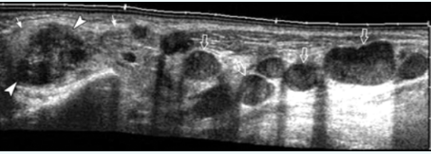
Answer
a) metastatic lymph nodes
b) panoramic
13) A 22-year-old male presented with a persistent dull ache in the left hemi-scrotum. The referral mentioned that a physical examination revealed the 'bag of worms' on the affected side.
a. Describe the ultrasound appearances of both images. [1.5 marks]
b. Given the ultrasound appearances, what is your provisional diagnosis? [0.5 mark]
c. Which side is this finding more commonly found? Give one reason why this can be the case. [2 marks]
d. Name the manoeuvre used to produce Image B. Describe how you would perform the manoeuvre. [2 marks]
[total marks=6]
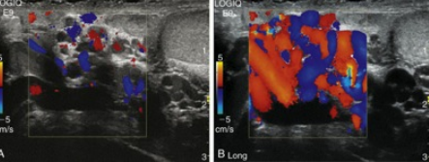
Answer
A. Pampiniform plexus image A and B with colour doppler being used. Image A is at rest, image B is with Valsalva/strain. We see prominent vessels during Valsalva with reflux/retrograde flow going into vessel and they would most likely measure over 4mm in size. Typical 'bag or can of worms' or hypoechoic tubular structures appearance.
B. Varicocele.
C. Varicoceles are more common on the left side for the following reasons:
- the left testicular vein is longer.
- the left testicular vein enters the left renal vein at a right angle.
- the left testicular artery in some men arches over the left renal vein, thereby compressing it
- the descending colon distended with faeces may compress the left testicular vein
D. Valsalva, get patient to push breath out and hold it - like blowing a balloon up or get them to tense their lower abdomen or cough. This straining will place pressure on the lower abdomen and will cause veins to dilate if they are abnormal. Forcibly exhale while keeping the mouth and nose closed.

14) A 6-year-old boy presents with a midline neck mass demonstrated in the image below. The clinical diagnosis was a thyroglossal duct cyst.
a. Briefly describe the embryological basis of the thyroglossal duct cyst. [3 marks]
b. What dynamic technique would you use to confirm the origin of the thyroglossal duct cyst? [1 mark]
c. Describe how you would approach the child and gain their compliance for the scan. [2 marks]
[total marks= 6]
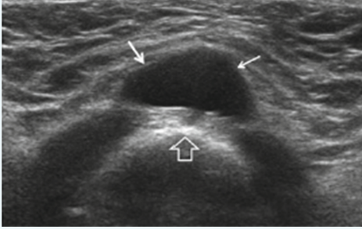
Answer
A. Embryology: Thyroid tissue usually arises from the posterior tongue base and descends down to the thyroid bed along the thyroglossal duct. The thyroglossal duct extends from the foramen caecum in the posterior third of the tongue, along the floor of the mouth down the cricoid cartilage. The duct involutes at around 5-6 week of gestational age. Any segment of the duct that fails to regress and subsequently differentiates into an epithelial-lined cyst with persistent secretory activity results in the formation of a thyroglossal duct cyst.
B. Ask patient to stick tongue out - with protrusion of tongue, should lift cyst up.
C. Hyoid bone.
15) The image below represents a salivary gland from a patient who presented with right sided acute pain on eating. Please answer the questions in the space provided below.
a. Describe the abnormal sonographic appearances in the image. [2 marks]
b. In which of the salivary glands is sialolithiasis most common? Give 2 reasons why. [3 marks]
c. How will you extend this examination? [1 mark]
[total=6 marks]
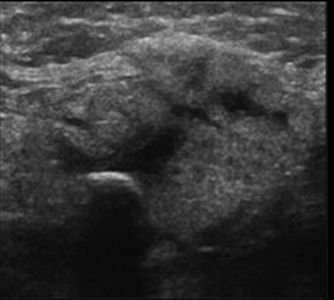
Answer
A] The salivary gland appears hypoechoic, oedematous & heterogeneous with dilated duct. Gland appears globular with rounded margins. A large hyperechoic focus with acoustic shadowing is seen within the duct.
B] Submandibular gland.
- More mucinous saliva of the SMG compared to the watery saliva of parotid
- Wharton’s duct has an ascending course
- Carunculate of Wharton’s duct is tighter than orifice of Stenson’s duct
c) colour, scan contralateral gland
16) Below is a B-mode image of a normal Neonatal Brain.
a. Which imaging plane has been used to produce this image? [0.5 Marks]

b. Label the structures from A to E on the above image. [2.5 Marks]
c. What significant patient history would you elicit from the guardian/parent before beginning a neonatal brain examination? Justify your answer [2 Marks]
d. What is the importance of the caudothalamic groove in relation to neonatal brain pathology? [2 marks]
[Total Marks: 7]
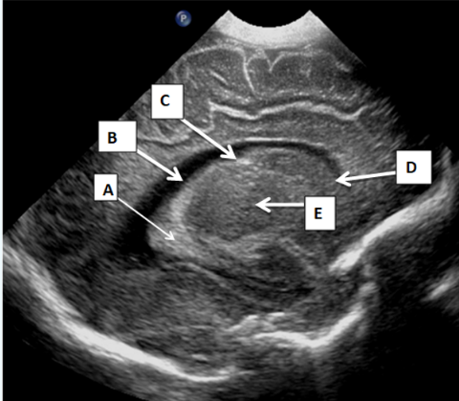
Answer
A) parasagittal imaging plane.
B)
A= CHOROID PLEXUS
B=LATERAL VENTRICLE
C= CAUDOTHALAMIC GROOVE
D=CAUDATE NUCLEUS
E= THALAMUS
C) GA at birth, whether preterm and weight at birth
D) Any echogenicity anterior to the groove indicated IVH
17) The image below is a from a neonatal lower spine sonographic study.
a) Is this a normal view or is it abnormal? [1 mark]
b) Justify your answer by discussing the fundamental sonographic features that you would look for and document in a normal neonatal spine ultrasound? [3 marks]
c) Label the structures shown on the ultrasound image below from A to F. [3 marks] Please type in the text box provided below as A=, B= and so on.
[total marks: 7]
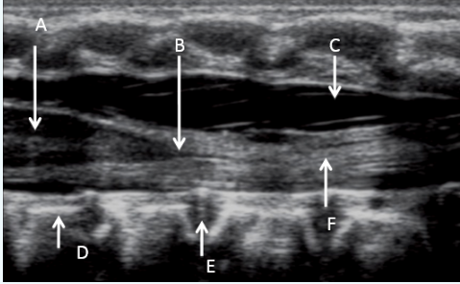
Answer
a) normal
b) Conus Medullaris comes to a nice point and ends at or above the level of L2/3 disc space.
Cord position within the spinal canal and motion of cord and nerve roots – CINE evaluation.
Normal filum thickness of 2mm or less.
Termination of the thecal sac should be at around S2.
Nerve roots of cauda equine should be delineated within the thecal sac.
c)
A - Cord/ central echogenic complex
B - Conus medullaris
C - CSF
D - Vertebral Body
E - Intervertebral disc
F - Filum terminale

18) A 52-year old lady comes in for a thyroid scan. The referral is for the evaluation of goitre and hypothyroidism. This following image represents a longitudinal image of right lobe of the thyroid of this lady.
a) Describe the grey scale sonographic appearances of the gland. [2.5 marks]
b) Give a likely diagnosis based on the history and the image. [1 mark]
c) What do the focal hypoechoic areas represent? [1 mark]
d) How does the autoimmune process affect the feedback loop mechanism in this case? [2.5 marks]
Total 7 marks
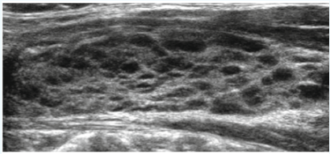
Answer
a) diffuse, coarse, heterogenous echotexture, small multiple hypoechoic nodules, micronodular pattern, separated by linear echogenic fibrous septations
b] Hashimoto’s thyroiditis
c] lymphocytic infiltration
d) autoimmune process. In primary hypothyroidism, the thyroid produces insufficient amounts of T3 and T4, which leads to loss of negative feedback inhibition, and increased production of TSH from the anterior pituitary.
19) A 25-year-old lactating female presents for a breast ultrasound to assess for pain and tenderness in the upper, inner quadrant of the right breast. Below is an image from the ultrasound examination. Please use this image to answer the questions below.
a. Describe the sonographic appearances of the image. [2 marks]
b. What is your probable diagnosis? [1 mark]
c. How would you extend the examination? [2 Marks]
d. List any 4 specific criteria that are recommended to be included in the labelling of a breast mass on an ultrasound examination. [2 marks]
[total marks= 7]
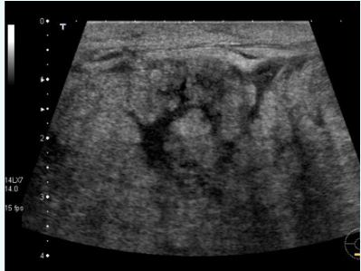
Answer
A) B mode image of the breast with a high frequency, linear transducer with beam steering turned on to increase field of view. The image shows diffuse echogenic inflammatory changes within breast tissue, increased fluid retention within the breast tissue (anechoic parts), and associated skin thickening with possible debris within the fluid.
B) Mastitis or breast abscess
C) We can extend the examination by scanning the axillary lymph nodes - these lymph nodes may be larger and reactive due to the inflammatory changes happening within the breast.
D) When labelling lesions, some characteristics that must be included are:
Side, plane, quadrant, distance from nipple
20) The following images X & Y are depicting 2 nodules from different patients who were referred for a thyroid ultrasound examination.
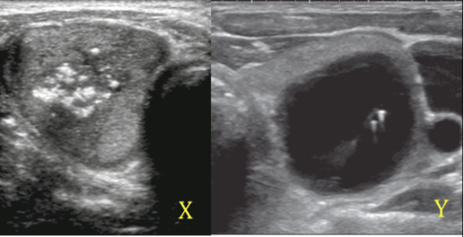
a. Which of the 2 images is more likely to be a benign pathology? [1 mark]
b. Justify your answer to question (a) by comparative description of the sonographic appearances of the nodules in both images. [4 marks]
c. What is the most probable diagnosis for image Y? [1 mark]
d. Elaborate on your understanding of using the TIRADS classification by classifying the nodule shown in image X. [2 Marks].
[total marks: 8]
Answer
a) Y is benign
b) X: hypoechoic, solid, heterogeneous, calcifications, irregular borders
Y: clear anechoic well-defined margins with comet tail artifact
c) colloid nodule
d) for example: Thyroid US showing a markedly hypoechoic solid nodule that is taller than wide and contains punctate microcalcifications. This was assessed as very suspicious for malignancy.
Solid - 2
Echogenicity - hypoechoic - 2
Shape - Taller then wider - 3
Margins - irregular and possibly extending just out of thyroid anterior image - 3
Has macro and punctate calcifications within - 3
Total points awarded: TR 5 - highly suspicious - FNAC recommended.
This was a papillary thyroid cancer.
TIRADS chart to be used
