RADY 5016 Marking - Due May 28TH 11pm SP2 2023

Part B:
CASE STUDY
- Course weighting 20%
- Total Word count – 1500 words

Students have been asked to create a case study presentation and script –BOTH must be loaded into the portal.
Marking will be completed relative to the presentation ONLY, and should the marker need to assess further, they will use your script.
If they DO NOT submit a script, a deduction of 25% overall marks will be applied to your grade.
The presentation must include at least 2 self-acquired vascular images in their case study – AND THEY MUST INCUDE A DOPPLER MODE.
- Script to presentation with references
The work (presentation and script) should be incorporate 3 major headings, the tasks provide will fall into each of these.
- • Pre-Encounter
- • Encounter
- • Post encounter

Assignment tasks:
- Overview of your case study: The Pre encounter 300 words
Present your case study to the reader: who what how and why is your patient presenting to your department. Your response should incorporate the following:
- Details of the ultrasound request form – the type of study being requested.
- What would the protocol be for this type of study where does this standard of practice come from?
- Are there any clinical indicators/ clinical history from your patient that may alert you to pathology or areas of concern?
- Based on this information, what is your expected provisional diagnosis
- Pathology 400 words
- Provide an overview of the pathological process that may lead to the pathology you have been allocated
  - Include aetiology and other relevant information to this pathology (is it genetic or acquired for example)
- Based on this pathology, what sonographic or protocol changes could occur to assist with presenting this pathology.
- Sonographic appearances and examination: The encounter 500 words
You are to consider both the examination and patient when responding to the tasks provided.
  - You are to select a series of images that BEST reflect your findings of this case study – these images should be presented in a logical process to demonstrate to the reader how you have captured relevant information in this case study- You are to use appropriate sonographic language and measurements where relevant when presenting your findings
  - You should indicate if relevant any modifications to protocol and scanning techniques might take place with patients presenting with this pathology?
  - You should include a worksheet, that is legible and clearly demonstrates your findings- if you do not have worksheets in your department, you are to create a worksheet to demonstrate your findings to the reader
  - You are to include a provisional diagnosis of your findings and any recommendations for additional imaging or follow up
- A reflection based- The post encounter review 300 words
Consider the case scenario you have chosen and the research you have conducted – your reflection may incorporate some of the following or be something completely independent – there is NO right or wrong answer, but you need to demonstrate you have considered your responses.
- Did you discover any major gaps in your knowledge in this area of clinical sonography?
- Are there aspects of the clinical examination that you need to think about in more detail to ensure you have a good diagnostic examination for the referring clinician?
- Would a discussion with your patient and obtaining a clinical history assist with this examination?
- Are there any complimentary tests, other imaging or advanced ultrasound techniques that might assist with your patients’ clinical picture?

Practical Marking: Process
- View All submission
- You have your allocation of students in the EXCEL spread sheet
- Click edit – see image below
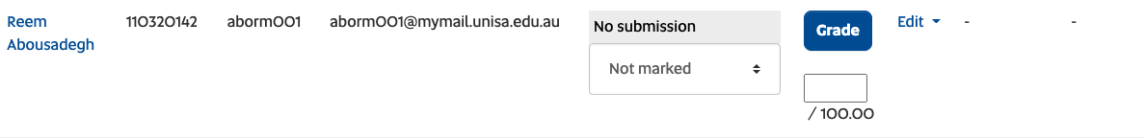
- Check the turn it in AND the AI score- you will see 2 submissions,
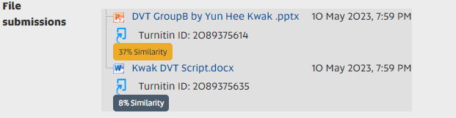

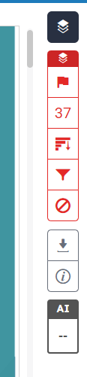 this one is from a power point presentation. compared to word 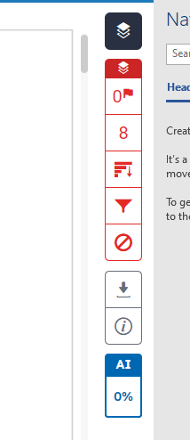

- Download the Presentation – this may be powerpoint or MP4 player – you will allocate a marking rubric to each student
  - Watch the presentation and grade against marking rubric
    - Grading/ marking
    - PowerPoint style 15%
    - Academic integrity (unless they fail then overall grade is fail) 5%
    - Pre encounter - 15%
    - Pathology description 25%
    - Encounter and sonographic appearance 30%
    - Post encounter 10%
Total grade/ 100%

If they have no script -25%
Must have at least 2 least 2 self-acquired vascular images

Common phrases please include
Common phrases – to add when marking papers – many of these themes will be repeated

The purpose of this assignment was for students to demonstrate a logical approach to a vascular scanning scenario – students were provided with a range of scenarios, from which they needed to demonstrate their understanding of a vascular scan in an audible presentation + fully referenced script.
From the moment a patient arrives for a vascular scan, sonographers will be crafting an approach to their scan – for this assignment students would be addressing patient request form, clinical history possible diagnosis to the sonographic features of the scan.
Additionally, students were asked to research a pathology associated with a chosen case study
  - How you would document any pathology discovered in your chosen case study sonographically
- Did you consider your case study and provide a reflection in relation to your interaction with your patient, gaps you recognised in your own study
  - Be able to describe other complimentary tests or imaging that might assist with this type of study
- Appropriate use of referencing for a presentation (APA7 or IEEE or Vancouver) APA 7 for script/

Thank you for your presentation, you have completed the aspects of this paper – well done, and all the best for the rest of your studies.

