O&G Q &A ONLINE EXAM with answers SP2 2023

1) True or False (1 mark)

The appearance of the Mirena in the following image is normal.

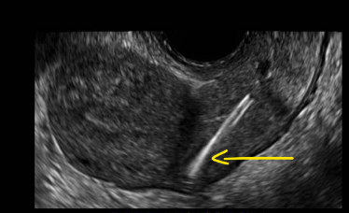

CORRECT ANSWER: FALSE

2) True or False (1 mark)

The gestational age and the EDD should be determined from the last menstrual period (LMP), the first accurate ultrasound examination, or both and documented clearly. Subsequent changes should not be made to the EDD except in rare circumstances.

CORRECT ANSWER: TRUE

3) True or False (1 mark)

In the third trimester, follow-up biometry growth scans should be performed in intervals of less than 14 days.

CORRECT ANSWER: FALSE

4) Below is an image of a fetal face profile at 19 weeks of gestation. Answer the questions below.

a) Comment on the sonographic appearances of the fetal profile. (1 mark)

b) State whether it is normal or abnormal. If abnormal, name the abnormality. (1 mark)

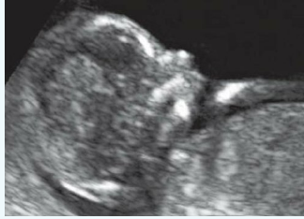

ANSWER
- Chin/ maxilla receded.
- Micrognathia

5) A 38-year-old woman came for a routine first trimester screening scan. The following image was obtained on her trans-abdominal scan.
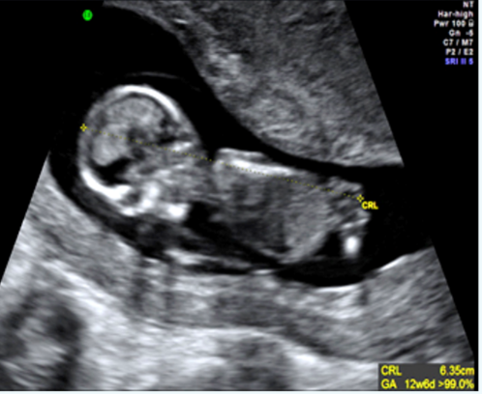

Do you think the CRL has been measured correctly? Justify your answer. If yes, explain why. If no, explain why not. Answer in dot points. (3 marks)

ANSWER

No, incorrectly measured.
Not in mid sagittal plane, fetus rotated, not supine.

6) The following image is from a 57-year-old lady with post-menopausal bleeding. Read the questions below the image and answer in the space provided.

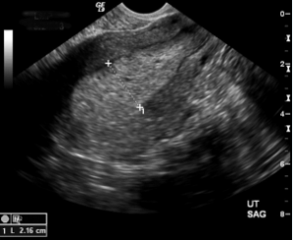
a) Comment on the sonographic appearances of the endometrium (2 marks)

b) List any two conditions that would cause this appearance (1 mark)

ANSWER

- Endometrium very thick with multiple tiny cystic spaces within
- Hyperplasia, malignancy, polyp, tamoxifen therapy

7) A lady presents for a dating scan of her first pregnancy. She gives a history of couple of episodes of spotting. Mean sac diameter measures 23mm on transvaginal imaging. Fetal pole is not identified. Answer the following question in the space provided below

a) What would be the protocol for management of this case as per the early fetal demise guidelines? (3 marks)

ANSWER

ASUM guidelines for sonographic diagnosis of early fetal demise:
• CRL ≥ 7mm with no fetal heartbeat
• MSD ≥ 25mm with no visible fetal pole
If the above criteria are not met, follow up imaging is required with the following criteria for early fetal demise:
Still no visible fetal pole with cardiac activity after 7 days if MSD was initially >12mm (but <25mm)
• Still no visible fetal pole with cardiac activity and MSD has not doubled after 14 days if MSD was initially <12mm

8) You are examining the head at a 20 week morphology scan.

a) Look the image below and comment on whether the appearances of the cerebellum are normal or abnormal. Justify your answer (1.5 marks)

b) How will you extend the scan? (1.5 marks)

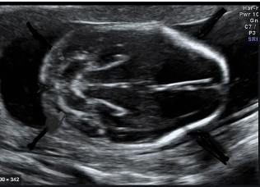

ANSWER

a) abnormal, banana shaped (or a description)
b) scan the rest of the head, post fossa, and entire spine, scan for Arnold Chiari malformation 2

9) The following axial image of the thorax was obtained during a morphology scan.

a) Identify the abnormal sonographic features in this image. (2 marks)

b) Mention the most probable diagnosis. (1 mark)

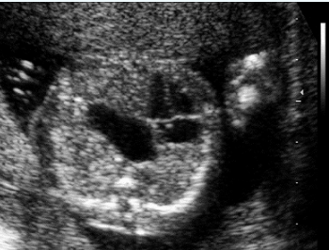
ANSWER

a) an anechoic are posterior to the heart and pushing the heart to the periphery
b) Congenital diaphragmatic hernia

10) What is the importance of a scout scan while doing the 20-week fetal morphology? In other words, what are all the structures you are assessing while doing a scout scan and why? Please elaborate in the space provided below. (3 marks)

ANSWER

Scout scan (It is important to get an idea of the following points early in the scan which is why a scout scan should be performed):

Check fetal heartbeat
Number of fetuses
Lie and presentation
Amniotic fluid/liquor
Placenta: placental location, placental thickness, accessory lobes, echo lucencies, masses, calcifications, signs of abruption, placental cord insertion, distance from inferior margin of placenta to internal os
Maternal structures (Uterus Long Lt>Rt, the fundus of the uterus needs to be documented and the position and measurements of any fibroids, assess the adnexae for any cysts, masses or lymph nodes)
Cervix (B-mode and colour) - Ensure cervix is closed and not shortened (<30mm = cervical incompetence), measured from internal to external os (TV most accurate), use colour Doppler to identify blood vessels crossing the internal os.

11) Below is an image showing the mid-sagittal plane of a 12-week fetus.

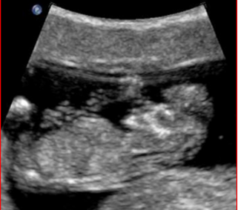
a) Comment on the abnormal sonographic appearances. (1.5 marks)

b) What other images would you document to confirm the abnormality. (1 mark)

c) Name the most probable diagnosis. (0.5 mark)

ANSWER

- Sagittal B mode image, Cranium not seen, brain tissue appears to be free floating in the amniotic fluid
- Axial and coronal images
- Anencephaly/ acrania

Q12) Label the structures of the fetal heart labelled 1 to 8. Use the space provided below and label the corresponding structures mentioning the numbers. (0.5 mark each; total 4 marks)
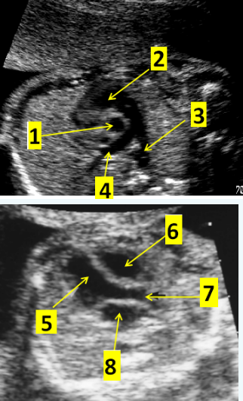

ANSWER

Heart Labelling
1= Aorta
2= RVOT
3 = Pulm artery
4= Rt PA

5= LV
6= RV
7= LVOT or Aorta
8=LA

Q 13)
The image is from an early dating scan.
a) What is the arrow pointing to?
b) Is this normal or abnormal for the GA?
c) Justify your answer
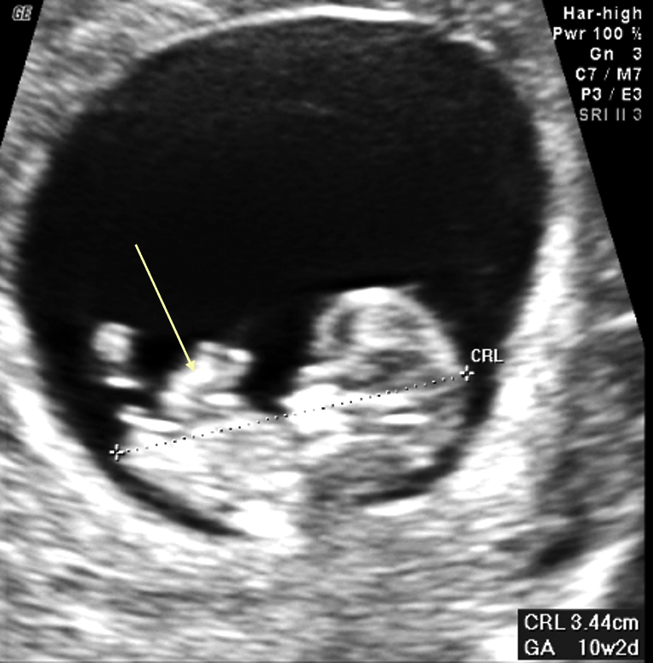
ANSWER

a) herniated bowel loop
b) normal at 10 weeks
c) physiological gut herniation, should resolve by 12-14 weeks

Q14) Below is an image of the lower extremity taken at a 20-week morphology scan.
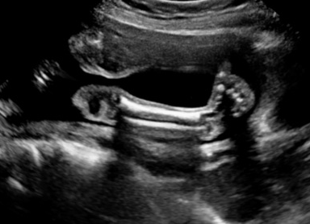

a) Describe the appearances of the lower limb and the foot
b) What is the most probable diagnosis?
c) Describe the normal protocol for scanning lower extremities.

ANSWER

a. in the image, we can see an AP view of the tibia and fibula. The foot appears rotated with heel inversion.

b. Congenital talipes or club foot

c. On this image we see the whole foot in AP tibia/fibula image which is abnormal as we should only see an AP ankle in this view. In a normal image, the foot should only be viewed in its length once we turn 90 then from the AP tib/fib projection.

15) 1) As a sonographer trainee, what is your spiel for obtaining appropriate consent from a lady for a trans-vaginal ultrasound examination? (2 marks)

2) As a sonographer trainee, what is your understanding of the implications of not obtaining appropriate consent from a lady for a trans-vaginal ultrasound examination? (2 marks)

ANSWER

patients are given a consent form for transvaginal scanning to read upon arrival. The sonographer/trainee then discusses the transvaginal examination with the patient when they are in the ultrasound room. This ensures privacy and a chance for the patient to ask any questions.

explain to the patient that all sexually active women presenting for a pelvic ultrasound are offered two types of scans - the transabdominal (across the tummy) and the transvaginal (internal scan). The transvaginal scan involves placing a camera into the vagina and allows us to see the organs in a different way that can help with diagnosis. The camera is gently moved from left to right and up and down during the examination. The procedure takes 10-15mins. It should not be painful. At any stage if you wish to stop the scan, you can stop, just let me know. The transvaginal scan is performed with an empty bladder.

A consent form must be signed by the patient which includes asking if they are allergic to latex and some other information about their gynaecologic history (e.g. LMP, previous pregnancies, previous pelvic surgeries).

b) Consenting and communication is vital in our profession. With any scans we are touching a patient’s body and consent is required. Clearly communicating to the patient how and why a vaginal scan is required, the time it will take and that the patient can stop at any point, allows the patient to have autonomy in their health.
Sonographers who do not have consent may be liable to legal or disciplinary action. Patients have a right to access appropriate, safe, and high-quality care and to receive services that respect the patient’s individual circumstances and background. They also have the right to participate in the decision-making concerning their health. Effective communication is essential to avoid inadvertent emotional and physical harm to patients. It is important to ensure the patient understands the purpose and scope of an examination and that informed consent is obtained before proceeding.

17) You have been given a referral for a growth scan and to assess the amniotic fluid volume.

a) What are the two ways to assess the quantity of amniotic fluid? (1 mark)

b) In terms of diagnostic assessment of amniotic fluid, discuss the protocol and the technique of amniotic fluid assessment. (2 marks)

c) What are any two fetal causes for oligohydramnios? (1 mark)

d) What are any two fetal causes for polyhydramnios? (1 mark)

ANSWER

a) AFI 4 quadrant and deepest pocket
b) transducer position, at least 1 cm of free fluid either side and no vessels or fetal parts
c) fetal anomalies, renal agenesis, Potters syndrome,
d) fetal anaemia, multiple gestation, anomalies, duodenal atresia, oesophageal atresia

18) The below image was documented by a sonographer as a normal four-chamber heart in a morphology scan. Answer the below questions.
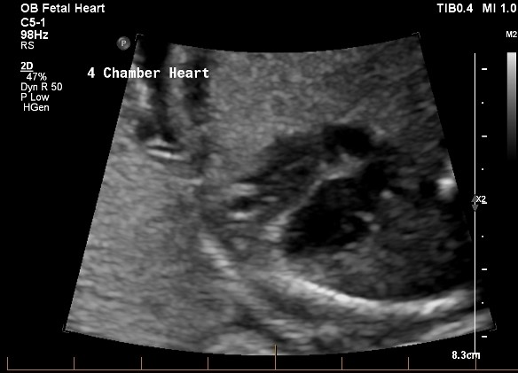
a) Would you document this image as an optimal view of the four-chamber heart? Comment on the technical and diagnostic quality of the image. (2 marks)

b) Discuss the sonographic features that must be present on an image for obtaining an optimal four-chamber view of the fetal heart. (4 marks)

ANSWER

a) This is not an optimal view of the 4-chamber heart.
- The B-mode image of the heart is too magnified, that the spine is not seen in this image. There is loss of significant details in the image.
- The spine could help determine if the heart is in the correct position.
- The heart is almost occupying almost half of the image.
b) Sonographic features:
- Ventricles and atria are evenly sized
- The cardiac axis with apex at 45-degree angle to the left should be seen
- The foramen ovale is a gap in the atrial septum with a prominent flap in the left atrium
- Colour Doppler should be applied to show flow from right to left through the foramen ovale
- With Colour Doppler, blood flow is seen directed from the atria to the ventricles
- The overall 4 chamber heart view should occupy approximately 1/3 of the chest size
- Whole axial chest should be seen with the spine as well

Technical features:

Consider fetal lie to ensure correct situs (left)
Use a cardiac pre-set.
Narrow FOV
High contrast
Low persistence

19) You have been given a referral for a third trimester growth scan and umbilical artery Doppler. It states, "to rule out increased vascular resistance in the umbilical artery". Demonstrate your understanding of this statement by answering the below questions.

a) Discuss the significance of waveforms in interpreting the umbilical artery Doppler by providing explanations for normal and abnormal waveforms. (4 marks)

b) Mention any two challenges with obtaining the umbilical artery Doppler waveform? (1 mark)

c) How will you overcome these challenges? (1 mark)

ANSWER

a)
- At a growth scan, we assess the umbilical artery with spectral Doppler. The spectral Doppler trace reflects the resistance in the placenta.
- We look at the waveform and the Pulsatility index (PI) reading which is used to assess the placental circulation.
- Normal low resistance waveform and normal PI reading indicates placental sufficiency.
- Abnormal high resistance waveform and high PI reading is a marker for placental insufficiency. Can lead to IUGR.
b)
- Low resistance Doppler waveform
- There is no flow reversal seen.
- Indicates that the placenta is a low resistance bed, and deoxygenated blood is constantly moving to the placenta in systole and diastole.
- Indicates placental sufficiency.

Limitations would be body habitus, incorrect technique, incorrect machine settings etc.

20) You have been given a referral for a dating scan with a request for confirming viability and gestational age. The lady is unsure of her last menstrual date. On scanning you realise that it is a twin gestation in the first trimester.

a) Mention the three types of twins that can be distinguished on ultrasound (1 mark)

b) Discuss the sonographic features of the three types of twins that can be documented based on chorionicity and amnionicity. (2 marks each)

Total marks: 7

ANSWER

Viability of both embryos should be ensured as well as both of their CRLs documented and compared to ensure adequate/ equal growth. If the LMP and CRL are discordant, then the CRL of the largest twin is used to obtain the new estimated due date.

- The chorionicity and amnionicity must be determined.

Diamniotic/dichorionic gestations have two gestational sacs with a thick dividing membrane seen known as the 'lambda sign'. Within both gestational sacs are a yolk sac and an embryo.
Diamniotic/monochorionic gestations have one gestational sac but two separate yolk sacs and amniotic sacs with a thin dividing membrane with a characteristic 'T' configuration.
Monoamniotic/monochorionic gestations have a single gestational sac, single yolk sac and single amniotic sac but two embryos. No dividing membrane is present.
Conjoined twins have the same characteristics as mono/mono twins, but the embryos are fused.

The twins should be labelled 'Twin A' and 'Twin B' and the rule for this is that 'Twin A' is the leading twin, which means the gestational sac which is closer to the internal os. However, to ensure that the Twin A and Twin B labelling is consistent, their relation to the membranes must be noted as otherwise Twin A, on a follow up scan can become Twin B which can lead to confusion while monitoring the growth.
- Once this is defined, the positions of the twins in the uterus should be documented, for example, 'Twin A' is to the maternal right/left, 'Twin B' is to the opposite side; 'Twin A' is inferior and 'Twin B' is superior.

21) The following image represents an abnormality of the fetal face as identified on a coronal view in a morphology scan. Answer the questions in the space provided below.

a. Identify the abnormal feature in this image. (1 mark)

b. What other adjoining structural abnormality will you look for in this fetus? (1 mark)

c. What are the technical difficulties in obtaining the necessary views to rule out the involved abnormality? (2 marks)

d. What are clinical implications of this finding either as an isolated or combined anomaly? Justify your answer. (3 marks)
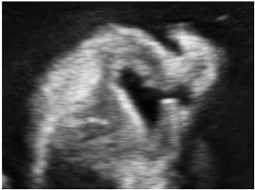

ANSWER

- Cleft lip (unilateral)
- Cleft palate
- In cases of isolated cleft palate, diagnosis can be missed, technically challenging and experience required, coronal views need experience
- Speech, feeding issues and appearance

22) You are obtaining the biometry measurements in a morphology scan.

a) Mention the landmarks and the criteria for obtaining an abdominal circumference (AC). (1 mark)

b) What are the limitations in obtaining an appropriate AC? (2 marks)

c) Discuss how you will overcome these limitations. (2 marks)

d) What could an abnormally small or large AC indicate? Justify your answer. (2 marks)

ANSWER

- Stomach bubble, aorta, single rib, umbilical vein, no kidneys
- Fetus position, maternal habitus, stomach emptying, experience, rib shadowing.
- ideally spine at 3 or 9 o clock, move patient around, scan after a break.
- Small = IUGR, large =macrosomia

Q23) The following image is from the spine series at a 20-week morphology scan.

a) Comment on the technical and diagnostic aspects of the above image in terms of ruling out spinal anomalies. (2 marks)

b) How would you improve the technique to appropriately evaluate the fetal spine? (2 marks)
c) Describe sonographic features of any 2 abnormalities seen at 20 weeks scan
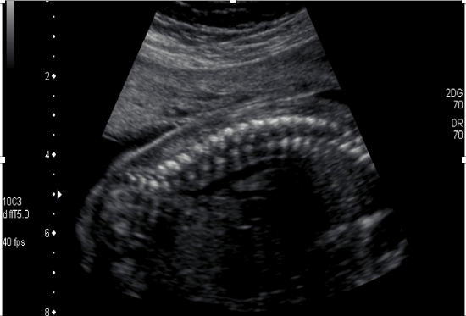

ANSWER

a) Sagittal is a view to assess the skin line. Technically it is difficult to assess the overlying skin line as the fetus is against the uterine wall- this makes it difficult to diagnose spina bifida as unable to see skin defects.

b) To improve the technique the spine should be imaged away from the wall with clear view of the skin margins- need to assess that there is a uniform intact posterior skin edge

The fetus is prone which is an ideal position to assess the spine and can see the sacrococcygeal tapering of the spine. The vertebral bodies and spinous processes are seen aligned from thoracic to sacral spine indicating a good sagittal position.

either reduce probe pressure or roll patient to hopefully allow amniotic fluid to fill the space between the thoracic skin edge and the placenta. If this didn't work, it would be necessary to wait for the fetus to move to allow proper visualisation.

Also, good that this is at 20 weeks- any earlier than 19 weeks the distal spine may not be ossified

c) Main features seen in any 2 abnormalities at morphology scan:

Spina bifida seen as splaying of the lateral processes, defect in the skin line, herniation of spinal fluid/nerves through a sac (myelomeningocele)

Sacrococcygeal teratoma: tumor of the sacral region seen as large complex mass attached to the coccyx

