OSCE VIDEO FEEDBACK

- Abdominal Imaging
  - The video scan was well done. The real patient was clearly a challenge with their pathologies and from the description you gave and the images obtained you did well with this.

- Vascular Imaging
  - This was a thorough scan well done
- Small Parts imaging
  - An intimate examination therefore based on reflection and Images provided

- Gynae imaging
  - Examiners comments
  - Films only,
  - Think this was an emergency presentation
  - Patient scanned TA no full bladder – this was mentioned in reflection
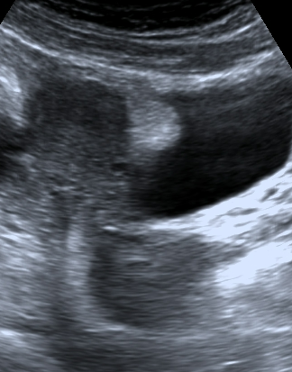
  - No mention of last LMP in relation to this scan,
  - There was a concern for R adnexa – considering the concern for possible ectopic I would have liked to see more information either in the reflection OR in the images
  - This is suppose to be a demonstration of the best scanning
  - Borderline study – not a good representation of a pelvic scan for a ? ectopic, this student should have scanned patient with a full bladder

- Obs imaging
  - Examiners comments
  - Well done this appeared to be little challenging (38 weeks) and you were kind to your patient
  - The submission demonstrated a good knowledge of clinical application and the student demonstrated that they are at a competent level for this scan. Well done.

- MSK imaging
  - Examiners comments
  - Appeared to have a good understanding of the anatomy of all the areas listed throughout the scan as could explain them well and used the correct terminology.
  - Struggled at times to get the area and moved a lot with the transducer going back and forth but recognized when was in the correct location and would then visualize the anatomy adequately.
  - Measured areas correctly when required.
  - Perhaps has not done many of these in the clinical setting and needs to develop confidence with more practice of this scan.
  - This was a good submission where the student demonstrated that they are at a competent but still developing level for this scan. This will improve quickly with more experience in this area.

