Case Scenario
Introduction
In the examination of breasts, cysts are the most frequent encountered breast condition and are normally asymptomatic and identified by accident in performing ultrasound examinations (Athanasioua et al 2014, p.169). In the identification of lesions in the breast a wide range of diagnosis such as benign lesions to high risk or atypical lesions or even malignant lesions are possible. Cysts are classified as lesions when identified they need to be described and classified as malignancy rate range from 23 to 31% (Athanasioua et al 2014, p.178). The diagnosis of 2.3 million women in Breast cancer recorded globally in 2020 makes it the most common cancer (Mridha et al 2021, p.1). Therefore the early and accurate detection of breast cancer plays a critical role in improving the prognosis and bringing the patient survival rate to 50% (Mridha et al 2021, p.1).
The case scenario is of a 48 year old woman who presented with bilateral breast tenderness. The aim of this case scenario is to attain knowledge on benign and malignant breast pathologies, scanning technique, the equipment settings used for breast imaging, patient preparations and aftercare, anatomy of the breast together with the ultrasound appearances and the differential diagnoses of breast pathology.
Case description
A 48 years old female patient went to see the referral doctor due to tenderness of both breasts that began in July 2020. The patient reported that both breasts are often tender with the right breast more painful around the nipple area. No lumps were identified during physical examination of patient X, no breast discharge was noted and the overlying skin appeared normal. Patient X’s last menstrual cycle was mid-July and her cycle is usually regular. Patient X is currently on oral contraceptives; she does not take any hormonal treatment but is currently on hypertension medication. Patient X has a strong family history of cervical cancer. Her maternal grandmother was diagnosed with cervical cancer at the age of 50-55. No blood tests or other relevant clinical examinations were requested by the referral doctor except for the mammogram. Patient X does not smoke but consumes alcohol.
Discussion
Considering the patient signs and symptoms together with her family history, differential diagnoses may include:
Simple cyst
A cyst is defined in ultrasound as simple when it is round or oval, circumscribed anechoic mass with a thin imperceptible wall Simple cysts may have a single thin septation Posterior acoustic enhancement should also be present, although this feature may be minimised if spatial compounding is used (Parsian et al 2011, p.35-36). If a cyst identified on ultrasound meets all of these criteria for a simple cyst it is considered benign on the other hand when a cystic appearing mass does not meet the strict criteria for a simple cyst, it is considered a complicated cyst (IAME 2018). The diagnostic accuracy of a simple cyst evaluated with ultrasound is nearly 100% (1-3) (IAME 2018).
Fibroadenomas
According to Lumturije et al (2009, p.174) fibreadenomas are benign tumors commonly found in the female breast in women before the age of 30. Fibroadenoma is a mixture of stromal and epithelial tissue. In simple terms, in fibroadenomas there are epithelial cells arranged in a fibrous stroma. Fibroadenomas are generally considered benign and they have been associated with increased risk of breast cancer in complex fibroadenomas. It is among those with proliferative disease and when there is a relevant family history of the patients with fibroadenomas ( Aydin et al 2015, p.195). Fibroadenoma gradually grows up to two to three centimeter in size (Gupta et al 2019, p.136). It may be accompanied with fibrocystic changes namely apocrine metaplasia, cysts and papillary apocrine changes). In rare instances, lobular and ductal non- invasive and invasive carcinoma may occur with fibrodenomas (Lumturije et al 2009. P.174). With the help of ultrasound fibroadenomas can be diagnosed however there are no medicines to decrease lumps. This can only be achieved by surgical excision (Gupta et al 2019, p.140).
Invasive Ductal Carcinoma
The development of invasive carcinoma is observed generally to develop in females over the age of 40. According to Knipe & Radswiki (2015), Invasive ductal carcinoma (IDC); also known as ductal carcinoma in situ (DCIS), refers to breast carcinoma limited to ducts with no extension beyond the basement membranes as a result of which the disease has not infiltrated the parenchyma of the breast and lymphatic system and therefore cannot metastasize. Invasive carcinoma can hold onto the fibroadenomas itself by originating from neighbouring breast tissue. The epithelial component can develop into a carcinoma in situ that develops within the fibroadenomas (Aydin et al 2015, p.195). The development of carcinoma in situ within fibroadenomas has been confirmed by Ma Nukyan et al (2012, p.204-205). The transformation of malignancy in fibroadenomas is considered rare, the highest risk have been identified in complex fibroadenomas. An increased risk of cancer of 1.89 times in complex fibroadenoma was identified when compared to the simple ones (Dupont et al 1994, p.10-11).
Invasive Lobular Carcinoma
According to Reed et al (2015, p.1) Invasive lobular carcinoma (ILC) of the breast is the most common ‘special’ morphological subtype of breast cancer and constitute approprimately 15% of all cases (Read et al 2015, p.1). This type of tumour can be difficult to detect by screening, invasive in nature and has a propensity for widespread metastatic colonisation. Therefore clinicians face countless challenges in its diagnosis and long term management in patients (Reed et al 2015, p.1.) ILC occurs in breast lobules with the word invasive meaning cancer has spread to other areas from the point of origin. ILC is the second most common type of breast cancer affecting about 10 % of people meaning at least 30% - 50 % of patients will develop a second primary in the same or opposite breast within 20 years (Roth 2014). ILC is relatively a slow growing cancer treatments such as lumpectomy chemotherapy or radiation are the various treatment options offered to patients that may increase the chances of full recovery. This is however highly dependent on whether the stages of the cancer are manageable (Roth 2014).
Mammogram findings
The patient X through the suggestion of their referral doctor underwent a mammogram. The mammogram findings show that a simple cyst was identified at the right side of the breast. In Figure 1 is below is an image of the breast structure with a cyst.
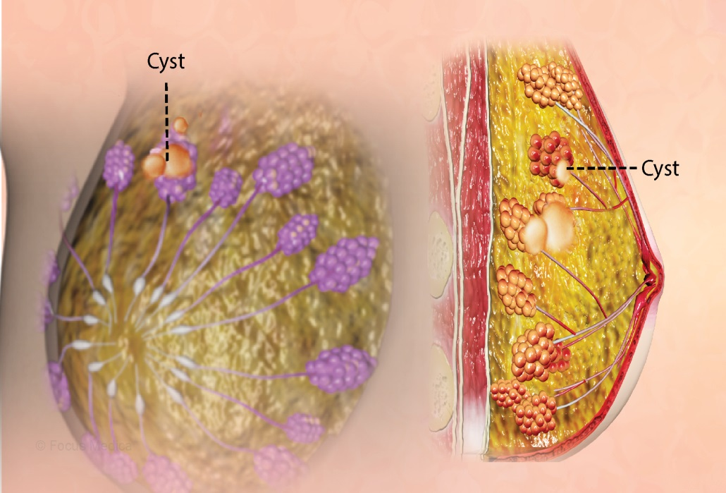
Image by https://www.msn.com/en-za/health/condition/breast+cysts?ocid=entnewsntp.
In Figure 2 below is the mammographic image of a simple cyst.
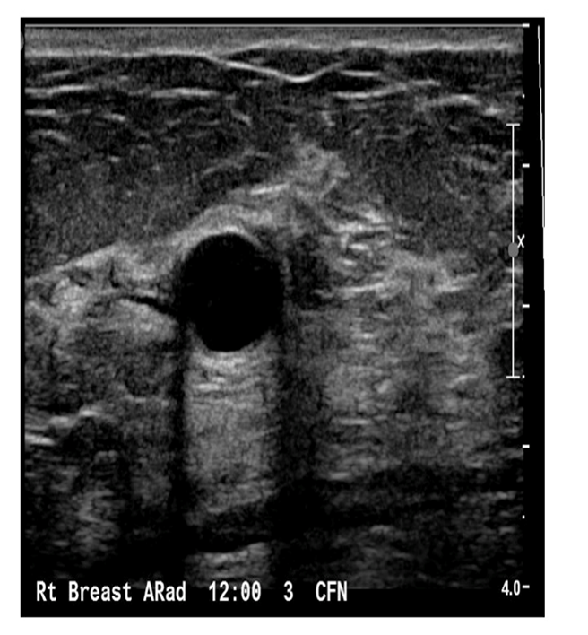
Image by IAME. https://www.iame.com/course/1000/print
Scanning Technique and Findings
Patient X from the mammogram continued to have further imaging using ultrasound. The reason for an ultrasound examination was explained to the patient (breast ultrasound is generally performed to further evaluate the mammographic and clinical findings and obtain additional clinical history while she lay on the ultrasound table (Stavros 2004, p.774). Patient was asked to lie supine in a rolled oblique position; this reduces the thickness of the breast in the area being scanned. It is useful for scanning the upper outer quadrants. To achieve the supine oblique position the patient was rolled 45 degrees onto her side away from the side being scanned. To maintain the oblique position, a wedge sponge was placed under the patient’s side. Patient X was scanned using the radial scan plane which is a wagon wheel pattern that keeps the nipple at the center. Patient X radial plane was annotated according to the position within a clock face parallel to the ductal system. An anti- radial scan plane was performed on both breasts oriented at 90 degrees to the radial plane. The anti-radial plane was at right angles to the ductal system. Transverse and longitudinal images were taken of both breasts. In the radial and anti-radial images were captured at position 12 o'clock, 9 o'clock, 6 o'clock and 3 o'clock. Further radial images were taken in between the above clock positions at 10 o'clock, 7 o'clock, 4 o'clock and 1 o'clock. In undertaking longitudinal and transverse images the axilla was taken over the nipple. Pathologies identified were imaged in the radial and anti- radial planes including the longitudinal and traverse planes and that was dependent on the longest axis of the pathology. The pathologies identified were measured in three dimensions according to their height length and width. The color power and spectral Doppler images of the pathology identified were taken. In order to enhance the margin of the lesion, vocal fremitus technique using the power Doppler was used.
The longitudinal and transverse images of the right and left breast were taken according to the following quadrants:
  - right upper outer quadrant (RUOQ)
  - right upper inner quadrant (RUIQ)
  - right lower outer quadrant (RLOQ)
  - right lower inner quadrant (RLIQ
  - left upper outer quadrant (LUOQ)
  - left upper inner quadrant (LUIQ)
  - left lower outer quadrant (LLOQ)
  - left lower inner quadrant (LLIQ)
The images in longitudinal and transverse of the axilla were taken including images over the nipple. In the same manner the pathologies identified were imaged in the radial and anti-radial planes. The length height and width measurements of the pathologies were taken on the longest axis of the pathology. In enhancing the margin of lesions identified, vocal fremitus technique was used this was preceded first by taking the color power and spectral Doppler images of the pathology. In the breast examination undertaken on Patient X, the abnormalities identified on the mammogram required a targeted breast examination to get further images of the breast area. The use of radial and anti- radial breast examinations was performed including the measurements of the pathology in the length width and height dimensions. The vocal fremitus technique was used in order to enhance the margin of the lesions identified.
Findings
Upon scanning the right breast of Patient X the following observations were identified:
The skin was imaged as the most anterior structure appearing as an echogenic line. Sanders & Winter (2007, p.266) state that the skin in most instances 2mm thick. The subcutaneous fat appeared posterior to the skin as low level of echoes with hyperechoic margins. The mammary layer which consists of 15 to 20 lobes appeared as low level of echoes combined with areas of high echogenicity; the intra lobular connective tissue (Stavros 2004, p.775). Fat lobules connective tissue and the pectoralis appeared to the posterior of the parenchymal layer. The fat lobules appeared as low levels of echoes with the connective tissue seen as hyperechoic bands and the pectoralis muscles appearing as low echogenicity running deep in the breast above the ribs and parallel to the skin (Stavros 2004, p.778-779). The appearance of the nipple was lateral on the image appearing as low echogenic oval structure creating a posterior acoustic shadowing on the longitudinal section. The lactiferous ducts seen as anechoic small structures were medial to the nipple. Copper’s ligaments looked hyperechioc as bands coursing through the subcutaneous fat with ribs seen as highly attenuating structures interposed by the intercostal muscles. In the observation of the image, an oval lymph node with a hypoechoic outline and echogenic center was identified on the right axilla (Stavros 2004, p.778). The identified lymph node measured 1.06cm in length and 0.61cm in diameter. Ahuja and Ying (2002, p.1692) state that for a lymph node to be classified as normal it must appear oval with hypoechoic outlines and echogenic hilus that is continuous with adjacent soft tissue. In that regard, according to Patients X’s imaging of the right breast, no obvious spiculations or lesions were identifiable in conjunction with the right axilla as suggested by the Radiologist.
A small simple cystic lesion was found on the left breast demonstrated at the 9 o’clock position measuring approximately 0.4cm x 0.4cm. This can be in keeping with early fibrocystic changes of the breast tissue. Normally retro areolar tissue was noted and no axillary lymph adenopathy was detected. An annual follow up ultrasound of the breasts is recommended for future evaluation. See Figure 3, 4 and 5 below are mammogram images of left breast with simple cyst.
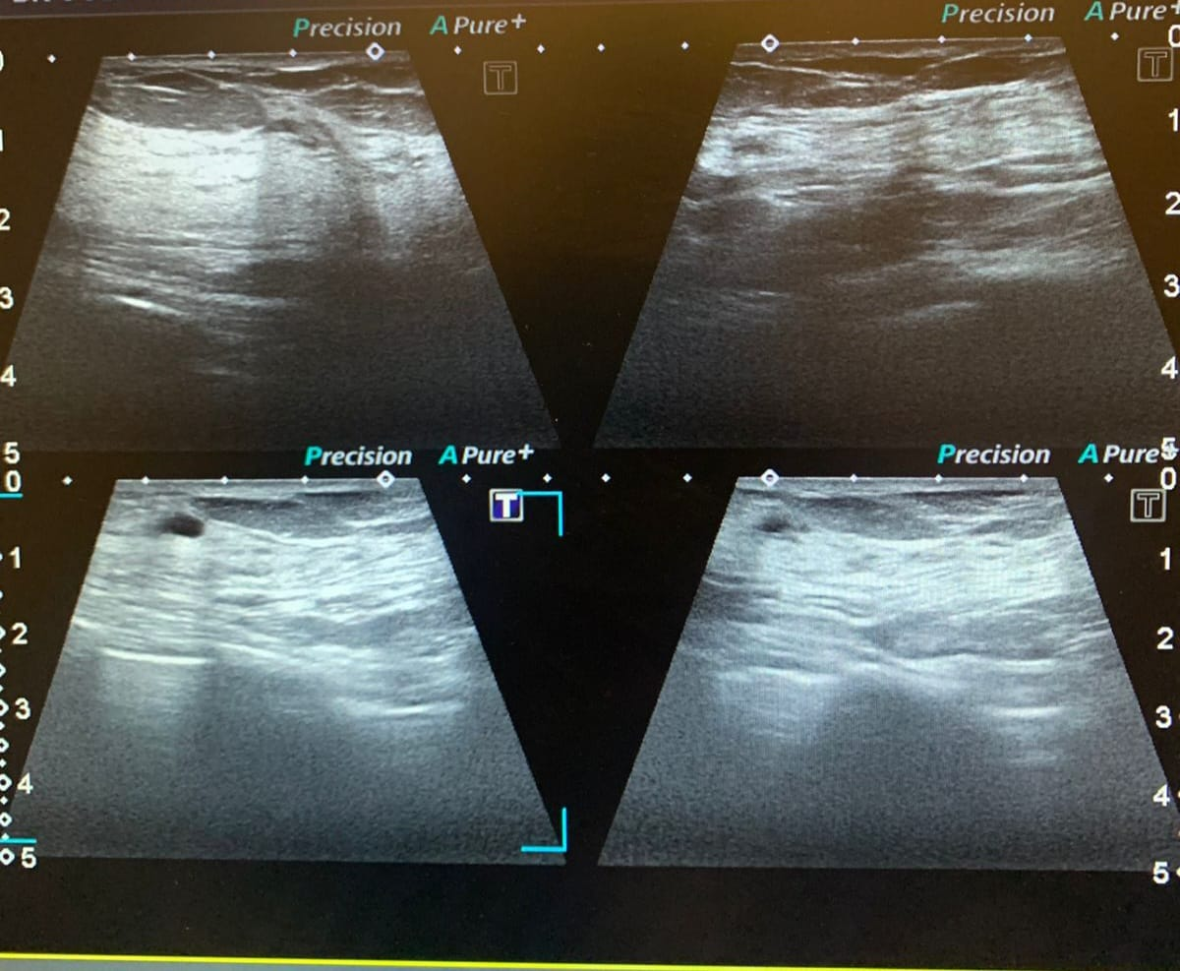
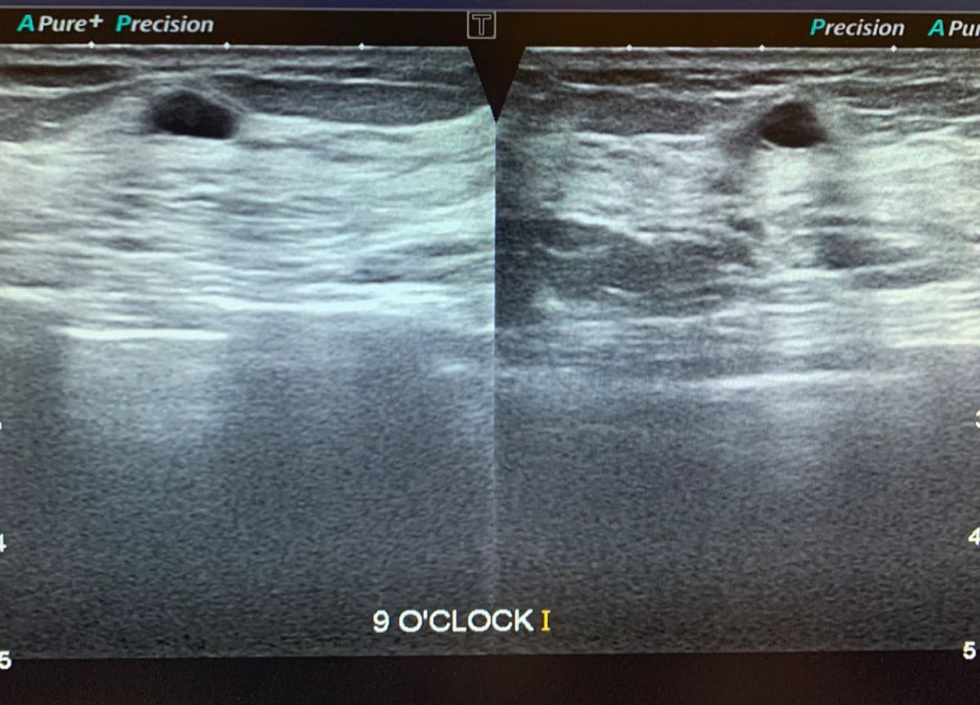

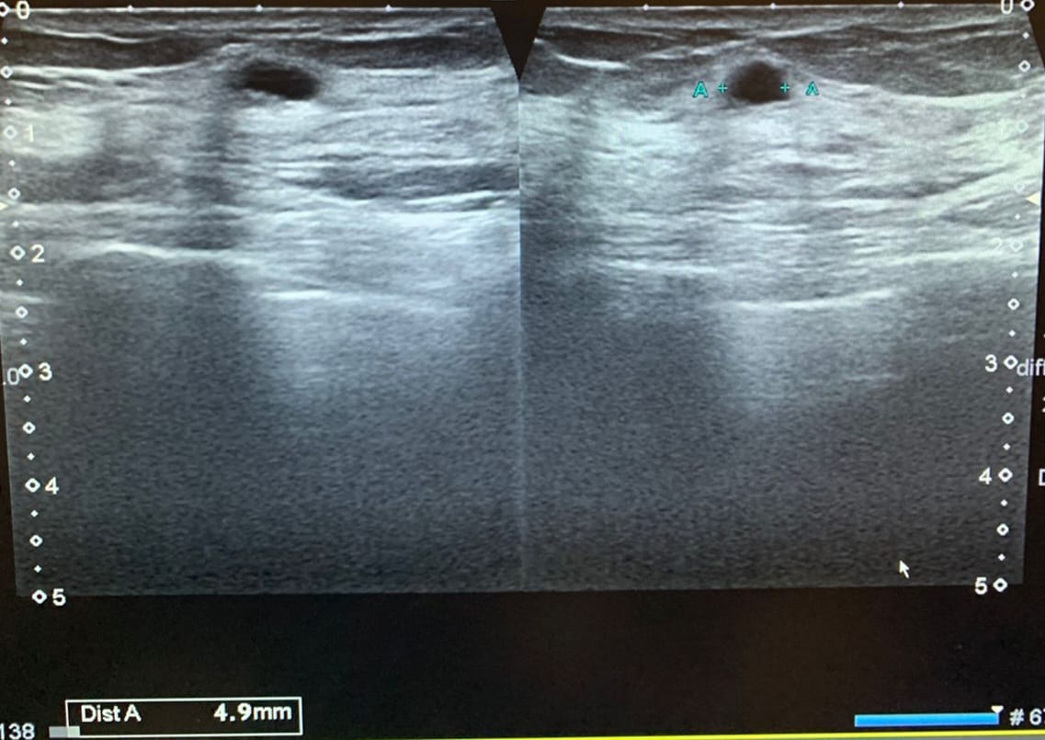
Images courtesy of IPEG imaging

Conclusion
Patient X ultrasound demonstrated a left cyst at 9 o’ clock position and radiologist suggested regular 6 months breast screening and self- breast examination as family history showed strong likelihood of malignancy. The mammogram findings were normal. The patient had an appointment with the referring doctor where she was prescribed medication for breast tenderness. The findings of the mammogram and ultrasound on Patient X substantiate that these two procedures need to be correlated in the evaluation of the clinical findings to improve patient management.

References
Ahuja, A T & Ying, M 2005, Sonographic Evaluation of Cervical Lymph nodes, American Journal of Roentgenology, vol 185, no. 5, pp.1691-99.
Athanasioua, A, Aubert, A, Salomonb, VA and Tardivon, A 2014, “Complex cystic breast masses in ultrasound examination”, Diagnostic and Interventional Imaging, vol 95, pp. 169—179.
AME. 2018. Sonographic Evaluation of Benign and Malignant Breast Masses. Retrieved 17 December 2018, from Institute for Advanced Medical Education website: https://iame.com/online/sonographic_evaluation_of_benign_and_malignant_breast_masses/content.php
Du Pont, WD, Page, DL, Parl, FF, Vnencak-Jones, CL, Plummmer, WD Jr, Rados, MS & Schuyler, PA. 1994, “Long term risk of breast cancer in woman with fibroadenoma”, North England Journal of Medicine, 1994, no. 331, pp.10-15.
Gupta, A , Zhang, H and Huang, JB 2019, “The Recent Research and Care of Benign Breast Fibroadenoma: Review Article”, Yangtze Medicine, no.3, pp. 135-141.
Knipe, H & Radwiski (2015). Ductal Carcinoma in Situ.Radiopaedia.org. Available from: http://radiopaedia.org/articles/ductal-carcinoma-in-situ
Lumturije, H G, Limani, RA and Fisnik, I and Kurshumliu, FI 2009, “Invasive ductal carcinoma within fibroadenoma: a case report”, Cases Journal, no.2, pp. 174-79.
Manukyan, MN, Deveci, U, Kebudi, A, Midi A, Yener N, Çelik L 2012, “Fibroadenom içine yerleşmiş duktal karsinoma insitu: Olgu sunumu”, Journal of Breast Health, 2012, no. 8, pp.204-09.
Aydın, OU, Soylu, L, Ercan, Aİ, Bilezikçi, B and Koçak S 2015, “Invasive Ductal Carcinoma Developing From Fibroadenoma”, The Journal of Breast Health, 2015 Vol 11, no.4, pp.195-98.
Mridha, MF, Hamid M.A, Monowar M.M, Keya, AJ, Ohi, AQ, Islam, MR, Kim J 2021, “Comprehensive Survey on DeepLearning-Based Breast Cancer Diagnosis”, Cancers, vol 13, pp. 1-36.
Reed, AE, Kutasovic, JR, Lakhani, SR and Simpson, PT 2015, “Invasive lobular carcinoma of the breast: morphology, biomarkers and ’omics”, vol 17, pp.1-11.
Roth, E (2014). What is Lobular Breast Cancer. Healthcareline. Available from:
http://www.healthline.com/health/breast-cancer/lobular-breast-cancer-prognosis-survival#Overview1.
Sanders, RC and Winter, T 2007, Clinical Sonography. A practical guide, 4th Ed, Philadelphia.
Stavros, T 2004, Breast Ultrasound, Lippincott Williams and Wilkins, Philadelphia
Tempkin, BB 2006, Ultrasound scanning principles and protocols, 3rd Ed, St Louis, Missouri.

