Case Report: A rare finding of male breast cancer in a 56 year old
Word count: 2616

Introduction:
The incidence of Breast cancer in males is relatively low. In Australia, roughly 150 men, most of whom are over the age of 50, are diagnosed with breast cancer each year (Cancer Council, 2021). This condition constitutes only 0.5–1% of all patients with breast cancer and it constitutes less than 1% of all male cancers (Yalaza et al. 2016).
Despite the low incidence of male breast cancer (MBC), these patients often present at a later stage due to a lack of awareness, insufficient attention given to this area and the general belief that breast cancer is a condition that only affects females (Yalaza et al. 2016) (Stavros, 2004).
The following case scenario describes a 56 year old male patient with invasive ductal carcinoma.

Case History:
A 56 year old, otherwise healthy, male presented for bilateral breast ultrasound with a history of breast discomfort and a retroareolar lump. No other physical signs were noted at the time of scanning. The patient experienced no nipple inversion, discharge or bleeding; there was no evidence of redness or other skin changes such as thickening or dimpling. No palpable lumps could be felt in the axillary regions or in any other part of the right or left breast. The patient did not have a personal or family history of breast cancer, nor did he have a history of prostate or testicular cancer. He could not recall any trauma to the breast and was not currently taking any hormonal medications.
Ultrasound was the initial imaging modality performed on this patient. Ultrasound is an effective imaging modality for assessing the male breast. Differentiation between gynaecomastia and MBC is possible using only ultrasound in the majority of cases. Fentiman et al (2017) suggests that mammography is not required in all cases, however it is desirable when there is a strong suspicion of MBC or the clinical and ultrasound findings are equivocal.
A detailed sonographic assessment of the patient’s right and left breasts and axillary regions was performed. Both breasts were scanned in their entirety as per the request and the departmental protocol, however the region of interest (the palpable lump) was awarded careful investigation. MBC is most frequently unilateral. According to Sencha (2015) only 5% of cases progress to bilateral, synchronous, or metachronous disease; nonetheless the scanning of both breast and axillary regions in their entirety is still warranted.
Ultrasound revealed a 1.5 x 1.2 x 0.6cm non-compressible, hypoechoic mass immediately deep to the right nipple, corresponding to the palpable lump. The mass demonstrated highly irregular, angulated margins, some internal vascularity and no evidence of distal acoustic shadowing. Elastography was not available and so greyscale and colour Doppler were used exclusively for interrogation of the lesion.
The lesion was considered suspicious and was given a BIRADS score of 4B-4C (RANZCR, 2018). The lack of distal shadowing and the presence of pain in the patient, meant that consideration needed to be given to other more common differentials, particularly gynaecomastia.
An atypical lymph node was also visualised in the right axilla. The node was hypoechoic, rounded and the normal hilar appearance had been obliterated. No abnormal vascularity or calcifications were noted within the node. This finding raised the suspicion of metastatic spread.
The patient was referred for ultrasound guided biopsy of the lesion and the abnormal node, which was performed at a different facility. Biopsy subsequently diagnosed an invasive ductal carcinoma. The abnormal appearing lymph node did not contain any neoplastic cells.
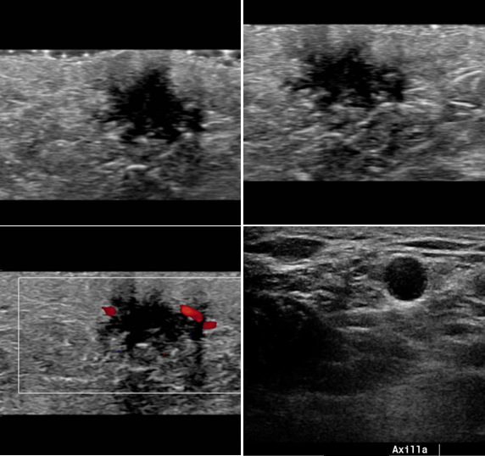

Discussion:
SCANNING TECHNIQUE
The patient was scanned using a Philips Epiq7 ultrasound machine. A 12 MHz transducer was used and a standoff pad was utilised due to the superficial nature of the lesion. ASUM (2018) states that ‘a linear array transducer with a broad range of operating frequencies is desirable to evaluate both superficial lesions and the dense breast. The transducer must at least operate at 7.5 MHz’.
The patient’s details were checked against the request, the procedure was explained and informed consent was obtained. A thorough clinical history was obtained from the patient and the lump was palpated by the sonographer. At all times during the examination the patient was treated with dignity and respect; their privacy and confidentiality was maintained throughout. The patient was scanned in the supine position with the ipsilateral arm raised above the head. As the male breast tissue is thinner than that of the female, there was no requirement to turn the patient obliquely to even out and minimise the thickness of the breast.
The breast was scanned in an orderly and comprehensive fashion using the grid scanning technique. The axillary regions were also included in the examination. The breast lesion was accurately documented according to the guidelines set out by ASUM for the documentation of lesions, this is outlined in the following table:
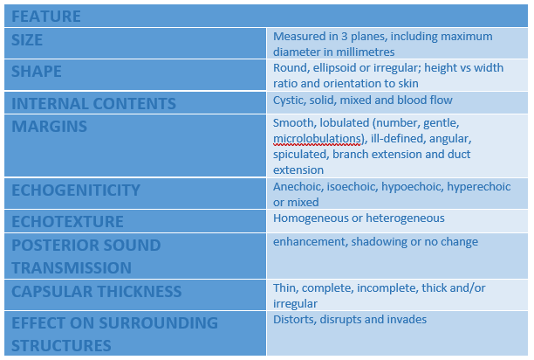

ANATOMY AND PHYSIOLOGY
In both women and men, breasts have the same origin and development until the point of puberty, when male breast development ceases and the breast remain rudimentary (Sencha 2015).
The size and shape of the male breast is variable. In general each breast is located on the anterior surface of the chest, within the superficial fascia, resting on the serratus anterior and the pectoralis major muscles (Seltzer, 1994). The breast extends from the second rib superiorly to the sixth rib inferiorly and from the parasternal to the midaxillary line, in the mediolateral direction. The nipple and areola, which are small in men, are typically situated on the midclavicular line (Sencha, 2015).
The breast is a highly vascular structure. It is supplied by the branches of the internal thoracic, subclavian, axillary, and intercostal arteries (Sencha, 2015). Venous drainage occurs via perforating branches of the internal mammary vein, tributaries of the axillary vein, and perforating branches of the posterior intercostal veins (Kalimuthu, 2015).
Lymphatic drainage occurs primarily through the axillary lymph nodes, along with the parasternal and the internal thoracic lymph nodes to a much lesser degree (Kalimuthu, 2015).
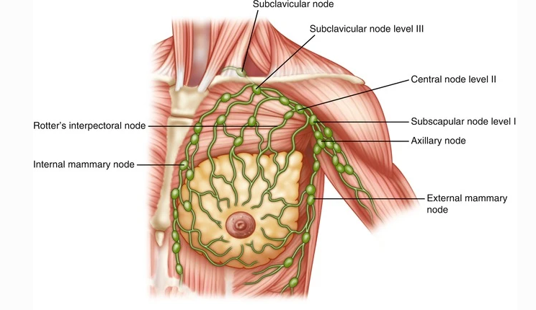
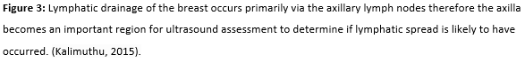
In men, the vast majority of breast tissue is situated in the retroareloar area and as such, most pathology is found in this location.
After puberty, atrophy of ducts and involution of the breast occurs in males. As a result, the breast of an adult male consists primarily of adipose tissue with meagre residual ducts and fibrous tissue. Lobular development is lacking in male breasts as the development of breast lobules requires estrogens and progesterone, which occur in limited quantities in men (Sencha, 2015). For this reason, lobular carcinoma is extremely rare in male subjects. The main histological types of breast carcinoma observed in men include pre-invasive ductal carcinoma and infiltrative ductal carcinoma. Additional malignancies described in men include inflammatory and papillary carcinomas along with Paget’s disease of the nipple (Giordano et al. 2004).

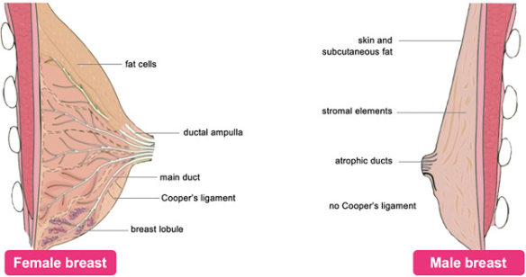
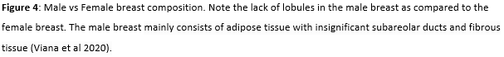
PATHOLOGICAL CONSIDERATIONS
The etiology and pathogenesis of MBC are complicated and somewhat unclear, this in part is due to the limited data available as a result of the low incidence of the disease. It is generally considered however, that the etiology and pathogenesis of MBC is similar to that of female breast cancer (Sencha, 2015).
A number of risk factors for MBC have been identified, these are outlined in the following table:
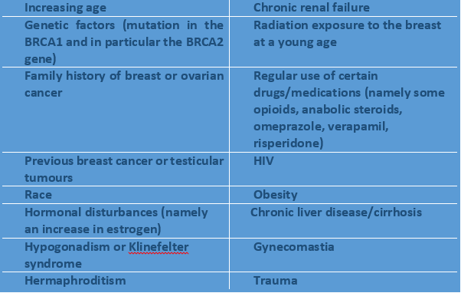
Gynecomastia has been described by a number of authors as an important risk factor for MBC. Korde et al (2010) however, state that it has not yet been determined whether this is a true risk factor, or that the risk factors for MBC are simply the same as those for gynecomastia.
Despite the known risk factors, MBC appears on a normal background in the vast majority of cases (Ruddy & Winer 2013).
In general, males are frequently diagnosed with more advanced-stage cancer than females, this occurs most notably in regions where women undergo routine mammographic screening (Korde et al. 2010). At the time of presentation, roughly 50% of patients are diagnosed with locally spread cancer and 50% of patients present with metastatic lymph nodes (Sencha, 2015). Axillary nodal involvement is the strongest predictor of both local recurrence, as well as the risk of metastatic spread (Korde et al. 2010).
Similar to females, the most common presentation in male breast cancer is that of a palpable lump (Yalaza et al 2016). Ulceration, nipple retraction and discharge (Yalaza et al 2016) as well as thickening and dimpling of the skin are also commonly noted at the time of presentation (Sencha 2015). In a study by Miao et al. in 2011, only 13% of males had a single sign or symptom upon presentation, the remaining 87% had more than one feature. Fentiman (2017) states that breast pain is a symptom present in up to 10% of men. There are a number of pathological differences between male and female breast cancer that have been outlined in the literature, these are included in the following table:
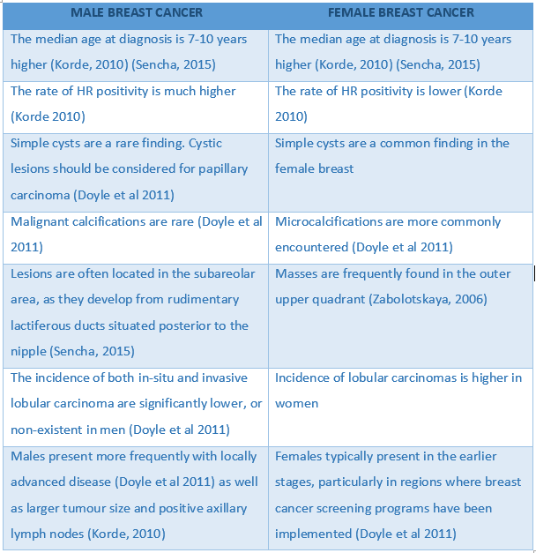
The vast majority of MBCs are reported as being invasive ductal carcinoma (85% to 95%). Ductal carcinoma in situ is the next most commonly diagnosed type at 5% to 10% (Korde et al. 2010). A study out of China in 2014 concluded that invasive carcinoma of no special type was the most common histological type of MBC in this population. The same study stated that hormone receptors, estrogen receptors (ER) and progesterone receptors (PR), were observed positive in over 90% of individuals (Zhou, 2014).
Invasive ductal carcinoma or IDC originates in the lactiferous duct and invades the surrounding stroma. Most invasive ductal carcinomas are the general type, or of no specific type, as in the case of our patient. There are also four additional sub-types of IDC, Medullary, mucinous, papillary and tubular; however they are far less commonly diagnosed (Zhou, 2014).
Differentials which should be considered in the case of MBC include Gynaecomastia (most notably), tuberculosis and retro-areolar abscess (Popli et al. 2009).Furthermore, Sencha (2015) outlines possible causes of a palpable breast mass in males, including: lipoma, fibroadenoma, schwannoma, angiolipoma, posttraumatic hematoma, fat necrosis and tuberculosis.
Focal Gynaecomastia frequently appears as a retroareolar, triangular, hypoechoic mass on ultrasound (Popli et al. 2009) and hence there is a significant overlap between the appearance of gynaecomastia and MBC. In the case of this patient, the appearance of the lesion certainly mimicked that of gynaecomastia. The presence of an abnormal axillary lymph node however, increased the suspicion for malignancy.
The following table demonstrates the overlap in appearances between MBC, gynaecomastia and retroareolar abscess. This illustrates the importance of mammographic and clinical correlation in narrowing the differential diagnoses.
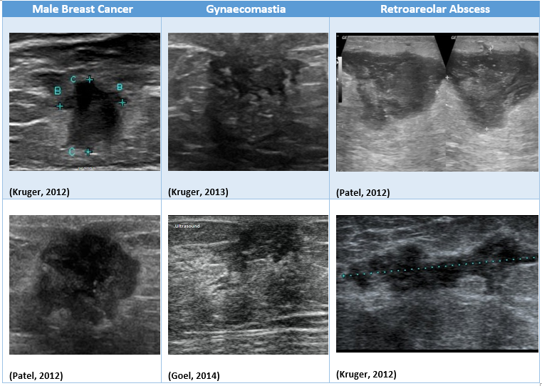
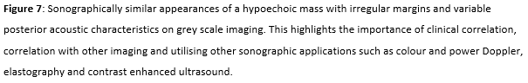

IMAGING CONSIDERATIONS
Ultrasound is a powerful tool in the diagnosis of breast carcinoma in men due to its high sensitivity and specificity. Some authors report up to 100% sensitivity and 98% specificity in the diagnosis of MBC in the case of a palpable lump (Fentiman, 2017).
Sencha et al (2015) outlines the typical ultrasound features of MBC in the following table; however as with female breast disease, it is important to remember that there is considerable overlap between signs of benign and malignant pathology.

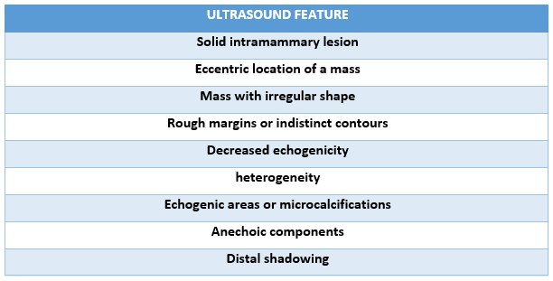

In this case, mammography was not readily available, so ultrasound was the initial modality employed for the investigation of the patient’s symptoms. Mammography can be difficult to perform in the male patient due to the small amount of breast tissue. It is however, highly sensitive in the detection of a malignancy (Carrasco et al. 2010) and has a diagnostic accuracy of up to 90 % (Sencha, 2015). Popli et al (2009) state that Mammography has proven to be effective in distinguishing between benign gynecomastia and carcinoma of the breast. In contrast, a study by Hanavadi et al (2006) concluded that mammography was unnecessary for most males due to the significant overlap between signs of benign and malignant disease and because of the high sensitivity of ultrasound, rendering mammography superfluous. In conjunction with one another however, it is widely reported that ‘Mammography and ultrasound, make it possible to avoid many unnecessary surgical procedures in men’ (Carrasco et al. 2010).
On mammography, masses are frequently retroareolar or eccentric and only very occasionally peripheral in location. The most frequently encountered mammographic sign is an uncalcified subareolar mass (Dershaw et al. 1993). Masses are commonly round, oval, irregular or lobulated. Margins can be well- or ill-defined, and can sometimes exhibit speculation. The following mammographic image from Buicko, 2017 is typical for MBC:

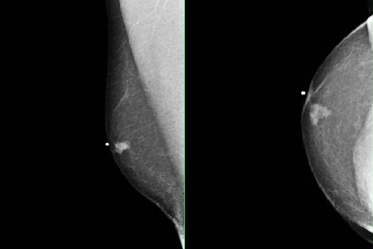

ETHICAL CONSIDERATIONS
There are a number of fundamental ethical considerations pertaining to breast sonography. All radiological examinations must be warranted and the benefit must outweigh the risk related to the procedure (Parker & Carter, 2016). The individual performing the breast ultrasound must hold accreditation with the required organisations. Breast sonographers are required to maintain the professional standards as outlined by such organisations.
It is a legal requirement that informed consent must be obtained prior to commencing any examination. This must occur following the provision of all the necessary information (Australian Commission on Safety and Quality in Health Care, 2022).
Privacy and confidentiality are of the utmost importance, particularly due to the sensitive nature of breast ultrasound and must be maintained throughout the examination.
The sonographer is required to maintain honesty and transparency towards the patient, however it is not appropriate to confirm or exclude diagnosis of breast cancer without undertaking a triple test. This includes a clinical examination, radiological imaging and biopsy (ASUM, 2018).
Further considerations in breast ultrasound include infection prevention and control. This encompasses hand hygiene, environmental cleaning, PPE and appropriate handling of wastes and linen (ASA, 2021).

FURTHER INVESTIGATIONS
The utilisation of 3D ultrasound, elastography and contrast enhanced ultrasound may help facilitate a definitive diagnosis in regards to a breast lesion.
Other fundamental imaging modalities which are utilised in the investigation of breast disease include mammography and MRI. Contrast enhanced MRI is reported to have a sensitivity of between 83-95% and a specificity ranging from 29–97 % in regards to the diagnosis of MBC (Sencha, 2015). This modality however is often less accessible and can be unnecessary given the high diagnostic accuracy of ultrasound and clinical examination combined. In the case of this patient, MRI and mammography were not performed as he was referred directly for ultrasound guided biopsy.
Following a suspicious or equivocal finding on imaging, biopsy is often warranted to determine a definitive diagnosis and to guide the treatment pathway for the patient. Image-guided core needle biopsy with histology, or fine needle aspiration biopsy with cytology are performed.
Due to the lack of additional resources at our institution, this patient was sent to another facility for further management. On follow up with the patient over the phone he stated that he underwent ultrasound-guided core biopsy of both the retroareolar mass and the right axillary lymph node. The patient kindly provided the results for this examination over the phone for the purpose of this case review (see appendix).

TREATMENT
MBC is an extremely rare disease, hence most data on MBC comes from limited single-institution studies. Because of the insufficient amount of data, the optimal treatment for MBC is not yet known and so female models are used to guide treatment regimens (Korde et al. 2010).
Treatment of male breast cancer depends highly upon the stage at which the disease is diagnosed, as well as patient age, existing comorbidities and other prognostic factors (Yalaza et al. 2016).
The standard treatment for early stage MBC is surgery followed by adjuvant endocrine treatment, chemotherapy or radiotherapy (Yalaza et al. 2016). At any stage of the disease, radical mastectomy or modified radical mastectomy is the most commonly performed surgery, followed by lumpectomy (Korde et al. 2010).
Indications for post-mastectomy radiation therapy also follows recommendations used for treatment of breast cancer in women. Radiotherapy is mandatory if breast-conserving surgery or lumpectomy is performed (Gradishar & Wood, 2000). Additionally, the presence of local muscle invasion should be considered an important indication for radiation therapy (Korde et al.2010).
Chemotherapy is found to be more successful in the cases of younger individuals, a higher tumour grade and axillary node involvement (Korde et al. 2010).
Around 90% of MBCs are hormone receptor-positive (Zhou, 2014). There are a number of hormonal therapies that are effective for either ER- or PR-positive MBCs. Hormone therapy is ineffective in patients whose tumours are hormone receptor-negative. Tamoxifen, Aromatase inhibitors, Fulvestrant and Luteinizing hormone-releasing hormone (LHRH) are drugs which work by either blocking estrogen receptors, stopping estrogen production, destroying estrogen receptors or lowering testosterone levels (Korde et al. 2010).

Conclusion:
Breast cancer is rare in men and most males referred for breast imaging will have benign conditions, in particular gynaecomastia. However rare, roughly half of patients are diagnosed with locally spread cancer and lymph node metastases at the time of first presentation (Sencha, 2015). Increased awareness as well as further research and development is needed in order to improve the prognosis for males presenting with breast cancer.

APPENDIX:

ULTRASOUND GUIDED CORE BIOPSY REPORT:
FINDINGS:
Informed consent was obtained. A sterile field was established. Xylocaine with adrenaline was used for local anaesthesia
4x 16 gauge core biopsy samples were obtained of the right retroareolar region. The right axillary lymph node was biopsied under ultrasound guidance using and 18 gauge core biopsy needle. Two passes were made. There was some haemorrhage at the biopsy site obscuring the lymph node after the second pass.
Samples have been sent for histopathology review.

PATHOLOGY REPORT:
CLINICAL NOTES:
Right breast retroareolar region, new irregular hypoechoic lesion ? Ca
Abnormal LN, Right axilla

MACROSCOPIC EXAMINATION:
R breast, retroareolar. Four cores of tan tissue 15mm, 14mm, 11mm and 8mm in length
R axilla. Two cores of 7mm and 8mm in length
MICROSCOPIC EXAMINATION:
The core biopsies from the breast show presence of infiltrating carcinoma composed of cords and single files of malignant cells which show low grade nuclear atypia and diffusely infiltrate

Ancillary studies:
ER: strongly positive in >95% of cancer cells
PR: strongly positive in >95% of cancer cells
HER2: negative
Ki-67 index: <5%
The core biopsies from the lymph node show polymorphic lymphoid population with no significant abnormality. Fragment of fibroadipose.



REFERENCES:

Australasian Sonographer’s Association, 2021, ASA Clinical statement, infection prevention and control, viewed 22 April 2022, https://www.sonographers.org/publicassets/d9b321db-4e90-ec11-9107-0050568796d8/UPDATE---PUB_0874_CS-Infection-Prevention-and-control-update.pdf
Australasian Society for Ultrasound in Medicine, 2018, ASUM Guidelines, Policies and Statements Guidelines on Breast Ultrasound Examination and Reporting, Australasian Society for Ultrasound in Medicine, viewed 1 May 2022 <https://www.asum.com.au/files/public/SoP/curver/Breast/Guidelines-on-Breast-Ultrasound-Examination-and-Reporting.pdf>
Australian Commission on Safety and Quality in Health Care, viewed 29 April 2022, <https://www.safetyandquality.gov.au/our-work/partnering-consumers/informed-consent>
Cancer Council, 2021, Breast cancer in men, viewed 29 April 2022, <https://www.cancer.org.au/cancer-information/types-of-cancer/breast-cancer-in-men>
Buicko, J, Lopez, MA & Lesnikoski, B 2017, Breast cancer in a male with BRCA2 mutation: is screening mammography necessary in men?, Medicine
Carrasco, RM, Benito, MA, Muñoz Gomariz, E, Povedano, JLR, & Martínez Paredes, M 2010, Mammography and ultrasound in the evaluation of male breast disease, European Journal of Radiology, vol. 20, no. 12, pp. 2797-2805
Dershaw, DD, Borgen, PI, Deutch, BM & Liberman, L, 1993, ‘Mammographic findings in men with breast cancer’, American Journal of Roentgnology, vol. 160, no. 2, pp. 267-270
Doyle S, Steel J & Porter G, 2011, ‘Imaging male breast cancer’, Clinical Radiology, vol.66, no. 1, pp. 1079–1085.
Fentiman, 2017, Male Breast Cancer, Springer, London
Giordano SH, Cohen DS, Buzdar AU, Perkins G, Hortobagyi GN, 2004, ‘Breast carcinoma in men: a population-based study’, Cancer, vol, 10, pp. 51–57
Goel, A. Gynecomastia. Case study, Viewed 14 May 2022, <https://radiopaedia.org/cases/29879>
Gradishar, WJ & Wood, WC, 2000, Advances in Breast Cancer Management, 2nd edition, Springer, New York
Hanavadi, S, Monypenny, IJ & Mansel, RE, 2006, ‘Is mammography overused in male patients?’, Breast, vol. 15, no. 1, pp. 123-126
Kalimuthu, R, Yegiyants, SS & Brenzek, C, 2015, Anatomy of the breast, axilla and chest wall’, in Riker, A (ed), Breast Disease, Springer, New York
Korde, L, Zujewski & Cardoso, 2010, Multidisciplinary meeting on male breast cancer: summary and researche recommendations, Journal of Clinical Oncology, vol. 28, no. 12, pp. 2114-2122
Kruger, G. Breast abscess. Case study, viewed 14 May 2022, <https://radiopaedia.org/cases/19713>
Kruger, G. Male breast cancer - massive. Case study, viewed 14 May 2022, <https://radiopaedia.org/cases/19033>
Miao, H, Verkooijen, HM, Chia, K, Bouchardy, C, Pukkala, E, Mellemkjaer, SL, Czene, K & Hartman, M, 2011, ‘Incidence and outcome of male breast cancer: an international population-based study’, Journal of Clinical Oncology, vol. 29, no. 33, pp. 4383-4386
Parker, LM & Carter SM, 2016, ‘Ethical and societal considerations in breast cancer screening, inHoussami, N & Miglioretti, DL (eds) Breast cancer screening: an examination of Scientific evidence, Academic Press, pp. 347-374
Patel, M. Breast abscess. Case study, Viewed 14 May 2022, <https://radiopaedia.org/cases/16242>
Popli, MB, Popli, V, Bahl, P and Solanki, Y 2009, ‘Pictorial essay: mammography of the male breast’, Indian Journal of Radiology and Imaging, vol. 19, no. 4, pp. 278-281
Royal Australian and New Zealand College of Radiologists, 2018 Breast Imaging Grading Comparison and Lesion Classification,
<https://www.ranzcr.com/college/document-library/breast-imaging-grading-comparison-and-lesion-classification>
Ruddy, KJ & Winer, EP, 2013, ‘Male breast cancer: risk factors, biology, diagnosis, treatment and survivorship’, Annals of Oncology, vol. 24, no. 6, pp. 1434-1443
Sencha, AM, (ED) 2015, Imaging of Male Breast Cancer, Springer, London
Seltzer, V, 1994, The breast: embryology, development and anatomy, Clinical Obstetrics & Gynecology, vol. 37, no. 4, pp 879-880
Stavros, TA, 2004, Breast Ultrasound, Lippincott Williams & Wilkins, Philadelphia
Stewart, RA, Howlett, DC & Hearn, FJ, 1997, Pictorial review: the imaging features of male breast disease, Clinical Radiology, vol. 52, no. 10, pp. 739-744
Tangerud, A, Potapenko, I , Skjerven, HK , Stensrud, MJ, 2016, Radiologic evaluation of lumps in the male breast, Acta Radiologica, vol. 57, no. 7, pp. 809-814
Viana, MP, Torres, US, Aguillar, VL, Bresciana, BH, Shimizu, C, Chala, LF, de Barros, N, de Mello, GG & de Mello Tucunduva, TC, 2020, ‘Imaging of male breast disease, the good, the bad and the ugly- A pictorial review’, Clinical Imaging, vol. 68, no. 1, pp 45-56
Yalaza, M, Inan, A & Bozer M, 2016, ‘Male breast cancer’, Journal of breast health, vol. 12, no. 8, pp. 1-8
Zhou, R, Yu, L, Zhou, S, Bi, R, Shui, R, Yu, B, Lu, H, Cai, X & Yang, W, 2014, Male breast carcinoma: a clinicopathological and immunohistochemical characterization study, International Journal of Clinical & Experimental Pathology, vol. 7, no. 10, pp. 6852-6861

