Part B – Questions and Answers
1] Select a breast image associated with an artefact from a text/ article/ workplace. Discuss whether the artefact is obscuring or aiding in the diagnosis. Also explain how better to optimise the image if applicable to your selected image.

Posterior Acoustic enhancement
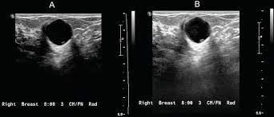
https://www.google.com/imgres?imgurl=https%3A%2F%2Fwww.intechopen.com%2Fmedia%2Fchapter%2F57001%2Fmedia%2FF9.png&tbnid=MesNePTdmxFSXM&vet=12ahUKEwiuiv_Rser9AhVY_XMBHaavBgYQMygXegUIARDsAQ.i&imgrefurl=https%3A%2F%2Fwww.intechopen.com%2Fchapters%2F57001&docid=AIGYdPNgTI8mGM&w=765&h=305&q=acoustic%20enhancement%20breast%20ultrasound&safe=active&ved=2ahUKEwiuiv_Rser9AhVY_XMBHaavBgYQMygXegUIARDsAQ
The artifact shown in the image above is called acoustic enhancement, also known as posterior enhancement. Posterior enhancement is due to an increase in echo caused by sound waves penetrating the fluid very well and hitting the posterior wall of the breast cyst.
Posterior enhancement artifacts aid in the diagnosis of lesions by enhancing benign features of echo-lucent (black/anechoic) patterns, circular or oval shapes, and sharply circumscribed borders.
The optimisation of the image to demonstrate the benign cystic features can be achieved by -:
- The selection of appropriate high frequency linear ultrasound probe. Choosing a higher frequency will improve image sharpness and provide ideal resolution and image contrast.
- The selection of the correct pre-sets (small parts, breast) on the ultrasound machine.
- The choice of proper depth and focus to maximize image quality.
- The application of ultrasound gel to couple sound to the skin to avoid acoustic impedance mismatch.
- Selection of the right depth and focus to maximise image quality.
- The correct selection of applicable Time, Gain, Compensation to enhance/darken echoes returning at certain point. It is of importance to be mindful of the dynamic range.
- Depth – the size of the examination window and the reproduction scale are influenced by the depth penetration. Tissue Harmonic Imaging, transducer frequency, and transmission power all play a role (THI). The depth penetration should be determined after considering several factors. To get a comprehensive view of the anatomy, a high depth penetration is necessary, but it also results in slower image acquisition because each extra image line requires an echo signal to be sent and received.
2] What are the standard parameters to be used while labelling a breast lesion on an ultrasound image? Demonstrate this with an example of a labelled image from a scan that you have performed. Please erase all patient identification data.
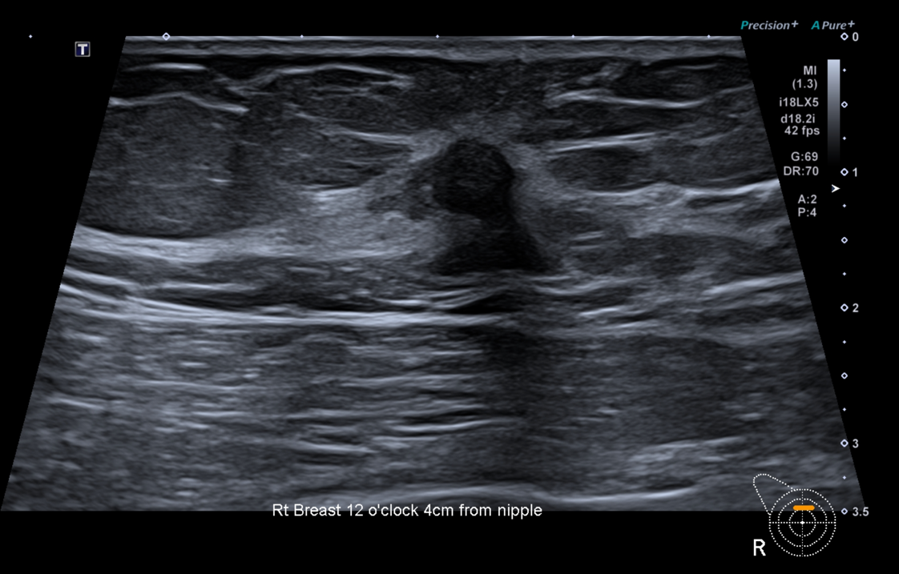
(Image from workplace, 2023)
As per ACT Breast Ultrasound protocol, the standard image display is to show -:
- The client’s name, Date of Birth, and client ID
- The Sonographer’s initials.
- Probe/display protocol
- Depth
- Body mark
- Annotations: (Breast) (o’clock) (distance from nipple)
- Alternate annotations: (Breast)(Quadrant)

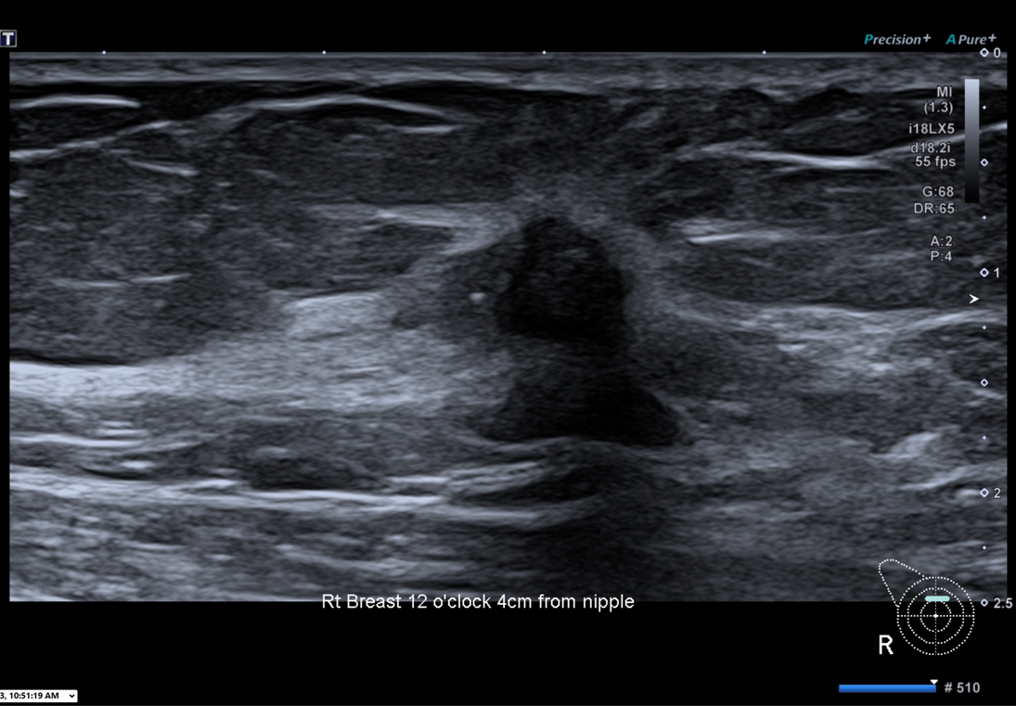
(Image from workplace, 2023)

As per the ACT Breast Screen protocol with the identification of a lesion, the following steps are taken for the recording of ultrasound images.
- Axillary view with lymph nodes
- A radial view of the lesion with a field showing the lungs at the bottom of the image.
- Anti radial view of the lesion with a field showing the lungs at the bottom of the image.
- A radial view of the lesion with a reduced field of view to better visualize lesion features. Lesions are measured in two planes.
- Anti-radial view of the lesion with reduced field of view to better visualize lesion features.
- View of the lesion with reduced field of view using CT Sono.
- Colour Doppler image showing whether the lesion shows vascularity.
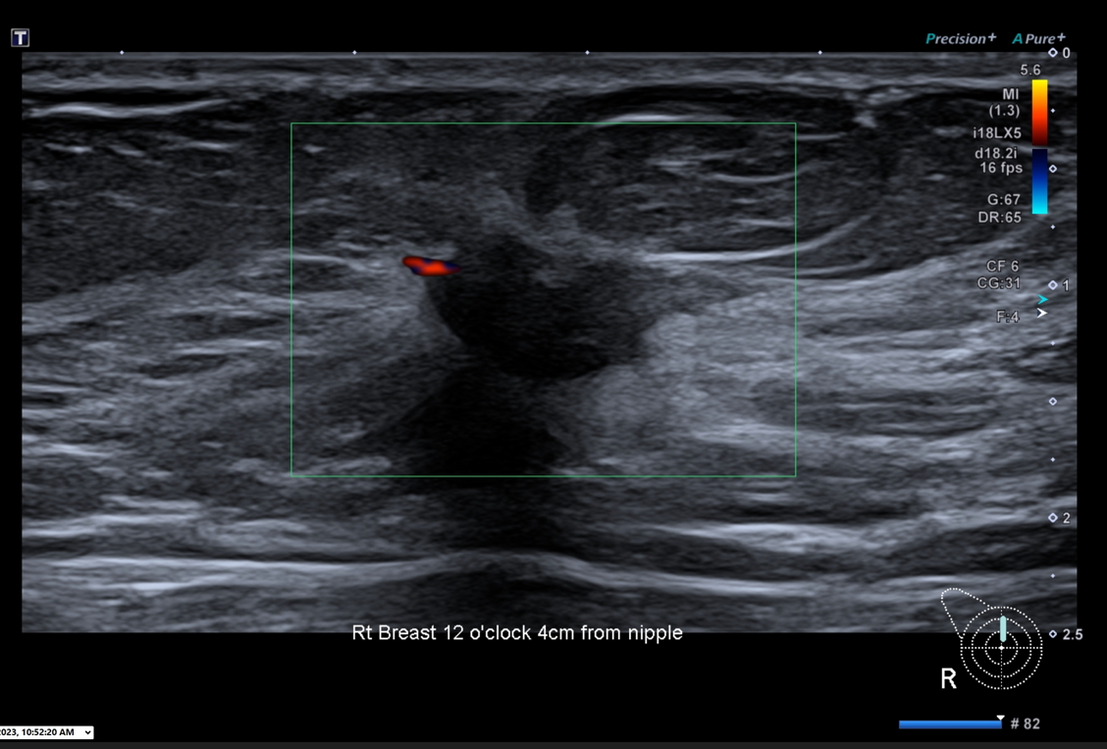
(Image from Workplace, 2023)

3] What are the sonographic characteristics of benign versus malignant lesions. Use image/s as examples to elaborate.
Normal benign tumours have an oval or circular shape and are well-defined. Malignant tumours typically have lobules and are ill-defined and irregular.
Benign Lesion Vs | Malignant
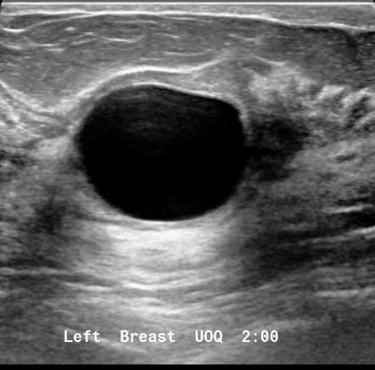  Breast cyst -:  - Anechoic pattern  - Oval or round  - Well defined margin  - Posterior enhancement  - No calcifications | 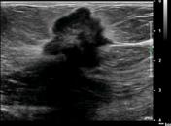  - Hypoechoic  - Irregular in shape  - Margin is not circumscribed.  - Other features could be indistinct, angular, micro lobulated, spiculated.  - Posterior shadowing  - Likely to have small calcification inside or outside the mass.  - Thick hyperechoic halo  - Branching pattern
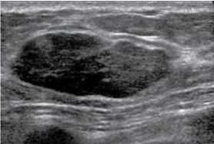  Fibroadenoma -:  - Hypoechoic  - Oval or round  - Less frequent lobulated  - Circumscribed margin  - Sometimes minimal posterior enhancement  - Likely to have +/- calcifications.  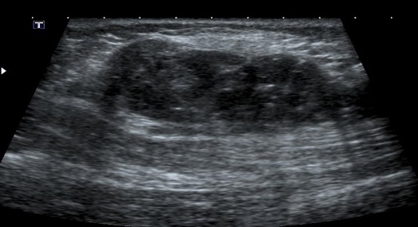  Fat necrosis (benign lesion)  - Accidental or surgical trauma can result in a palpable lump of fat necrosis, or dead fat, in the affected area.  - Surrounding skin may appear red, bruised, or even dimpled, however this will normally feel solid and painless.  - In ultrasound, fat necrosis can be very difficult to distinguish from malignant breast tumours, hence a biopsy may be advised. | 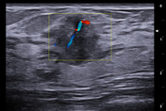  Mucinous breast carcinoma  - Tall  - Wide  - Internal vascularity  - Frequently exhibit mixed echogenicity with solid and cystic components on ultrasound.  - Posterior acoustic enhancement  - Micro lobulated borders and distal enhancement  - Mucinous breast Ca – boarders are typically clearly defined, and the tumour is isoechoic in relation to the fat surrounding the breast tissue on ultrasound.
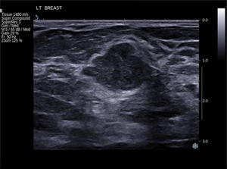  Adenosis  - The term adenosis describes the growth of the breast’s lobules and the increase in the number of glands located within them.  - It is a non-cancerous lesion even though it can resemble breast cancer on a mammogram which is due to microcalcifications prone regions.  - Adenosis is also known as sclerosing adenosis, in which scar tissue develops inside the larger lobules and distorts them.  - The diagnosis of sclerosing adenosis is confirmed by a biopsy. | 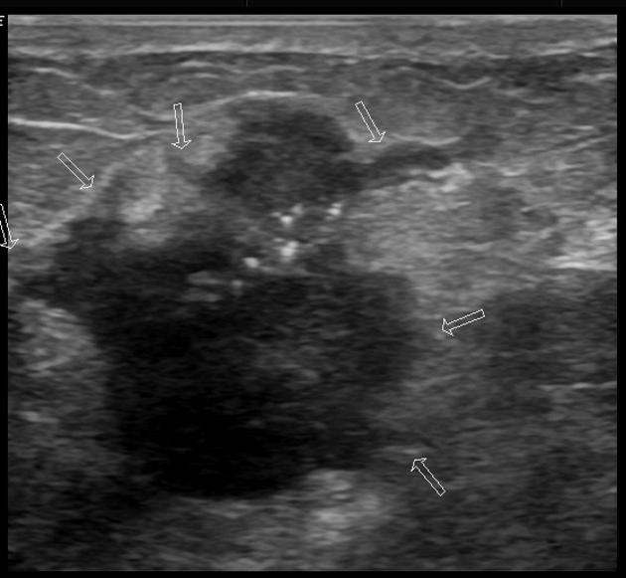  Lipoma in axillary  - Ill defined.  - Branching  - Increased vascularity  - Presence of calcifications

4] What visible skin changes (physical changes visible to the naked eye) should you observe and document when performing a breast ultrasound, and what underlying pathologies can these changes signify?
- Dimples on the skin – may be a sign of inflammatory breast cancer.
- Redness and swelling – signs of breast infection.
- Orange peel wrinkles and scars – a sign of inflammatory breast cancer
- Pink, purple, red, or broken skin – this may be an early sign of inflammatory breast cancer. A small area may appear red and scaly and may also cause bleeding and nipple discharge. This could be a sign of Paget’s Disease, a rare skin condition often associated with breast cancer in the tissue behind the nipple.
- Inverted or retracted nipples – can be a worrying sign of breast cancer, Paget’s Disease which is rare. Other conditions that are likely to be associated with inverted nipples include mastitis (bacterial infection), duct ectasia, nipple discharge, a lump behind the nipple, redness around the areola, and itchy nipples.
- Other visible changes are swelling and redness affecting at least one-third of the breast, breast tenderness, or a feeling of heaviness felt by the client.
- Another sign to look out for is swollen lymph nodes under the arm and near the collarbone.
- Watch out for persistent itching of the breasts, skin conditions, psoriasis, and rapid increase in breast size.

5] What is the significance of micro-calcifications? Discuss the limitations of ultrasound in imaging micro-calcifications.

Breast microcalcifications are calcium deposits that are considered strong markers of breast cancer when identified by mammography. Micro-calcifications are commonly associated with pre-cancerous and malignant lesions.
Micro-calcifications are associated with pre-cancerous and proliferative breast disease, and their identification facilitates prevention of invasive disease. Micro-calcification may influence the prognosis of invasive cancer. Breast cancers with micro-calcifications appear to have worse outcomes than cancers without micro-calcifications. Furthermore, micro-calcifications with fine linear branching are associated with worse outcomes compared to nonlinear micro-calcifications.
Microcalcifications appear as bright spots on ultrasound images. Ultrasound assessment of microcalcifications is not considered a valid method due to the lack of contrast between normal parenchyma and microcalcifications in breast tissue.

References
Axmacher, J. A., Bhatt, A. A., & Hesley, G. K. (2020). Nodular sclerosing adenosis detected as focal uptake on molecular breast imaging. Radiology Case Reports, 15(8), 1211–1215. https://doi.org/10.1016/j.radcr.2020.04.008
Babu, V., & Patel, M. (2012). Malignant breast nodule. Radiopaedia.org. https://doi.org/10.53347/rid-18604
Bonvissuto, D. (n.d.). What Causes Inverted Nipples? WebMD. https://www.webmd.com/women/inverted-nipples-causes
Breast Infection vs. Inflammatory Breast Cancer. (n.d.). WebMD. https://www.webmd.com/breast-cancer/breast-infection-breast-cancer
Breast Screen, A. (n.d.). Breast Screen ACT - Ultrasound Taining Module.
breastcancerspec. (2016, April 16). Benign Breast Lesions. Dr Chantel Thornton. https://www.breastcancerspecialist.com.au/symptoms-conditions/benign-breast-lesions
El-Feky, M., & Stanislavsky, A. (2018). Intraductal papilloma. Radiopaedia.org. https://doi.org/10.53347/rid-62189
Inverted Nipple: Symptoms, Signs, Causes & Treatment. (n.d.). MedicineNet. Retrieved March 27, 2023, from https://www.medicinenet.com/inverted_nipple/symptoms.htm.
Journo, G., Bataillon, G., Benchimol, R., Bekhouche, A., Dratwa, C., Sebbag-Sfez, D., Tardivon, A., Thibault, F., Ala-Eddine, C., Chérel, P., & Malhaire, C. (2018). Hyperechoic breast images: all that glitters is not gold! Insights into Imaging, 9(2), 199–209. https://doi.org/10.1007/s13244-017-0590-1
Khanbhai, M., Borgen, R., & Dobrashian, R. (2017). Ultrasound Can Accurately Diagnose Fibroadenomas in Women Less Than 35 Years. International Journal of Radiology and Imaging Technology, 3(2). https://doi.org/10.23937/2572-3235.1510026
Knipe, H., & Radswiki, T. (2011). Mucinous carcinoma of the breast. Radiopaedia.org. https://doi.org/10.53347/rid-12792
Logullo, A., Prigenzi, K., Nimir, C., Franco, A., & Campos, M. (2022). Breast microcalcifications: Past, present and future (Review). Molecular and Clinical Oncology, 16(4). https://doi.org/10.3892/mco.2022.2514
Machado, P., Eisenbrey, J. R., Stanczak, M., Cavanaugh, B. C., Zorn, L. M., & Forsberg, F. (2018). Characterization of Breast Microcalcifications Using a New Ultrasound Image‐Processing Technique. Journal of Ultrasound in Medicine, 38(7), 1733–1738. https://doi.org/10.1002/jum.14861
Murphy, A., & Gaillard, F. (2008). Benign and malignant characteristics of breast lesions at ultrasound. Radiopaedia.org. https://doi.org/10.53347/rid-1014
Rapelyea, J. A., & Marks, C. G. (2018). Breast Ultrasound Past, Present, and Future. Breast Imaging. https://doi.org/10.5772/intechopen.69790
Sinclair, M. (2006). Ultrasound breast imaging versus pathology; correlation of reported benign ultrasound scans with subsequent biopsy. Breast Cancer Research, 8(S1). https://doi.org/10.1186/bcr1490
Wei, M., Du, Y., Wu, X., Su, Q., Zhu, J., Zheng, L., Lv, G., & Zhuang, J. (2020). A Benign and Malignant Breast Tumor Classification Method via Efficiently Combining Texture and Morphological Features on Ultrasound Images. Computational and Mathematical Methods in Medicine, 2020, 5894010. https://doi.org/10.1155/2020/5894010
Zander, D., Hüske, S., Hoffmann, B., Cui, X.-W., Dong, Y., Lim, A., Jenssen, C., Löwe, A., Koch, J. B. H., & Dietrich, C. F. (2020). Ultrasound Image Optimization (“Knobology”): B-Mode. Ultrasound International Open, 06(01), E14–E24. https://doi.org/10.1055/a-1223-1134

