Week 2 discussion info

Dear students, please look at the following document in context with the recording from 08/03/2023

Logbook entry example

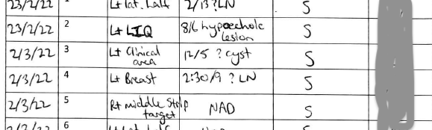

Image on breast ergonomics

Use the link to access the full article https://doi.org/10.1093/jbi/wbz005

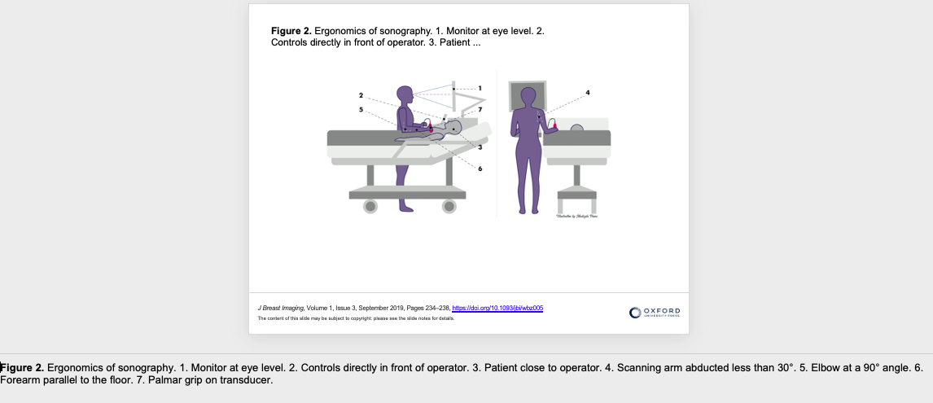

Axilla imaging

Use the doi below to search the article.
DOI 10.1007/s13244-014-0367-8
Image of a normal axillary lymph node is below

