Rubric
Part A submission | Does not meet standard  Fail | Meets standard  Pass
Submission  Weighting 10% | - No evidence of a submission  - Longer than 7 minutes | - Submission meets requirements
Student performs ABI  Weighting 35% | - Submission fails to demonstrate ABI  - Poor demonstration of an ABI study  - Audio is unacceptable | - ABI performed with clear explanation  - Clearly demonstrates self-performance
Extension of an ABI  Weighting 10% | - No evidence of ABI extension  - Incorrect extension | - Speaks to extension of physiological study
Reflection  Weighting 35%  This weighting will be ½ if there are no notes | - No evidence of a reflection  - Poor understanding of ABI  - fail to provide link between PAD and ABI study | - Considered presentation  - Clear reflection on the purpose of the ABI study  - Demonstration of link between ABI and PAD
Academic Integrity  Weighting 5% -  If the student fails this category,  they will be referred to  an academic integrity officers.  Please be careful with this in your next assignment | - There is no evidence or little evidence of citation of literature.  - Literature if cited is limited in number and incomplete.  - No evidence of paraphrasing.  - Inconsistent referencing.  - Workplace images used without a signed statement from supervisor. | - Literature cited and complete with a variety of relevant, unique peer reviewed and scholarly resources.  - Appropriate referencing style as advised.  - Sources are integrated exceptionally well in the content to cover a comprehensive and succinct analysis of key concepts.
Grammar and mechanics  Weighting 5% | Multiple typographic, grammatical and punctuation errors throughout reflection. | - Presentation flows smoothly  - There are no typographic, grammatical and punctuation errors throughout reflection.

Thank you for your submission:
This assessment piece was structured to demonstrate your understanding of how the ABI provides valuable insight into your client’s Peripheral arterial disease status, whilst there are some limitations, as a front-line assessment tool, it is easy to perform, and can direct sonographers and clinicians to disease states:
You were also asked to create a presentation including evidence of you performing an ABI study – how you did this was up to your imagination.
I have provided both video and written feedback on your submission
Thank You for video and Presentation. Your video of you performing the ABI was terrific as you talked to how you need to improvise in your department.
Collectively with Doppler on your machine you have managed to obtain your ABI measurements,
Those presentations that did well incorporated their video int the PowerPoint presentations either with video OR with captured images and presented their findings in the PowerPoint as you would at a conference. So, whilst you have provided all the relevant details, there are things to improve on.
Presenting in this style can be a little challenging, you should be able to speak to each PowerPoint slide, by pressing “Record” at the top of the slide.
So if you look at ABI MODEL Demonstration - you could have taken an image of this and inserted it into your presentation
I acknowledge that instructions may be interpreted different ways, and so students have NOT been affected as this was an interpretation for your submission.
Remember as a masters submission, you need to reference your work – so please ensure you are utilising appropriate referencing styles, as per guidelines provided - see this link
https://lo.unisa.edu.au/course/view.php?id=3839&sectionid=555863
See this example – the number at the end of the sentence is linked to your reference list
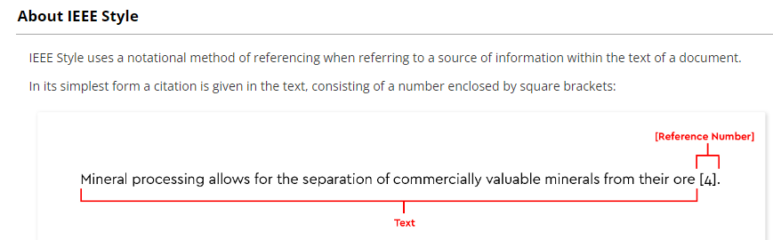
From your submission perspective, did you consider a “real patient” and provide a reflection on a study with a real patient? You have given information on limitations, and exercise ABI options, but a brief overview of you actually performing this on a real patient would have been good

