Weighting 20% | FAIL | MEETS STANDARDS | EXCEEDS STANDARDS
Weighting 20% | FAIL | Pass | Credit | Distinction | High Distinction
Major Case Study -  Section A  Student or sonographer presents ultrasound findings in an organized manner incorporating both direct and indirect vascular assessments.  a] Clarifies the question & applies discipline-specific ethical values.  b] Demonstrates understanding of pathophysiology via  evidence-based practice.  c] Elicits/ synthesizes additional data & suggests  appropriate extension of examination based on questioning and observation techniques and interpretation of sonographic findings and clinical presentation with relevant research evidence.  Final present findings in a concise video utilising PowerPoint with clear language  Weighting 60% | Most answers are unclear and lacks depth of content.  Limited or no evidence to  Demonstrate understanding of  theory underpinning the case scenario.  Lack of research based  evidence.  Student did not provide appropriate case study  Student failed to provide detailed information relating to the pre encounter.  Student failed to provide details relating to aetiology and epidemiology Student failed to indicate details relating to clinical information obtained from patient during encounter.  No Audio PowerPoint submitted | Student demonstrates adequate case study and associated reading, and mostly identifies and categorises descriptors.  And mostly identifies what questions should be asked, observations should be made and what was learned  Student provides non-imaging report with no other information  Audio PowerPoint goes over time | Student demonstrates a Clear understanding of purpose of review of case study and associated reading, and mostly identifies and categorises descriptors.  And identifies applicable questions, observations and what was learned.  Student provides non-imaging report and clear presentation and description of findings.  Audio submitted and covers all aspects of task | Student provides evidence of Clear and focused understanding of case study and associated reading, and mostly identifies and categorises descriptors.  And identifies and articulates well applicable questions, observations and what was learned.  Student provides non-imaging report and a clear focused and well-articulated presentation and description of findings  Audio submitted with good overall presentation – clear and concise. | Student demonstrates Clear, focused and sophisticated understanding of case study and associated reading, and mostly identifies and categorises descriptors.  And identified and articulates extremely well applicable questions, observations and what was learned.  Student provides non-imaging report, with an exceptionally well-articulated engaging presentation and explanation of this report.  Excellent audio submission concise on all points.
Academic Integrity – Note equal weighting for both aspects  Weighting 5% -  However, if the student fails this category, they will be referred to an academic integrity officer. | There is no evidence or little evidence of citation of literature.  Literature if cited is limited in number and incomplete.  No evidence of paraphrasing.  Inconsistent referencing.  Workplace images used without a signed statement from supervisor. | Literature cited and complete with a variety of credible, peer-reviewed scholarly sources.  Appropriate referencing style as advised.  Consistent paraphrasing of data and ideas seen.  No patient identifying details in images
Quality of writing and presentation using correct grammar, spelling, punctuation, syntax, and terminology  Weighting 5% - | There are several typographic, grammatical and punctuation errors. Limited or no presentation provided | Writing is free of typographic, grammatical and punctuation errors.  Presentation completed | Writing is free of typographic, grammatical and punctuation errors.  Presentation style is coherent. | Writing is free of typographic, grammatical and punctuation errors.  Writing style is coherent and very easy to follow.  Presentation of work is engaging. | Writing is free of typographic, grammatical and punctuation errors.  Writing style is coherent, very easy to follow and flows well.  Presentation style and written paper are highly integrated. Professional in appearance.

Hi Areeta, this was a pleasure to review – your tone presentation style is a very easy one to listen to – well done.
I want to acknowledge the fact you provided a background to your department and obviously the types of patients you might have every day, but typically how a podiatry visit can extend to a visit the vascular department for follow up from outpatients. WHAT A COMPLEX case, but I am sure this is an everyday occurrence for you. Thank you for not shying away from a complex patient – this certainly demonstrates your confidence in this space.
Your images certainly tell a tale for this client. I am interested, in a couple of images presented where there appeared to be considerable drop out- this may be due to the patient disease, Or is this a limitation of the system - I couldnt see what frequency probe was being used, but in the 2D/ colour and spectral image the 2D image appeared to struggle with colour. The spectral Doppler looked good, however. It might be an idea when switching to curved array probe that you drop the dynamic range a little to assist with something.
The image below, you can see the last few centimetres its hard to decipher, is this machine OR patient
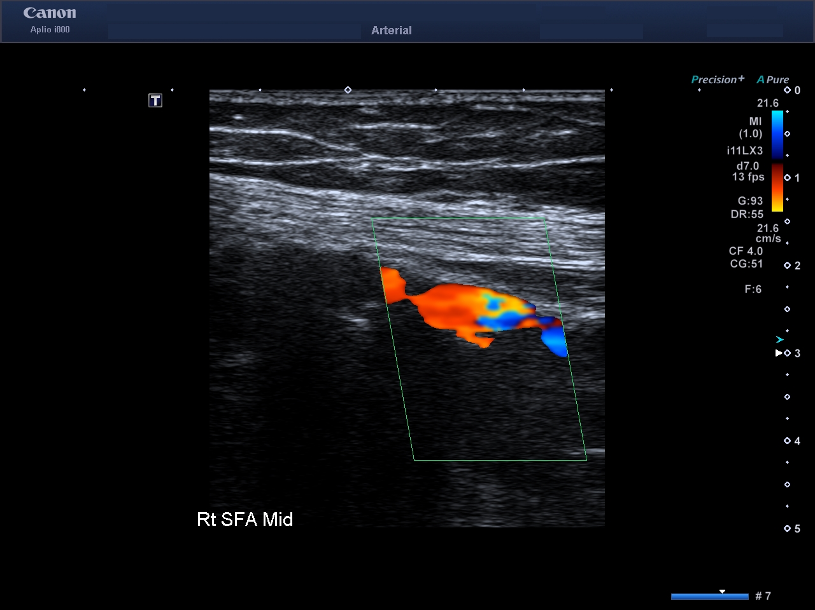
A few thank yous in this presentation
- Thank you for using the consensus document descriptors for this submission.
- Thank you for the pressure + CW Doppler
- Thank you for the on bulk great imaging and comprehensive presentation of your findings.
- Use if a different imaging teqhcnie, and change of probe to try and instruct your conclusions.
- I am thrilled to see neat handwriting on your worksheet as well
I thoroughly appreciated reviewing this submission, it clearly demonstrates excellent skills in the process of the clinical ultrasound examination which the CDM process sought to break down and ascertain from each student – thank you

