Top 5 shopping center owners in Aus:
- Scentre Group: Mr Brian M Schwartz AM (Independent Chairman)
- Size: 3.3 million sq m;
- Location: 85 Castlereagh Street, Sydney, Australia
- Owner and manager of Westfield centres in Australia, Westfield Bondi Junction (NSW)
- 34 shopping centres across Aus within 10,693 outlets
-> The shopping centres are highly productive, with strong franchise value and the ability to attract the world’s leading retail brands.
-> Scentre Group also works with the world’s leading retail and luxury brands to create a unique shopping and leisure experience. They mange many aspects from design, construction and development to leasing, management and marketing

-> Their strategies are to own interest in the highest quality regional shopping centre in the market and invest those assets through redevelopment opportunities by providing retail spaces.

No | Centre name | Location
No | Centre name | Location | m2 | Stores
1 | Westfield Bondi Junction | Bondi Junction, New South Wales | 127,716 m2 | 499
2 | Westfield Burwood | Burwood, New South Wales | 63,319 m2 | 240
3 | Westfield Chatswood | Chatswood, New South Wales | 77,107 m2 | 282
4 | Westfield Hornsby | Hornsby, New South Wales | 99,953 m2 | 325
5 | Westfield Hurstville | Hurstville, New South Wales | 62,542 m2 | 259
6 | Westfield Kotara | Kotara, New South Wales | 68,491 m2 | 258
7 | Westfield Liverpool | Liverpool, New South Wales | 85,199 m2 | 343
8 | Westfield Miranda | Miranda, New South Wales | 107,929 m2 | 396
9 | Westfield Mount Druitt | Mount Druitt, New South Wales | 60,190 m2 | 242
10 | Westfield Parramatta | Parramatta, New South Wales | 137,321 m2 | 480
11 | Westfield Penrith | Penrith, New South Wales | 91,690 m2 | 335
12 | Westfield Sydney | Sydney CBD, New South Wales | 167,975 m2 | 353
13 | Westfield Tuggerah | Tuggerah, New South Wales | 83,391 m2 | 262
14 | Westfield Warringah Mall | Brookvale, New South Wales | 126,634 m2 | 324
15 | Westfield Carindale | Carindale, Queensland | 135,496 m2 | 412
16 | Westfield Chermside | Chermside, Queensland | 150,927 m2 | 410
17 | Westfield Garden City | Gravatt, Queensland | 98,651 m2 | 420
18 | Westfield Helensvale | Helensvale, Queensland | 44,626 m2 | 189
19 | Westfield North Lakes | North Lakes, Queensland | 71,177 m2 | 236
20 | Westfield Marion | Marion, South Australia | 133,852 m2 | 325
21 | Westfield Tea Tree Plaza | Modbury, South Australia | 93,561 m2 | 253
22 | Westfield West Lakes | West Lakes, South Australia | 72,047 m2 | 247
23 | Westfield Airport West | Airport West, Victoria | 52,315 | 171
24 | Westfield Doncaster | Doncaster, Victoria | 122,998 m2 | 434
25 | Westfield Fountain Gate | Narre Warren, Victoria | 178,131 m2 | 460
26 | Westfield Geelong | Geelong, Victoria | 51,900 m2 | 183
27 | Westfield Knox | Wantirna South, Victoria | 141,458 m2 | 415
28 | Westfield Plenty Valley | Mill Park, Victoria | 51,919 m2 | 178
29 | Westfield Southland | Cheltenham, Victoria | 129,256 m2 | 396
30 | Westfield Carousel | Cannington, Western Australia | 82,338 m2 | 293
31 | Westfield Innaloo | Innaloo, Western Australia | 47,030 m2 | 171
32 | Westfield Whitford City | Hillarys, Western Australia | 77,781 m2 | 302
33 | Westfield Belconnen | Belconnen, Australian Capital Territory | 96,505 m2 | 285
34 | Westfield Wooden | Woden Valley, Australian Capital Territory | 72,256m2 | 249

- Vicinity Centres: Perter Hay (chairman, independent non-executive directors)
- Size: 2.9 million sq m;
- Shopping centres: Chadstone (VIC), the Glen (VIC)
- They are retail property ownership and management.
- Headquarters: Chadstone shopping centre, Melbourne, Aus
- 91 owned and managed centres
-> They aim to enrich community by providing unique centre with shops, services and amenities that tenants need even it is a local shopping centre or premium retail destinations.
-> Based on the annual report, as they have predicted, some international and luxury brands desire to invest in Aus markets as well as the apparel stores consider a larger store to operate.
-> The financial position, they invest and own more assets in 2016 leading to the amount they spent in investment properties is higher than 2015.
Centre | Location | m2 | stores
Tuggeranong Hyperdome | Tuggeranong, ACT | 76,205 | 171
Armidale Central | Armidale, NSW | 14,688 | 35
Bankstown Central | Banktown, NSW | 83,945 | 290
Bathurst City Centre | Bathurts, NSW | 12,561 | 46
Carlingford Court | Carlingford, NSW | 33,145 | 100
Chatswood Chase Sydney | Chatswood, NSW | 63,713 | 216
DFO Homebush | Hombush, NSW | 29,943 | 129
Lake Haven Shopping Centre | Lake Haven, NSW | 43,049 | 133
Lavington Square | Lavington, NSW | 20,239 | 51
Lennox Village | Emu Plains, NSW | 9,995 | 37
Lidcombe Shopping Centre | Lidcombe, NSW | 29,652 | 49
Nepean Village | Penrith, NSW | 23,113 | 66
Riverside Plaza Shopping Centre | Queanbeyan, NSW | 21,410 | 62
Roselands Shopping Centre | Roseland, NSW | 61,611 | 150
Salamander Bay Shopping Centre | Salamander Bay, NSW | 23,954 | 82
Terrace Central | Raymond Terrace, NSW | 7239 | 18
Toormina Gardens | Toormina, NSW | 21,237 | 48
Warriewood Square | Warriewood, NSW | 30,043 | 112
West End Plaza | Albury, NSW | 15,824 | 46
Buranda Village | Buranda, QLD | 11,537 | 33
DFO Brisbane | Brisbane Airport, QLD | 26,093 | 150
Goldfields Plaza | Gympie, QLD | 7,659 | 19
Grand Plaza Shopping Centre | Brown Plains, QLD | 53,451 | 160
Gympie Central | Gympie, QLD | 14,050 | 47
Milton Village | Milton, QLD | 2828 | 22
Mount Pleasant Shopping Centre | North Mackay, QLD | 22509 | 73
Mt Ommaney Centre | Mt Ommaney, QLD | 56391 | 184
North Shore Village | Parcific Paradise, QLD | 4082 | 14
Oxenford Village | Oxenford, QLD | 5805 | 17
Paradise Centre | Surfers Paradise, QLD | 22882 | 86
QueensPlaza | Brisbane, QLD | 39062 | 79
Runaway Bay Shopping Village | Runaway Bay | 42,989 | 124
Taigum Square | Taigum, QLD | 22995 | 76
The Myer Centre Brisbane | Brisbane, QLD | 63747 | 181
Whitsunday Plaza | Cannonvale. QLD | 22194 | 44
Castle Plaza Shopping Centre | Edwardtown, SA | 22837 | 73
Colonnades | Noarlunga, SA | 83063 | 175
Elizabeth Shopping Centre | Elizabeth, SA | 80301 | 217
Kurralta Central | Kurralta park, SA | 10675 | 14
Eastlands Shopping Centre | Rosny Park, TAS | 33310 | 94
Northgate Shopping Centre | Glenorchy, TAS | 19442 | 70
Altona Gate Shopping Centre | Altona North, VIC | 26262 | 85
Bayside Shopping Centre | Frankston, Vic | 87446 | 263
Belmont Village | Belmont, Vic | 14029 | 17
Bentons Square | Mornington, VIC | 9993 | 43
Box Hill Central South predict | Boxhill, Vic | 23393 | 112
Box Hill Central North predict | Boxhill, Vic | 14580 | 84
Brandon Park | Wheelers Hill, VIC | 23044 | 85
Broadmeadows Shopping Centre | Broadmeadows, VIC | 61513 | 187
Chadstone Shopping Centre | Chadstone, VIC | 162645 | 407
Corio Shopping Centre | Corio, VIC | 31331 | 110
Cranbourne Park | Cranboourne, Vic | 46930 | 139
DFO Essendon | Essendon, Vic | 52487 | 143
DFO Moorabbin | Moorabbin, VIC | 24535 | 139
DFO South Wharf | South Whaf | 57046 | 202
Emporium Melbourne | Melbourne, VIC | 45341 | 227
Gateway Plaza | Leopold, VIC | 5613 | 22
Keilor Shopping Centre | Keilor Down | 19386 | 66
Mildura Central | Mildura | 20319 | 84
Mornington Central | Mornington, Vic | 11686 | 36
Myer Bourke Street | Melbourne, VIC | 39924 | 1
Northland Shopping Centre | East Preston, VIC | 97391 | 313
Oakleigh Central | Oakleigh, VIC | 13904 | 42
Roxburgh Park Shopping Centre | Roxburgh park, VIC | 24,744 | 74
Sunshine Marketplace | Sunshine, VIC | 33882 | 75
The Gateway | Langwarrin, Vic | 10848 | 41
The Glen | Glen Waverley | 59139 | 179
Victoria Gardens Shopping Centre | Richmond, VIC | 34979 | 79
Wodonga Plaza | Wodonga, Vic | 17503 | 43
Albany Brooks Garden | Albany, WA | 12204 | 16
Currambine Central | Curramnbine, WA | 16303 | 44
Dianella Plaza | Dianella, WA | 16866 | 57
Flinders Square | Yokine, WA | 5990 | 21
Galleria | Morley, WA | 80757 | 209
Halls Head Central | Hall Head, WA | 20208 | 60
Kalamunda Central | Kalamunda, WA | 8367 | 34
Karratha City | Karratha, WA | 23936 | 59
Livingston Marketplace | Canning Vale, WA | 15553 | 49
Maddington Central | Maddington, WA | 27517 | 85
Rockingham Shopping Centre | Rockingham, WA | 62338 | 210
Warwick Grove | Warwick, SA | 31977 | 97
Midland Gate Shopping Centre | Midland gate, WA | 55569 | 174
Stirling central | Geraldton, WA | 8441 | 36
The shops at Ellenbrook | Ellenbrook, WA | 34979 | 95
Warnbro centre | Warnbro, WA | 21416 | 66
Mandurah Forum | Mandurah, WA | 26,000 | 69
Victoria Park Central | Victoria Park, WA | 5472 | 29

- Stockland: is one of the largest retail property owners, developers and
managers in aus. Graham Bradley (Chairman, non executive)
- Size: 1.05 million sqm
- Shopping centres: Glendale, Green Hills (NSW), Hervey Bay (QL), the Pines (VIC),…
- 42 retail centres with more than 3,500 tenants.
- Headquarter: 133 Castlereagh street, Sydney, Australia
-> They own, manage and develop shopping centres, logistics centres, business parks, office buildings, residential communities and retirement living villages

-> Annual report 2016 shows the Stockland’s retail had a positive leasing spreads, also they have a future pipeline of $1.0 billion which involves supermarket, mini major, food catering and fast casual dining and some retail service.
Centre | Location | m2 | Stores
Balgowlah | Balgowlah, NSW | 12954 | 60
Bathurst | Bathurst CBD, NSW | 19461 | 38
Baulkham Hills | Baulkham Hills, NSW | 18055 | 71
Cammeray | Northern suburb of Sydney | 4792 | 16
Corrimal | North of Wollongong | 9837 | 38
Forster | North coast of NSW | 38889 | 69
Glendale | Northern fringe of Lake Macquarie, NSW | 55,133 | 70
Tamworth | New England highway | 13053 | 30
Green Hills | East Mailand, NSW | 31828 | 90
Jesmond | Jesmond, NSW | 20238 | 75
Merrylands | Sydney, CBD | 58,339 | 205
Nowra | Nowra, NSW | 75,000 | 220
Piccadilly | Sydney CBD, NSW | 3045 | 39
Shellharbour | South coast, NSW | 75696 | 223
Cammeray | Northern suburbs of sydney | 4792 | 16
Wallsend | Newcastle CBD, NSW | 12001 | 43
Wetherill Park | Wetherill Park, NSW | 71,689 | 200
Vincentia | Vincentia, NSW | 4,099 | 21
Jimboomba | south of brisbane, QLD | 11664 | 33
Pacific Pines | northern Gold coast, QLD | 5529 | 13
Benowa Gardens | Benowa gardens, QLD | 5804 | 39
Bundaberg | Bundaberg region airport, QLD | 22797 | 63
Burleigh Heads | South of Brisabne, QLD | 26780 | 105
Cairns | North Queensland,QLD | 49021 | 110
Caloundra | Southern end of Sunshine Coast, QLD | 17517 | 48
Cleveland | South east Brisbane CBD, QLD | 15626 | 58
Gladstone | Dawson highway, QLD | 27657 | 50
Hervey Bay | Hervey Bay, QLD | 35000 | 110
North Shore | Townsville, QLD | 5777 | 15
Rockhampton | Rockhampton, QLD | 59500 | 190
Townsville | Townsville, QLD | 60256 | 202
Point Cook | Wyndham, VIC | 43054 | 119
Highlands | Craigieburn,VIC | 7766 | 17
The Pines | Blackburn rd, VIC | 24938 | 101
Tooronga | Melbourne CBD | 8997 | 30
Traralgon | Latrobe Valley, VIC | 19473 | 50
Wendouree | City of Ballarat, VIC | 25284 | 82
Baldivis | Baldivis, WA | 31196 | 95
Bull Creek | South of Perth CBD | 16906 | 46
Riverton | Riverton, WA | 19596 | 60

- QIC: Don Luke ( Chairman- non-executive)
- It is a global real estate
- Head office: 66 Eagle Street, Brisbane, QLD 4001.
-Size: 884,000 sq m;
- Shopping centre: Canberra centre ( 278 shops) located ACT
-> They aim to expand a number of Aus retail assets in the next 5 years.
Centre | Location | m2 | Stores
Canberra | Canberra city, ACT | 90000 | 278
Castle towers | Castle Hill, NSW | 113,000 | 304
Claremont Quarter | Claremont, WA | 32,000 | 147
Eastland | Ringwood, VIC | 124,000 | 378
Grand central | Toowoomba, QLD | 46,000 | 136
Hyperdome | Loganholme QLD | 85,000 | 221
Noosa Civic | Noosaville, QLD | 21,000 | 93
Robina town centre | Robina, QLD | 138,000 | 353
Water garden town | Taylors Lakes, VIC | 69,000 | 218
Westpoint | Backtown, NSW | 97,000 | 299
Woodgrove | Melton,VIC | 52,000 | 170
Marsden park | Marsden, QLD | 8,277 | 49
Hinkler central | Bundaberg, QLD | 20,754 | 77
Domain central | Garbutt, QLD | 48,479 | 30

- The GPT Group: 803,000 sq m., Rob Ferguson (Chairman)
- Head quarter: MLC centre Sydney, Australia
- It is a leading owner, manager and developer of $10.1 billion of Aus retail property.
- Consistent of 14 shopping centres with more than 37k investors
- Shopping centre: Australian Square (Sydney), Highpoint (500 shops) located in VIC
Centre | Location | m2 | Stores
Charlestown Square | Charlestown, NSW | 90,200 | 315
Rouse Hill Town | Rouse Hill, NSW | 69,700 | 245
Westfield Penrith | Penrith, NSW | 90,400 | 313
Macarthur Square | Campbelltown, NSW | 94,600 | 303
Norton Plaza | Leichhardt, NSW | 11,800 | 51
Wollong central | Wollongong, NSW | 56,600 | 230
Westfield Woden | Canberra, ACT | 74,400 | 234
Sunshine Plaza | Maroochydore, QLD | 73,400 | 249
Casuarina Square | Casuarina, NT | 53,000 | 181
Chirnside Park | Chirnside, VIC | 37,900 | 115
Highpoint | Maribymong, VIC | 153,100 | 483
Melbourne central | Melbourne, VIC | 54,700 | 301
Parkmore Shopping | Melbourne, VIC | 36,800 | 131
Northland Shopping | Melbourne, VIC | 97,200 | 322

Top 10 centers:
- Scentre group:

No | Centre | Address | M2 |  | Stores | Logo
1 | Westfield Bondi Junction | 500 Oxford St, Bondi Junction NSW 2022 |  | 127,716 m2 | 499 | 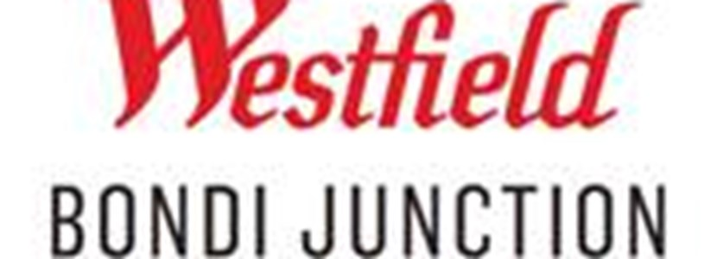
2 | Westfield Parramatta | 159-175 Church St, Parramatta NSW 2150 |  | 137,321 m2 | 480 | 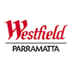
3 | Westfield Fountain Gate | 352 Princess Highway, Fountain Gate, Victoria 3805 |  | 178,131 m2 | 460 | 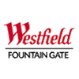
4 | Westfield Doncaster | Doncaster, Victoria |  | 122,998 m2 | 434 | 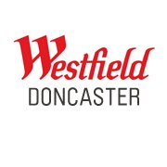
5 | Westfield Garden City | Cnr Logan & Kessels Rd Upper Mt Gravatt/ Brisbane, QLD 4122 |  | 98,651 m2 | 420 | 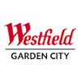
6 | Westfield Knox | 425 Burwood highway, Wantirna South VIC 3152 |  | 141,458 m2 | 415 | 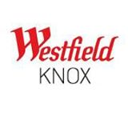
7 | Westfield Carindale | 1151 Creek Road, Carindale/ Brisbane QLD 4152 |  | 135,496 m2 | 412 | 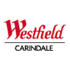
8 | Westfield Chermside | Cnr Gympie & Hamilton Rds Chermside/ Brisbane QLD 4032 |  | 150,927 m2 | 410 | 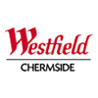
9 | Westfield Miranda | 600 Kingsway Miranda, NSW 2228 |  | 107,929 m2 | 396 | 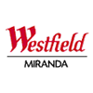
10 | Westfield Southland | 1239 Nepean Hwy, Cheltenham VIC 3192 |  | 129,256 m2 | 396 | 

- Vincinity:

Centre | Location | m2 | stores | Logo
Chadstone Shopping Centre | 1341 Dandenong Road, Chadstone VIC 3148 | 162645 | 407 | 
Northland Shopping Centre | 2-50 Murray Rd, Preston VIC 3072 | 97391 | 313 | 
Bankstown Central | Stacey St & North Terrace, Bankstown NSW 2200 | 83,945 | 290 | 
Bayside Shopping Centre | Stacey St & North Terrace, Bankstown NSW 2200 | 87446 | 263 | 
Emporium Melbourne | Stacey St & North Terrace, Bankstown NSW 2200 | 45341 | 227 | 
Elizabeth Shopping Centre | Stacey St & North Terrace, Bankstown NSW 2200 | 80301 | 217 | 
Chatswood Chase Sydney | 345 Victoria Ave, Chatswood NSW 2067 | 63,713 | 216 | 
Rockingham Shopping Centre | 1 Council Ave, Rockingham WA 6168 | 62338 | 210 | 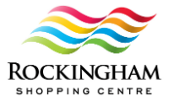
Galleria | Collier Rd & Walter Road West, Morley WA 6062 | 80757 | 209 | 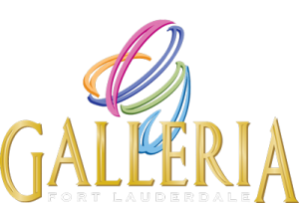
DFO South Wharf | 20 Convention Centre Pl, South Wharf VIC 3006 | 57046 | 202 | 

- Stockland
Centre | Address |  |  | m2 |  | Stores | logo
Shellharbour | 2528 Ground Floor, 211 Lake Entrance Rd, Shellharbour NSW 2529 |  |  | 75696 |  | 223 | 
Nowra | 32 East St, Nowra NSW 2541 |  |  | 75,000 |  | 220 | 
Merrylands | McFarlane St, Merrylands NSW 2160 |  |  | 58,339 |  | 205 | 
Townsville | Townsville, QLD |  |  | 60256 |  | 202
Wetherill Park | 561-583 Polding St, Wetherill Park NSW 2164 |  |  | 71,689 |  | 200 | 
Rockhampton | 120-331 Yaamba Rd, Rockhampton City QLD 4701 |  |  | 59500 |  | 190 | 
Point Cook | Main St & Murnong St, Point Cook VIC 3030 |  |  | 43054 |  | 119 | 
Hervey Bay | 6 Central Ave, Urraween QLD 4655 |  |  | 35000 |  | 110 | 
Cairns | 537 Mulgrave Rd, Earlville QLD 4870 |  |  | 49021 |  | 110 | 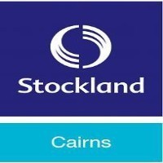
Burleigh Heads | 149 W Burleigh Rd, Burleigh Waters QLD 4220 |  |  |  | 26780 | 105 | 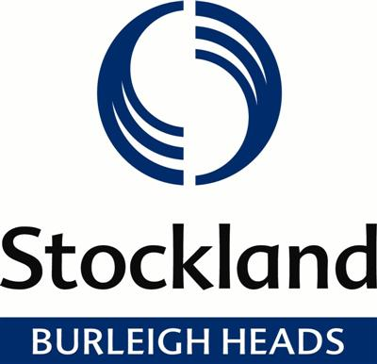

- QIC
Centre | Location | m2 | Stores | Logo
Canberra | 148 Bunda St, Canberra ACT 2601 | 90000 | 278 | 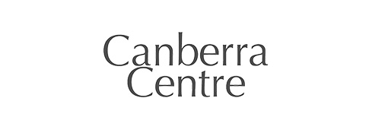
Eastland | 175 Maroondah Hwy, Ringwood VIC 3134 | 124,000 | 378 | 
Robina town centre | 19 Robina Town Centre Dr, Robina QLD 4230 | 138,000 | 353 | 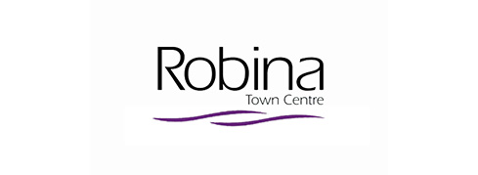
Castle towers | 6-14 Old Castle Hill Rd, Sydney NSW 2154 | 113,000 | 304 | 
Westpoint | 17 Patrick St, Blacktown NSW 2148 | 97,000 | 299 | 
Hyperdome | Pacific Highway & Bryants Road, Loganholme QLD 4129 | 85,000 | 221 | 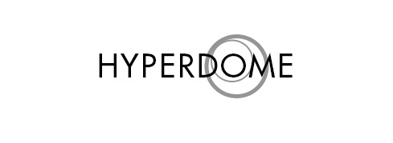
Water garden town | 399 Melton Hwy, Taylors Lakes VIC 3038 | 69,000 | 218 | 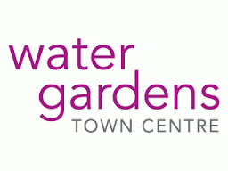
Woodgrove | 533-555 High St, Melton West VIC 3337 | 52,000 | 170 | 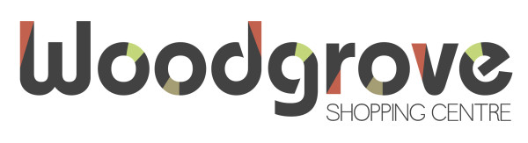
Claremont Quarter | 9 Bay View Terrace, Claremont WA 6010 | 32,000 | 147 | 
Grand central | Dent St & Margaret Street, Toowoomba City QLD 4350 | 46,000 | 136 | 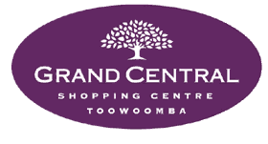

- GPT

Centre | Location | m2 | Stores | Logo
Highpoint | 120-200 Rosamond Rd, Maribyrnong VIC 3032 | 153,100 | 483 | 
Northland Shopping | 2-50 Murray Rd, Preston VIC 3072 | 97,200 | 322
Charlestown Square | 30 Pearson St, Charlestown NSW 2290 | 90,200 | 315 | 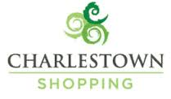
Westfield Penrith | 585 High St, Penrith NSW 2750 | 90,400 | 313 | 
Macarthur Square | 200 Gilchrist Dr, Campbelltown NSW 2560 | 94,600 | 303 | 
Melbourne central | 211 La Trobe St, Melbourne VIC 3000 | 54,700 | 301 | 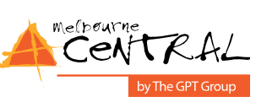
Sunshine Plaza | 154-164 Horton Parade, Maroochydore QLD 4558 | 73,400 | 249 | 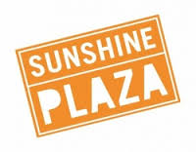
Rouse Hill Town | Windsor Rd & White Hart Dr, Rouse Hill NSW 2155 | 69,700 | 245 | 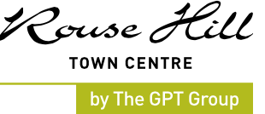
Westfield Woden | Keltie St, Woden ACT 2606 | 74,400 | 234 | 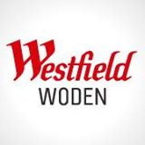
Wollongong central | 200 Crown St, Wollongong NSW 2500 | 56,600 | 230 | 

